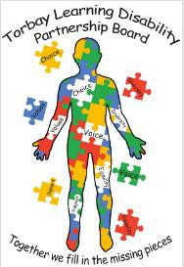
Torbay Learning Disability Partnership Board
30th September 2021

People at the meeting:
Sharon O - Co-Chair and Dep Director ASC Neil H - Co-Chair and LD Ambassador
Tracey (LD Ambassador) Shaun (LD Ambassador) Jamie (LD Ambassador) Alex (South Devon College) Pam (Carers Rep) Michelle (Carers Rep)
Emma (Mencap) Sue (Torbay LD Commissioner)
Kate (Police Diversity Officer) Adam (ASC Commissioning Manager) Ali (Hollacombe) Lindsey (carers service)
Si (SPACE) Helen (Social worker)
Sarah (Healthwatch) Dr Gaywood
Jo (Devon Link-up) Hannah ( Devon Link Up)

Who couldn’t be there:
Adele (LD Ambassador) Ben (LD Ambassador) Martin (LD Ambassador) Jon (Adult Safeguarding)

Introductions
Sharon and Neil welcomed everyone to the meeting, and everyone introduced themselves.

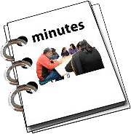
Updates for minutes
Sharon asked everyone if there was any updates or changes to the notes of the last meeting and the following points were raised:

- Adding Pam, Sue, and Alex to the notes of the last meeting as they were there.
- To be clear whether we are talking about National Mencap or Torbay Mencap.
- Add that there is another learning disability nurse at Torbay Hospital now.

Action: Sharon is going to confirm if Finance and Benefits assessments have started again.

Ambassadors’ report
Neil gave everyone an update from the Ambassadors.

Toilets
Neil said that the LD Ambassadors had good news - he had an email from Jo Williams to say there will soon be 15 contactless cards available to help people who don’t have debit cards access public toilets. This happened after the ambassador’s poem was read out at a Torbay Council meeting.
Neil asked if the cards will be free and, how many more cards will be needed. Sharon said the15 cards are free, but if any more are needed we will have to find funding. Each card costs £17 (and has £15 credit on).

Action: Please can everyone let Sharon know how many cards will be needed.

Sharon said that Torbay Mencap will be helping to lead this, and Alex said it would be good for people to work together. Lindsay asked if any other organisations are involved as that would be a great way to get the cards out there.
Sue said that younger people under 18 years old and older people also may need a card.

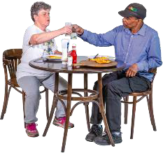
Pam said that public toilets are often shut by 6pm which means that for some people, this would mean they are not able to go out in the evenings.
Shaun said that as he has used a radar key and now it does not work. He wanted to know if he could get his money back and if he will get a card.

Pam asked if the cards could have a unique number so that anyone can check that the toilets are being used correctly by someone with a learning disability,

Action: Sharon agreed that this was a good idea and will ask the Council about all the questions.

Health
The Ambassadors had a meeting with Dr Rachel Gaywood. It was good to hear all about the good work that she has been doing.

The Ambassadors talked about trusting health staff and the importance of seeing the same doctor each time. Sue said that there were 6 big ideas on improving the health of people including better screening for colon cancer, breast cancer.

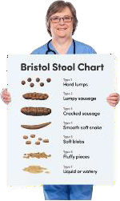
The Ambassadors talked about how people like to be communicated and annual health checks. They told Rachel how important it is for doctors to ask about them about sex, relationships, alcohol, drugs, smoking and constipation.

The Ambassadors would like to hold an event about constipation because too many people die early from it.

Supported Living Interview Feedback
The Ambassadors took part in Support Provider interviews and Sue said they really tested the providers who took part.

It had been a different experience for the providers, and they found the questions interesting. Sue also said that the Ambassadors had worked very hard. Neil said that some people had used a lot of jargon which people didn’t understand.

Neil said that the Ambassadors would like to run a housing event and would be good if the providers could be there and talk to tenants.
Alex said it would be good to set up a working party to talk about the event.
Adam gave a brief update on Extra Care housing for people with learning disabilities. Torbay Council are buying Crossways’ shopping centre in Paignton to build a new extra care housing service, and there will also be one in Torquay called Torre Marine.

Care Quality Commission – New Redvers
Neil said the Ambassadors were very sorry and shocked to hear about what had happened at New Redvers. They would like to know what actions are being taken.

Sharon said that the Adult Social Care Team were working with the owner to make sure everyone living there was safe and well.

Neil said that it is never ok for people to be treated badly and we all have the right to live a safe, healthy life.

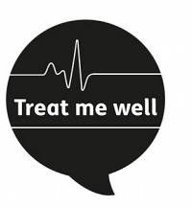
LD Treat me Well
Sharon said that meetings had been well attended and the Trust were moving closer to using easy read information.

Healthwatch Mencap Carers Report
Sarah and Emma shared a presentation about some work that has been done with Carers. There were some things which carers were not happy about.

Sue said it was important that carers have a voice and know how to make complaints when they are not happy.

Sharon said we need to work closely with Healthwatch and that as part of her role she sees every complaint and checks to see if there are themes.

Devon Learning Disability & Autism Programme Board
Sue said there is a monthly Board meeting and there is money for a small group of people with learning disabilities and autism to go to the meeting. Sue hopes that this can happen soon.

Art Competition Results (LD Ambassadors)

Sue said that there were 13 very good entries for the LDPB logo competition. The LD Ambassadors had judged the competition and a winner had been chosen. They thanked everyone for taking part.

Any Other Business
Neil told everyone about an art exhibition from the 25 - 29 October at the Grand Hotel and if anyone wants to go along.

Sue said Jon Anthony from Adult Safeguarding had asked her to raise the recent safeguarding report from Norfolk. It was very sad because 3 people had died in long stay hospitals in just 2 years.
Jon thinks lessons still haven’t been learnt about checking how people who are living ‘out of the area’ in a long stay hospital, are.
Jon would like to review the arrangements with a Learning Disability Partnership Board Member and Ambassador. Everyone said it would be a good idea and Neil said he was interested to help.

Lindsay said that she would like to share information about the things that are happening in Torbay.

Sue said we are still hoping to get a new page on the Council website where all the information can be put.

Neil closed the meeting and thanked everyone for coming.

