Appendix 3 Maps of Sites Described in the Main report

Key: Green= Sites where the principal of development is already established
Yellow= Sites assessed as having relatively minor constraints and are recommended for development.
Amber= Sites with significant constraints but are recommended for consideration.
Red = Rejected sites not recommended for inclusion in the Local Plan due to constraints.

Sites Considered in this report
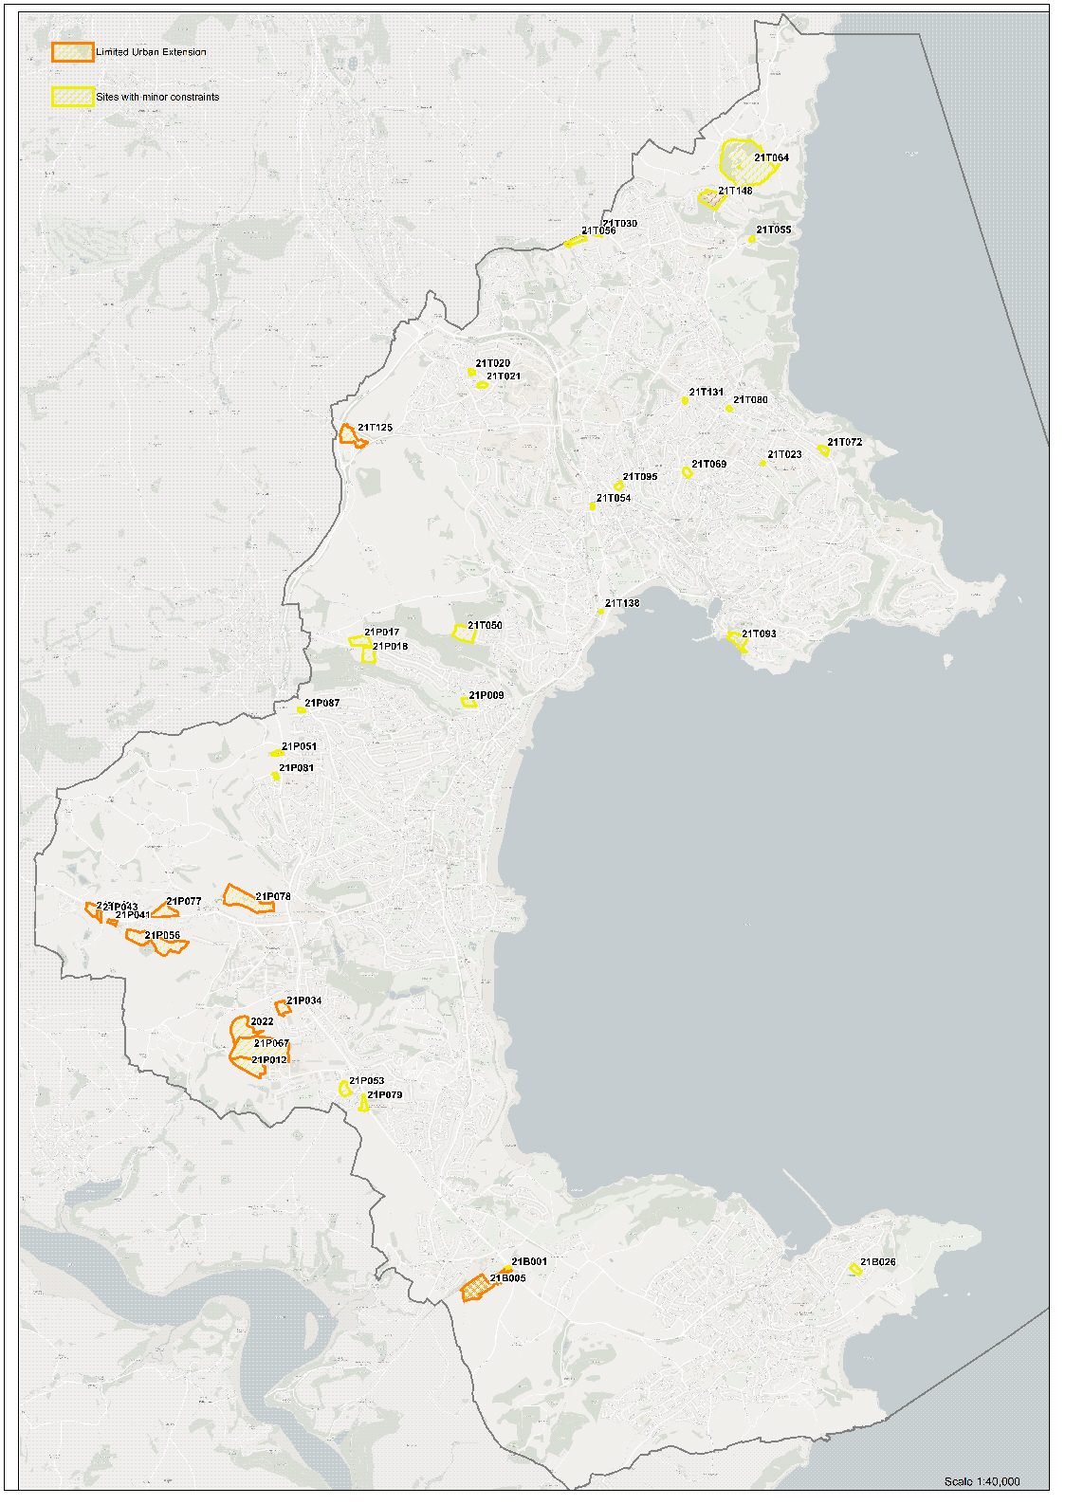
Sites considered in this report plus rejected sites/Broad Locations
