English Riviera

Destination Management Plan

2022-2027

  - February 2022
  - DRAFT

Contents
1. Vision and Objectives 3
2 Setting the Scene 7
3. Markets for Growth 11
4. Positioning and Branding 14
5. Destination Development 16
6. Destination Management 25
7. Delivery and Organisation 30

Vision and Objectives

Introduction
The English Riviera has a strong history of being a premier coastal resort, with a tourism sector that supports local and regional businesses, creates local jobs, and contributes to the sense of place and quality of life. But in recent times the English Riviera has struggled to keep pace with changing market needs, and the impact of Covid-19 and the climate crisis are creating unprecedented challenges, with a reduction of 55% of tourism earnings from staying visitors and a 50% reduction from day visitors in 2020 compared to 2019.
The English Riviera has many wonderful assets and a proud and committed partnership of business and public agencies that want to see the destination flourish. This Destination Management Plan (DMP) sets out the priority actions that can help the destination succeed. It is informed by local voices but driven by the needs and wants of the visitor.

Vision Statement
The ambition for the English Riviera is encapsulated in the following vision statement:
It is time to refresh and reposition the English Riviera as the UK’s premier holiday resort of the future. With a unique heritage, encompassing three towns, each offering a different coastal experience, set within an exceptional natural environment, the English Riviera is so much more than the sum of its parts.
Combining tradition and contemporary, we have a bright future. The English Riviera can offer the best of the seaside, outstanding seafood, exciting activities on and off the water, authentic cultural events and experiences, and a globally significant UNESCO Global Geopark designation that runs like a golden thread through the entire visitor experience.

Objectives
This DMP runs from 2022-2027 and sets out the interventions that can help propel the destination forward. It isn’t everything that can and will happen but includes proposals which will shift the destination into a higher gear, that build on the inherent strengths and reflect market trends and opportunities and help to achieve a more sustainable and resilient destination. Objectives for the life of this plan are:
- Recover – return to 2019 spend and visitor levels by 2024
- Grow – achieve an additional £75m of tourism spend and 1,500 new FTE jobs by 2027
- Re-balance – more sustainable visits, with 40% of visits from October - March (currently 35%)
These objectives will be achieved by the following priorities:
- Markets, positioning and branding - attracting new and existing visitor markets and an improved reputation and profile for the destination
- Destination development themes - new product investment and development of the existing offer
- Destination management - better destination management and visitor welcome (and resident satisfaction)
- Organisation and delivery - clear delivery arrangements
This DMP contains key actions and recommendations to achieve these objectives, and the steps from ‘from vision to action’ is detailed below.

Priorities

Markets, Positioning and Branding

Actions
- Market Research
- Brand Strategy Review
- Marketing Strategy Review

Indicators
- Higher market awareness
- Marketing reach

Destination Management Theme: Food and Drink

Actions
- Sustainable Food and Drink Destination
- Seafood Feast as a Signature Event
- Inspiring Dining

Indicators
- Spend on local suppliers
- Event economic impact
- Value of media coverage

Destination Management Theme: On the Water

Actions
- Watersports Hub Development
- Business Development
- Packaging On The Water Experiences

Indicators
- Feasibility study delivered
- No. businesses supported
- No. new experiences

Destination Management Theme: UNESCO Global Geopark

Actions
- Geopark Interpretation
- Digital Geopark Trails
- Designated Landscapes Partnership

Indicators
- No. businesses using Geopark
- No. geopark trails
- Geopark profile

Destination Management Theme: Culture and Events

Actions
- Signature Events
- Animating the Destination

Indicators
- Event economic impact
- No. public art installations

Destination Management

Actions
- Policy Review
- Joint Response to Visitor Survey
- Public Realm Improvements
- Bus Network Improvement
- Cruise Development
- Green Tourism Award for Business
- Glasgow Declaration
- Education/Business Plans for Tourism
- Workforce Skills
- Annual Performance Review
- Meet English Riviera

Indicators
- Stock of serviced accommodation
- Increased visitor satisfaction
- No. cruise arrivals
- No. businesses with accreditation
- Carbon impacts from tourism
- No. businesses engaged
- Monitoring DMP actions
- Value of conference bookings

Delivery, Organisation and Resources

Actions
- Destination Management Group (DMG) Terms of Reference
- Resource Schedule
- Investment Criteria

Indicators
- DMG Terms of Reference
- Discretionary funding secured
- Criteria in place

Outcomes
- Higher destination awareness and profile
- Increased marketing impact
- Increased visitor spend
- More skilled workforce and tourism seen as an attractive career
- Strong leadership for the visitor economy
- Improved destination experience
- More sustainable destination
- External funding secured to support priorities

Setting the Scene
This section contains a summary of the detailed analysis, which is contained in an accompanying Baseline Evidence document.

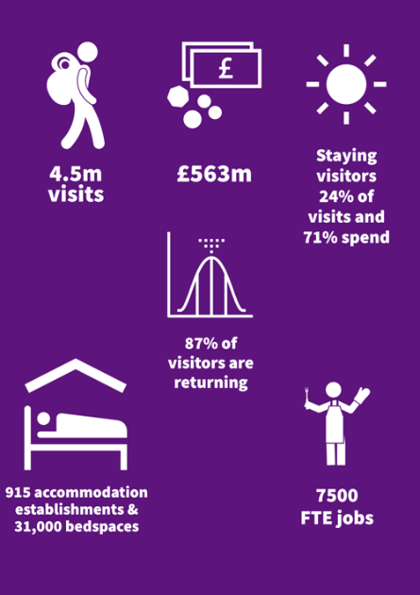
The Sector
Figure 1: The English Riviera Visitor Economy 2019
The English Riviera has a substantial visitor economy, as illustrated in Figure 1, and there has been steady progress during the previous DMP (2017-21), in particular:

- Strengthened partnership working across the private and public sector, with a new Destination Management Group (DMG) overseeing DMP delivery.
- Improved marketing delivery through focused work of the English Riviera BID Company Ltd (ERBIDCo).
- Better links between the sector and skills development, with the close collaboration of South Devon College (SDC).

As a traditional coastal resort, it is perhaps unsurprising that holidays dominate the visitor profile at 78% of all visits, compared to the England average of 47%, and 29% of all visits taking place during July and August .

Covid-19 has undeniably had a devastating impact on the resort. Despite this, the sector has remained resilient with positive results from summer 2021 and accolades such as TripAdvisor’s 2021 Number 1 Staycation destination. There has also been continued investment in existing and new products across the destination.

National Strategic Context
The 2021 independent review of Destination Management Organisations (DMOs) in England, the ‘De Bois Review’, is still being considered by Government. The review recommends the implementation of a new tiering system of DMOs and structured support for tourism and describes the confusing array of organisations highlighting the South West in particular. The review recognises the benefits of longer term commitments to marketing with funding models delivered by Business Improvement Districts (BIDs) and Tourism BIDS (TBIDS), with significant return on investment from the English Riviera (£75:£1) being the highest of those DMOs that responded to the review. Given the proposed tiering arrangements, the English Riviera should ensure it considers which neighbouring destinations it could collaborate with, and what activity it may undertake in partnership to strengthen these relationships (subject to the Government’s response to the review).
The recent outcomes of COP26 and the Glasgow Declaration on Climate Change for Tourism, as well as the ‘Towards 2030’ prospectus from the Great South West Tourism Partnership, lay down the challenge of achieving Net Zero in tourism by 2050. There is therefore an imperative to start now, and this DMP offers an ideal opportunity to think about an approach and actions that will help move the English Riviera towards a goal of Net Zero.

Local Strategic Context
As with most local areas, there are various plans and strategies for heritage, events, culture, regeneration, community and economic development. This DMP aligns with these other plans and likewise much of what is contained within them will help the English Riviera thrive as a destination.
In addition to the distinctive three towns, each appealing to different markets, our review of the English Riviera visitor experience identified six signature experiences:
- UNESCO Global Geopark – designation covering the whole of the English Riviera with specific locations including Kents Cavern, Berry Head Nature Reserve, Cockington Court and Country Park and Torre Abbey.
- Beside the Sea – boats and harbours, boat trips, seaside and beaches, seafood.
- Family fun – wide range of paid and free, indoor and outdoor family attractions.
- Walking – the South West Coast Path, UNESCO Global Geopark Walks, John Musgrave Heritage Trail.
- On the Water – adventure activities, stand up paddle boarding, kayaking, RIB rides, sailing and swimming.
- Heritage and Culture – museums, theatres, and galleries, including Agatha Christie related heritage and events.
In addition to these leisure signature experiences, the English Riviera has a range of conferencing and business event facilities for business visitors and conference and event organisers. This includes purpose-built venues such as the Riviera International Conference Centre (RICC), established hotels with conference and meeting spaces such as The Grand, The Imperial and Livermead Cliff Hotel, unique venues such as Torre Abbey, and new build hotels such as the Hampton by Hilton, Ibis and Mercure adding yet more modern facilities.

Comparators and Best Practice
From the examples of best practice in other destinations, the underlying lessons to take forward are:
- Quality is key – in public realm, gateways, accommodation and attractions.
- Communities and businesses need to buy in – to the DMP delivery and work collaboratively on taking the actions forward. E.g. adopting messaging, interpretation opportunities from the UNESCO Global Geopark.
- Creativity must be nurtured – E.g. ‘pop-ups’ in redundant spaces.
- Activities are fun to watch as well as ‘do’ – watersports development supporting activity with essential changing facilities.
- Culture and events can animate and invigorate destinations - and have the greatest impact out of the summer season, but they have a lifecycle and need to adapt or risk losing impact.
- ‘Brilliant Basics’ - successful visitor destinations look after their ‘brilliant basics’, things such as toilets, parking, cleanliness, access and water quality. While these things do not drive visits, if not looked after they will put visitors off coming.

DMP Consultation
The input of many stakeholders and businesses through a series of workshops, 1:1 consultations and online survey, provided many useful insights including:
- There is inconsistent quality across the visitor experience, including town centres and accommodation.
- An over-supply of accommodation is depressing prices and restricting investment. Current planning policies (TO2 Change of use of tourism accommodation and facilities⁾ are helpful in addressing this but need to go further.
- Environmental and sustainable improvements, e.g. Electric Vehicle (EV) charging and improving nature in the towns, are important.
- Market awareness and appeal of the English Riviera brand, there is a recognition that it unites the destination, giving coherence and a focus for businesses.
- The UNESCO Global Geopark designation is important, but often underused and misunderstood.
- Tor Bay is a magnificent asset and the underlying quality of the award-winning beaches, harbour and marine and sea-based activities are excellent.
- Developing demand out of the main summer season is vital.
- Connectivity between the towns, and also with the rail stations, needs improving.
- New markets demand a better range of food and drink, culture, retail, music and entertainment and see other destinations offering this.

Markets for Growth

What we know

Market Trends for the English Riviera:
- Time together - spending time with friends and family
- Activity, health and well-being – in the outdoors
- Appeal of less visited, undiscovered places with distinctive local culture
- Experiential tourism – culture, heritage, authenticity
- Responsible and sustainable tourism
The English Riviera is primarily a leisure destination, with over three-quarters of visitors on holiday (compared to England’s average of just under half). Given the ‘holiday focus’ it is unsurprising that 29% of all visits take place in July and August. And, again, not surprising with a holiday focus, visitors stay longer but on average spend less than the typical visitor elsewhere in England.
The English Riviera has an impressively high return visitor rate of 89%, who typically rate their experience very highly. Whilst this is a great achievement, it is an issue to consider when coupled with Torbay's typically older visitor profile (71% aged over 55), and the lower satisfaction rates of first-time visitors to the destination.
These key statistics paint a picture of a destination which is highly dependent on an ageing market and summer visitors.
To survive and grow, the English Riviera has to target a broader range of market segments, who are able and willing to spend more. Impressing these new markets during a first-time visit, to nurture a new generation of loyal visitors should be a top priority, and so the needs and wants of these segments should in turn dictate the investment in new product and experience development.

Target Markets
Three leisure segments have been selected as having growth potential for the English Riviera, drawing on robust research by ERBIDCo, VisitEngland and other UK National Tourist Boards (VisitScotland, VisitWales, Fáilte Ireland). Realising the growth potential of these segments will depend on the development of the offer and so should be built up over time. A fourth business tourism segment has also been identified, as a market to sustain and rebuild, capitalising on the destination’s existing and emerging assets.
Geographically, the primary focus for the English Riviera should be on the UK domestic market, where there is significantly more growth potential and return on marketing investment will be greater. In general, targeting should concentrate on a four-hour travel time for staying visitors.

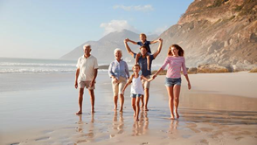
Immediate Priority

Fun by the Sea Families
UK Families with younger children (<13): extended families, multi-generational, groups.
- Strong affinity towards England breaks, particularly seaside during summer and other school holidays, weekends, Easter -October.
- Highly motivated by beaches, small towns, outdoor leisure, theme parks, family attractions.
- Cheaper/affordable accommodation especially caravans/ holiday parks.
- Prepared to spend on ‘treats’ and entertainment for the children.
- Child-friendly attractions and activities are a must.
- ‘Fun’ is the name of the game – learning is an added bonus.
- Need detailed practical information to reassure and inspire.

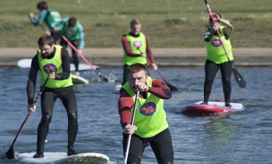
Short-Medium Term Growth

Young Actives
- Groups of friends and couples in 20s-30s.
- Year-round, but mostly Autumn-Spring.
- Activity is more important than place.
- Looking for excitement and adrenaline activities.
- Good infrastructure and facilities essential.
- Good value accommodation.
- Easy to access, organise, book etc.
- Socialising and sharing experiences – live and online.

Medium-Longer Term Growth
Cultural Explorers
- UK, international and cruise visitors – couples, groups of friends.
- Typically, 35+, older, working and retired, no/post children.
- Take lots of breaks and holidays, like to explore different places.
- Year-round, mid-week and weekends.
- Want inspiring, authentic, interesting places within easy reach.
- Interested in heritage, culture, gentle activities.
- Natural environment and beautiful landscapes and vistas important (potential for geo-tourism).
- Quality, authentic local food and drink – and good accommodation.

Sustain and Re-build

Business Tourism and Events
Regional/national association conferences and corporate meetings within 30-50 miles, will include international delegates.
- Looking for easy access, value, quality and flexible spaces and good accommodation.
- Post Covid-19 team building opportunities.
- Complement leisure tourism – corporate and conferences mid-week and in spring and autumn. Wider leisure offer and social programmes important for some markets.
- Opportunity around business to leisure ‘converters’.

Positioning and Branding

Marketing Review
The English Riviera BID Company (ERBIDCo) delivers the destination marketing for the English Riviera which includes the website, a suite of print and management of social media channels. The ERBIDCo has invested heavily in digital marketing and the new business plan (ERBID2) sets out the direction of travel and marketing investment over the next five years (2022-27).
The marketing takes a broad and inclusive approach, encompassing a wide range of locations, attractions, activities and themes. Whilst this is understandable given the nature of the destination, the sense of ‘something for everyone’ is in danger of diluting the overall proposition. Across channels and campaigns, a variety of straplines are used, and although these may be complementary, there is a risk of potentially confusing the visitor and weakening the brand.
The ‘English Riviera’ brand is rarely used by visitors or by travel media; greater recognition often lies with the three towns, and Torquay in particular. Visitors tend to speak of the area fondly, again reflecting high levels of repeat visits, (but non-visitors much less so). Awareness levels are low among non-visitors who do not tend to see it as a place to aspire to visit. It rates particularly low in terms of heritage, culture and food. The travel media generally presents the destination in positive terms and has attracted many positive articles and media coverage in recent times.
Positively, from a business perspective, there is widespread buy-in and use of ‘English Riviera’ in promotional activity, creating a sense of pride in place. The complexity of the brand architecture is evidenced however in the business survey undertaken as part of this DMP review. This revealed that around three-quarters of businesses strongly identify with ‘English Rivera’ as the destination brand. In addition, businesses also identified with their town – around half identifying with Torquay, and around a third also identify with South Devon/South Devon Coast.

Moving Forward
There is a challenge in communicating a multi-faceted destination brand which encompasses several places and propositions. The changing attitudes, perceptions and desires of a market faced with numerous choices create further challenges. The English Riviera has a long history and must ensure it continues to be relevant to new visitor markets, presenting them with a clear, memorable and compelling propositions.
Beyond the branding of the destination, work has been done locally in developing a ‘place story’ for Torbay (launched in January 2022) which is intended to cut across and support all sectors, encourage inward investment and nurture civic pride. While the destination brand is focused on visitors, it does make sense for it to align with the wider Torbay Story and Torbay Together Strategy, so that all place-related marketing is synergistic and reinforcing.
All of these factors therefore suggest it is timely to review the English Riviera brand to ensure the positioning of the destination will support the vision for tourism. This review must be market-focused and informed by the opinions and perceptions of current visitors and non-visitors (from the target segments identified within this plan).
The outcome of this research should be shared with businesses, partners and key stakeholders to consider what, if any, changes in approach are needed. This could include how the destination brand should be communicated in the marketplace, within a clear architecture of places and propositions which define the destination, position it clearly and convey what and where it is – and who it is for.

Branding and Marketing

Action 1: Market Research
Primary research among leisure visitor and non-visitors to explore current brand perceptions and associations, names, places and straplines.
Outcome: Increased market knowledge and insight to inform more effective marketing
Measured by: Research outputs and action taken
Delivered by: ERBIDCo (lead), TDA (support)
Resources: £20,000 (per annum)
Timetable: 2022-23

Action 2: Brand Strategy Review
Informed by the findings of the market research, engage stakeholders in reviewing and updating branding strategy and marketing assets. Consider producing brand toolkits for businesses to adopt. Reconfigure marketing collateral and channels accordingly.
Outcome: Improved destination awareness and appeal among target segments
Measured by: Visitor Surveys, Media tracking,
Delivered by: ERBIDCo
Resources: £10,000 (one off)
Timetable: 2022-24

Action 3: Marketing Strategy Review
Review the marketing strategy and update accordingly to the themes and target segments in the DMP. Review and refine messaging/activity where appropriate.
Outcome: Increased market exposure
Measured by: Increase visits from target segments, Visitor Surveys, Content generated, Sentiment tracking
Delivered by: ERBIDCo
Resources: Existing resources
Timetable: 2022-27

Destination Development
The English Riviera is an established coastal destination, but intense competition and changing visitor markets mean there is a continual need to develop new and better experiences to drive more visits, tackle the seasonal imbalance and increase spending and benefits for local communities and businesses.
Tourism faces some big challenges generally – not least how to develop sustainably and respond to the climate crisis, there is also a need to think about growth that is sustainable. New developments, including those identified below, should all aim for zero carbon, and this should be evaluated as part of the business case/feasibility assessments. Finally, there is a need to manage expectations. Changes take time to deliver and are part of a ‘long game’ if the destination is to emerge stronger from the pandemic.
The priority themes which follow are not everything that can or will happen. Rather they are the focus for development which is pragmatic, deliverable and catalytic and which responds to the market opportunities for the English Riviera.
The four priority development themes are:
1. Food and Drink
2. On the Water
3. UNESCO Global Geopark
4. Culture and Events

These development themes are explained in detail below, setting out the next steps and priority actions with a clear rationale validating their status as the major strategic action areas of this DMP:

Theme 1: Food and Drink
Expand and bring England’s Seafood Coast concept to life. Re-launch with a focus on high-quality, local food and drink. Develop a reputation for food and drink that emphasises the sustainable production and consumption with stronger local supply chains across the English Riviera, and potentially wider into Devon and the South West.

Rationale
Food and eating out is increasingly important to visitors who seek authentic local experiences, but it is hard to be distinctive. The seafood sourced from Tor Bay’s local waters is a strong Unique Selling Point. For visitors, it offers a ‘flavour of the English Riviera and UNESCO Global Geopark’ and the same product you can find in high end London restaurants at much better value. As well as flavours of the sea, there are flavours from the land to enjoy. Food and drink also offers an opportunity to fill and reinvigorate redundant spaces; and combined with music and entertainment can be a significant part of major events, as well as an opportunity for a standalone event in its own right.

Action 4: Sustainable Food and Drink Destination
Revive the ERBID food and drink focus group, explore options to work with the Devon Food Partnership and Sustainable Food Place award. Focus on initiatives to promote local producers/businesses to ‘taste the English Riviera and UNESCO Global Geopark’, reduce food waste, sustainability and improve local supply chains. Develop appropriate support tools for businesses. Increase food and drink experiences, including pop-ups, ‘try-me’, making, tasting and cookery experiences.
Outcome: 5% annual growth in spend on local suppliers
Measured by: Business Survey
Delivered by: ERBIDCo, Private Sector
Resources: £10,000 (per annum)
Timetable: 2022-27

Action 5: Relaunch Seafood Feast as a Signature Event
The September food and drink event should become a signature event in the destination calendar. Increase annual visitor footfall, overnight stays and spend
Outcome: £2.5m of annual economic impact
Measured by: Event Impact Survey
Delivered by: ERBIDCo, Private Sector, Torbay Council
Resources: Existing resources
Timetable: 2022-27

Action 6: Inspiring Dining
Enable inspiring dining spaces, such as around the waterfront, pop-ups and redundant spaces/buildings to create special and unique places to eat and drink with a focus on quality and local.
Outcome: £100,000 equivalent PR/media media coverage
Measured by: Media Monitoring
Delivered by: Private Sector, Torbay Council
Resources: Existing resources
Timetable: 2023-27

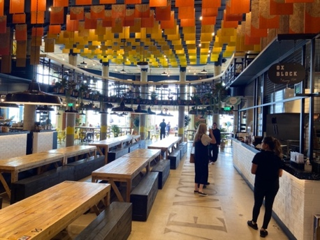
Our inspiration
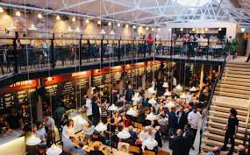
Shelter Hall is situated on Brighton’s seafront in a formerly derelict 15,000 sq. ft Victorian building. It is a pop-up food market that brings together seven independent kitchens and a bar, split over two indoor floors and an outdoor terrace. It offers emerging chefs a four-month residency, opening their first physical space and gain access to up to 100,000 customers at the venue including mentorship and training. Sessions, which operates Shelter Hall, is currently looking to expand to new destinations.
Duke Street Market opened in the heart of Liverpool city centre in 2019. Self-described as a ‘social eating concept’, it features six resident kitchens providing individual food concepts, a coffee kiosk, and bar within the shell of a restored 100-year old warehouse covering 5,000 sq. ft.

Theme 2: On the Water
Develop on/in the water products and activities across the destination with world class provision for ‘try-me’ visitor experiences, as well as providing adequate facilities and services for self-equipped enthusiasts. Develop the connection with the UNESCO Global Geopark designation, improving visitors’ awareness of the environment and link to land-based active experiences. Ensure all existing and new developments are designed, developed and operated sustainably and with a low-carbon impact.

Rationale
The 2021 ERBIDCo Visitor Survey found that 84% of visitors visited the beach/sea (23% of visitors gave this as the main reason for the visit). Water-based activities were pursued by 21% of visitors (5% of all visitors gave this as the main reason for their visit). 46% of those who did not take part in water-based activities found the idea appealing. Sport England states that 27.6% of the total active population are active outdoors, and according to the Watersports Participation Survey (2018) the volume of participants increased for the third year in a row. 94% of all watersports activities in 2019 took place at the coast, and 38% of all activities were in the South East and South West. The south coast dominates participation in boating activity. The most popular activities in 2018 included spending leisure time at the beach, coastal walking and outdoor swimming. There is a long-term trend for growth in surf/body/paddle-boarding, canoeing and small sailboat activities. Covid-19 has increased the interest and appeal of water-based activity and personal wellbeing, as evidenced through VisitEngland Covid-19 Sentiment Trackers (undertaken by BDRC).

Action 7: Watersports Hub Development
Undertake a feasibility study into a watersports hub development ensuring any new facilities align to Carbon Neutral Torbay and the English Riviera UNESCO Global Geopark Environmental Policy Framework. Use any resulting new facilities to interpret the UNESCO Global Geopark telling ‘the story of the landscape’.
Outcome: Feasibility study delivered
Measured by: DMG monitoring
Delivered by: Torbay Council, Tor Bay Harbour Authority, TDA, ERUGGp
Resources: £20,000 (one off)
Timetable: 2023-24 (feasibility)

Action 8: Business Development
Enable on the water/watersports development by supporting businesses to establish themselves and grow.
Outcome: 10 businesses supported
Measured by: Business Survey and DMG monitoring
Delivered by: Torbay Council, Private Sector, TDA
Resources: Existing resources
Timetable: 2022–27

Action 9: Packaging on the Water Experiences
Develop ‘on the water’ experiences for distribution through new and established channels.
Outcome: 10 new experiences presented over DMP life
Measured by: Business Survey and DMG monitoring
Delivered by: ERBIDCo, Private Sector, Meet English Riviera
Resources: Existing resources
Timetable: 2022 – ongoing

Our inspiration
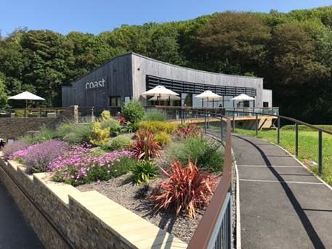
Coppet Hall Beach Centre in Saundersfoot, Pembrokeshire is a new building that contains a restaurant, watersports retail, activity centre, new public conveniences including family changing spaces and external beach showers. The Beach Centre is an environmentally friendly building - solar panels, air source heat pumps, a sedum roof, and improved footpath and cycling access all contribute to its BREEAM ‘Excellent’ rating. The restaurant ‘Coast’ focuses on using local ingredients and is recommended in the Michelin Guide. It was funded by a mix of private and public investment including Visit Wales’ Coastal Tourism Project, part funded by the European Regional Development Fund through the Welsh Government.
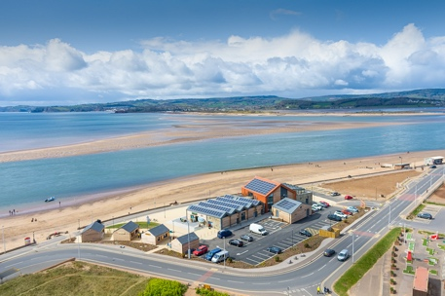
Sideshore is a community-owned watersports centre that opened in 2020 in Exmouth. As well as a watersports centre offering equipment hire, lessons and wellness activities, the development includes a casual seafront bar, restaurant and café run by Exeter celebrity chef Michael Caines. It is a Community Interest Company (CIC) made up of representatives from the local area. It aims to be the most sustainable building it can possibly be - all tenants have signed ‘’green leases’’ to ensure there is a ban on all single use plastics, twice as many solar panels were installed than the recommended coverage to generate as much renewable energy as possible, EV charging points and bike racks have been installed to encourage greener modes of transport, and construction was undertaken by a local firm, using 100% local staff.

Theme 3: UNESCO Global Geopark
The UNESCO Global Geopark designation is an international mark of quality and distinctiveness. Because Geoparks are about the connection between a landscape and people, the UNESCO Global Geopark essentially tells the story of the English Riviera and the story of its landscape. Key opportunities are to use existing and new experiences and locations to tell those stories in original and imaginative ways, highlighting and reinforcing the designation and running the UNESCO Global Geopark ‘story of the landscape’ through themes such as Heritage, Culture, Food and Drink, and Leisure. Sustainable tourism, Geo-tourism and ‘Slow Tourism’ initiatives are consistent with protecting and interpreting the landscape and reinforce the UNESCO Global Geopark designation.

Rationale
2020 research showed that 76 UK UNESCO designated destinations benefited from £151m of additional revenue as a result of their designation, mostly in the form of tourism revenues. The designation is more than geology – it is a wraparound for the heritage and culture of this unique area. While Geoparks are often not well understood by visitors, the UNESCO designation nonetheless brings with it a reputation for quality and distinctiveness that should be the foundations for destination development. As the designation must be revalidated every four years, the development of relevant tourism product strengthens the likelihood of retaining the designation.

Action 10: Geopark Interpretation
Integrate UNESCO Global Geopark into more products, experiences, visitor information and support businesses with creative storytelling and visual branding. Explore the options to further engage with businesses to develop ideas, such as simple toolkits and workshops. Explore developing Geopark Ambassadors to help tell the story of the Geopark while supporting the visitor welcome.
Outcome: 10% of tourism businesses using UNESCO Global Geopark in information/ marketing
Measured by: Business Survey
Delivered by: English Riviera UNESCO Global Geopark (ERUGGp), Private sector
Resources: £10,000 (one off)
Timetable: 2022-27

Action 11: Digital Geopark Trails
Develop options and implement digital trails for use on mobile devices with integrated interpretation.
Outcome: 3 new digital trails created and 5000 users/ downloads
Measured by: Usage figures for trail downloads
Delivered by: ERUGGp, ERBIDCo
Resources: £15,000 (one off)
Timetable: 2023-27

Action 12: Designated Landscape Partnership Trails and Promotion
Explore opportunities to work with other designated landscapes across the South West to promote the collection of unique landscapes and monuments.
Outcome: Twice yearly planning meetings held
Measured by: DMG monitoring
Delivered by: ERUGGp
Resources: Existing resources/ to be determined
Timetable: 2023-27

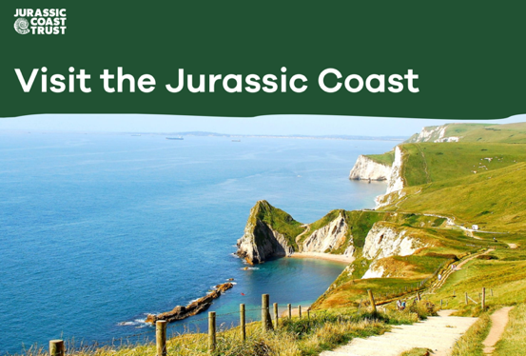
Our inspiration
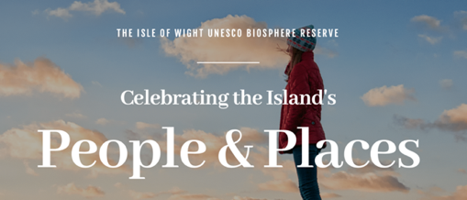
The Jurassic Coast stretches 95 miles along England’s South West coast from Exmouth in Devon to Swanage in Dorset. It became a World Heritage Site in 2001 for the outstanding universal value of its rocks, fossils and landforms. It celebrates the UNESCO World Heritage Site status it has been given by explaining on its website ‘what’s in it’ for a prospective visitor and making it meaningful to them. Visitdorset.com uses the strapline ‘Home of the Iconic Jurassic Coast’, giving prospective visitors the idea that they are going to experience something of real significance with a visit to the destination.
Isle of Wight was declared a UNESCO Biosphere in 2019. The focus on the tourism side has been to use the Biosphere status as a stamp of a high quality environment and to underline the opportunities to explore that natural environment sustainably on foot or on a bike. It links existing quality natural environment experiences to the new designation. In particular, it uses the Biosphere designation to underline the quality of its stargazing experiences and Slow Travel. It explains what Biosphere means to its visitors simply and clearly on its website and provides hyperlinks to more information where appropriate. It provides a joined-up visitor experience in the natural environment via an app with cycle and walking routes, incorporating attractions and places to stay, maps and user reviews. It encourages and incentivises tourism businesses to value the environment via a green star programme that also helps visitors know which establishments support slow travel and other environmental actions.

Theme 4: Culture and Events
Identify and develop four Signature Events for the English Riviera. This might include support for the growth and development of existing or new events to align with the objectives in the DMP. The cultural offer across Torbay includes a variety of venues and a programme of visual and performing arts. Given the importance of the UNESCO Global Geopark and the natural environment, it would be beneficial to consider how culture can be delivered in the natural environment as part of regeneration projects, UNESCO Global Geopark plans, orientation and interpretation. The use of sculpture and public art, lighting and events can help animate and interpret these special places.
RATIONALE

Rationale
Culture and events can bring a range of direct (economic) and indirect (reputation, wellbeing, quality of life) benefits. They help animate the destination, local cultural and event programmes can strengthen the sense and distinctiveness of the place, and these are the reasons why the Council has planned significant investment over the next three years. The benefits and opportunities are well articulated in the English Riviera Cultural Tourism Strategy and these recommended actions align with the ERBID2 Business Plan and Torbay Council Outdoor Events Strategy.

Action 13: Signature Events
Undertake a critical appraisal of current programming against clear criteria (e.g. seasonal benefits, environmental impact, market focus, economic impacts, reputation etc) Identify and delivery four Signature Events that align to the objectives, key themes and audiences of the DMP.
Outcome: £8m of annual economic impact
Measured by: Event Economic Impact surveys
Delivered by: Torbay Culture, Torbay Council, ERBIDCo
Resources: £200,000 (one off, existing)
Timetable: 2022-27

Action 14: Animating the Destination
Explore options to commission a series of public art installations over the life of the DMP. Work with Torbay Culture and local artists to enliven and animate the destination. Thread the UNESCO Global Geopark story through these projects.
Outcome: 5 new installations over life of the DMP
Measured by: DMG monitoring
Delivered by: Torbay Culture, Torbay Council
Resources: £75,000 (one off)
Timetable: 2022-27

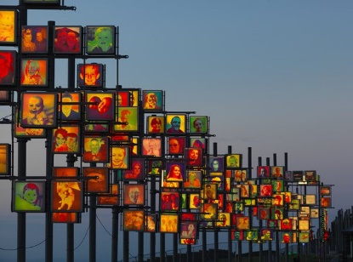
Our inspiration
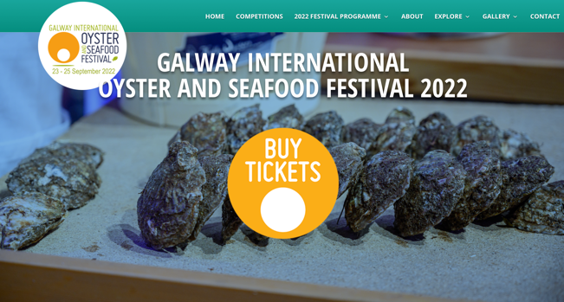
Blackpool’s CultureBlackpool project showcases and highlights the cultural offer that currently exists in-resort to visitors and residents. It has created a new partnership between public and private sector partners to promote Blackpool’s back story of architecture, heritage, exhibitions, internationally acclaimed installations and events to its 142,000 residents and 18 million visitors. It has launched a new B/Side Campaign in a bid to flip expected perceptions of Blackpool and persuade people to ‘tune in’, look up and around, and to appreciate the cultural side of the resort.
Galway is renowned for its vibrant lifestyle and for hosting numerous festivals such as Galway International Oyster Festival, an annual free event held on the last weekend of September in the centre of the city attracting tens of thousands of visitors. According to Tourism Ireland, it has been called “one of the greatest events on earth”.

Destination Management
The visitor experience must be a consistent high-quality right across the destination with ‘brilliant basics’ (parking, access, toilets, services, waste etc), animated and attractive towns in which to stay, linger, shop and eat, alongside the attractions and experiences that are the main draw.
The ‘brilliant basics’ are things which don’t in themselves drive visits, but influence visitor’s enjoyment, spend and dwell-time in the destination; and crucially if they are missing or poorly managed will negatively influence the resort’s reputation.
The public sector usually has an important role to play and while the Destination Management Group is not responsible for these services, it needs to influence and engage with those who are responsible.
There are seven Destination Management Priorities and associated actions as detailed below.

Priority 1 - Visitor Accommodation
The management of accommodation change of use with Council planning policies is essential to avoid the risk and drift toward low quality visitor accommodation. This includes the provision of temporary, emergency and short-term residential accommodation within the areas of tourism, (e.g. Core Tourism Investment Areas), which could damage the reputation of the destination and create conflict with neighbouring visitor-focused businesses.
It is better to support the transition to alternative uses which complement the ambitions for the remaining visitor accommodation and the objectives set within this Plan to drive the visitor economy. Torbay has 31,000 bedspaces and, even though half of it is non-serviced, the remaining 15,000 spaces still represents an over-supply.

Action 15: Policy Review
Review the Local Plan and prepare supplementary planning documents to assist in transition of redundant accommodation.
Outcome: 2% reduction in serviced accommodation stock
Measured by: Hotel Stock Study in 2027
Delivered by: Torbay Council
Resources: Existing resources
Timetable: 2023-27

Priority 2 - Brilliant Basics
Public services and open spaces, such as beach management, cleansing, signage, toilets, grounds maintenance, planting, parking, public safety and lighting are all examples of things which contribute to the visitor welcome, experience, enjoyment and overall satisfaction of the destination.
Consideration is therefore needed for the management of these services to support the objectives of this plan to grow the visitor economy all year round. Service providers, such as Torbay Council, should welcome the findings from visitor surveys and the DMG should ensure this happens and for the relevant services to proactively engage and where possible improve these ‘Brilliant Basics’.

Action 16: Joint Response to Visitor Surveys
Undertake a review exercise across delivery teams to plan actions that address the findings of visitor surveys.
Outcome: Lift all survey scores above 4 or by 0.5 points (‘21 baseline)
Measured by: (Annual) Visitor Survey
Delivered by: Torbay Council, ERBIDCo, TDA (support)
Resources: Existing resources
Timetable: 2022-27

Priority 3 - Towns and Connectivity
There are examples of excellent public realm across the three towns, but there are also areas in which it is poor and areas where retail is struggling. In some cases, investment through the Towns Fund and other programmes are being used to improve the public realm, but further work is needed in areas that include for example around the Inner Harbour in Torquay and the area around Brixham Harbour. These are areas with potential for visitors and which would benefit from improved design and investment.
The three towns are part of the ‘English Riviera’ offer and connectivity between the towns should be reviewed to see how it can be improved for visitors. This includes travel on foot and by bike, as well as public transport by water and bus. Future development of cruise-tourism by Tor Bay Harbour Authority and ERBIDCo, should aim to maximise the impact from day visitors in terms of spend and actively address and mitigate environmental impacts.

Action 17: Public Realm Improvement
Further develop public realm improvement plans for visitor areas. Focus on Brixham Harbourside and Torquay Inner Harbour to complement and enhance improvements around the Strand.
Outcome: Score 4.5 on Visitor Survey in these specific locations
Measured by: (Annual) Visitor Survey
Delivered by: Torbay Council, ERBIDCo, TDA (support)
Resources: £75,000 (tbd, one off, concept design)
Timetable: 2022-27

Action 18: Bus Network Improvements
Explore options to rename (rather than number) the visitor routes and align to the Geopark story e.g. ‘The English Riviera Route’.
Outcome: Score 4.5 on ‘Public Transport – Quality’
Measured by: (Annual) Visitor Survey
Delivered by: ERBIDCo, ERUGGP, transport providers
Resources: TBD
Timetable: 2022-23

Action 19: Cruise Development
Develop shore excursions and tailor-made experiences for cruise operators which relate to the development themes of this DMP.
Outcome: Three new shore excursion programmes developed
Measured by: Business survey and cruise arrivals
Delivered by: Private sector, ERBIDCo, Tor Bay Harbour Authority
Resources: Existing resources
Timetable: 2022-24

Priority 4 - Sustainable Tourism
There is a growing imperative to address climate change and consider measures that would have the greatest impact in reducing the climate impact from tourism to the English Riviera. Baselining the current impacts and developing measures that work across the three domains of business, visitors and the destination (public sector) will drive improvements. Ensuring low-carbon actions are implemented as part of any new developments, including those outlined in our development priorities, is necessary if the English Riviera is serious about becoming a sustainable destination. There is an opportunity to use the UNESCO Global Geopark designation as a focus for sustainable tourism in the area and a hook to engage with businesses.

Action 20: Green Tourism Awards for Business
Businesses encouraged to achieve the Green Tourism Award (or other scheme) to showcase exemplars of good practice and supporting the overall reputation of the destination.
Outcome: 5% of tourism businesses accredited by Green Tourism
Measured by: Award take up
Delivered by: ERUGGp, Private sector, ERBIDCo
Resources: Funded by business
Timetable: 2022-27

Action 21: Glasgow Declaration
Explore the options to sign up to the UNESCO Glasgow Declaration on Climate Change as a commitment to a more sustainable visitor economy.
Outcome: Deliver Declaration Action Plan
Measured by: Annual monitoring of Plan
Delivered by: ERuGGp, DMG
Resources: Existing resources
Timetable: 2022-27

Priority 5 - Skills
Making tourism an attractive career choice for young people with exciting career pathways needs to start early and is essential to growing the visitor economy. Connecting businesses with educational establishments for work experience, career talks and to highlight the career pathways will help to relaunch the sector and recover from the impacts of Covid-19.
Tourism and the visitor economy is a broad sector encompassing accommodation, culture, heritage, activities, events, hospitality, attractions, tour operators and more, all requiring a mixture of universal and specialist skills and offering long term, all year-round career options. The English Riviera is fortunate to have South Devon College in its boundary. There are a wide range of skills and education programmes delivered by the College including 16-18 year old studies, Apprenticeships, Adult Skills and Higher Education, which can support increasing skills and employment in the sector. The College also has a good reputation of working with businesses to develop curriculum to meet the needs of the sector, (e.g the alignment of the UNESCO Geopark with outdoor curriculum). These opportunities should be further explored further, as well as improving links with local schools and Careers Information Advice and Guidance.

Action 22: Education Business Plans for Tourism
Annual plan for business engagement in education supporting career pathways for young people.
Outcome: 10 businesses engaged
Measured by: Review of annual plan
Delivered by: SDC, Private Businesses
Resources: Existing resources
Timetable: 2022-27

Action 23: Workforce Skills
Annual plan to increase business engagement to improve the skills of the workforce (and the unemployed) through take up of programmes.
Outcome: 10 businesses engaged
Measured by: Review of annual plan
Delivered by: SDC, Private Businesses
Resources: Existing resources
Timetable: 2022-27

Priority 6 - Research and Insights
Research, data and insights is an important function which will help better understand English Riviera visitors, track performance and assess the impact of the DMP. As well as visitor research, economic impact studies and accommodation performance should be used to track destination performance. A small number of KPIs including accommodation occupancy and yield, destination spend and employment are the best measures for tracking performance. More detailed analysis can be added to this baseline and ad hoc studies (e.g. Visitor Surveys, Overseas Market Studies etc) can be undertaken over time.

Action 24: Annual Performance Review
Deliver a number of annual surveys to review destination performance.
Outcome: Surveys delivered and shared with businesses/ stakeholders
Measured by: Review of ERBIDCo business plan activity
Delivered by: ERBIDCo
Resources: £40,000 (per annum)
Timetable: 2022-27

Priority 7 - Business Tourism
Support should be given to the development of Meet English Riviera to capitalise on the growth opportunities for business tourism. While competition is fierce, the range and quality of venues in the English Riviera and the proximity to business and universities in Exeter, Plymouth and the surrounding area does present some opportunities. In the short term, many of these opportunities are constrained by Covid-19, but over the period of this DMP the sector is likely to recover. The £70bn value of the sector dropped by £59bn in 2020 and, despite some recovery in late 2021, is likely to take some time to fully recover due to international travel restrictions and risks to event organisers. Improving the capability of businesses to offer hybrid events will continue to be important for future success.

Action 25: Meet English Riviera
Develop activity to support conference sales and marketing activity over the life of the DMP.
Outcome: £5m value of conference bookings over life of DMP
Measured by: Enquiry monitoring
Delivered by: Meet English Riviera
Resources: £25,000 (per annum)
Timetable: 2022-27

Delivery and Organisation

Roles and Responsibilities
The Destination Management Group (DMG) has a critical role in bringing the different organisations and tourism businesses together to create an integrated approach to development, marketing and management of the English Riviera. Places that do tourism ‘well’ are joined up in their ambition and approach – a fact highlighted in the recent independent De Bois review of DMOs and further reinforced locally by the rollout of the ‘Torbay Story’.
The English Riviera should therefore continue with its approach to destination management, with the DMG having collective responsibility for implementing the new Destination Management Plan, making best use of existing resources, working together in partnership and attracting further investment where needed to deliver the DMP's objectives.
There are some clear roles and responsibilities for the different DMG partners, and for this plan to be effectively implemented public services, operational leads and frontline tourism businesses should also be involved. This will help to drive the experience and offer for visitors, supporting the marketing of the destination and working collaboratively to progress the DMP priorities. The approach to take with involving tourism businesses should be agreed by the English Riviera BID Company (who represent all ERBID levy paying businesses).
The DMG is working well. With the fresh impetus and focus of this Plan, the DMG should be the main body for delivering and monitoring progress. The mix of private and public sector partners is representative of the sector and while membership should be continually reviewed, the DMG should not grow too big and unmanageable. Within the partnership different organisations will lead on priorities relevant to their specialist knowledge and capabilities E.g:
- ERBIDCo will lead on destination marketing, brand delivery, industry engagement and visitor research.
- South Devon College will lead on skills and connecting the tourism industry to careers advice.
- TDA will continue to provide secretariat support to the DMG.
- Torbay Council will lead on public services and the ‘brilliant basics’.
- Meet English Riviera, English Riviera Global Geopark Organisation, Torbay Culture Board, Torbay Business Forum and Tor Bay Harbour Authority will lead or support on the specific actions identified within the DMP.

It is also important to recognise that the DMG and its members are giving their time in addition to their ‘day job’ and there are demands arising from the DMP which need a resourced executive to take them forward (secretariat support is currently provided by TDA).
This document clearly sets out who is responsible for different priorities and actions and this reflects the specialism, knowledge and capabilities of the DMG partners.

Action 26: DMG Terms of Reference and Annual Review
Terms of reference, including membership, frequency of meetings, responsibilities for actions and progress monitoring on an annual basis
Outcome: Annual TOR and action plan progress
Measured by: Annual Review
Delivered by: TDA
Resources: Existing resources
Timetable: 2022-27

Investment and Resources
The DMP provides a strategic approach to developing the destination over the next five years. In some cases, the immediate next steps necessitate further work such as feasibility studies or development plans, and the DMP provides the template against which future investment can be evaluated. Detailed planning will identify specific resource requirements over and above existing allocations.
Delivery may require re-allocation or re-focussing of existing resources. Having a detailed DMP will also support funding bids from Government or other agencies. The UK Government published its Tourism Recovery Plan in June 2021 and will identify the support available at business, destination and national level. While the overall headline budgets are substantial, the funds identified in many cases cover a range of economic sectors and the whole of England. Nonetheless for a destination with a clear plan and a built-in commitment to partnership working, the following in particular offer opportunities for the English Riviera, (some of which Torbay has already secured support from):
- Town Fund Investment
- Future High Streets Fund
- Cultural Investment Fund
- Green Recovery Challenge Fund
- £900m Getting Building Fund
- Levelling Up Fund
- UK Shared Prosperity Fund
- Lottery Funding

It is also expected that Net Zero 2050 policies will result in investment in carbon reduction initiatives.

Action 27: Resource schedule
Development of detailed plans against the DMP actions, identify resource requirements and sources of funding
Outcome: Investment for DMP actions
Measured by: Annual DMG Review
Delivered by: DMG partners
Resources: Existing resources
Timetable: 2022-27

Action 28: Investment criteria
Agree criteria to support investment decisions within DMP actions, vision and objectives
Outcome: Clear criteria for DMP action and investment
Measured by: Annual DMG Review
Delivered by: DMG partners
Resources: Existing resources
Timetable: 2022-27
Note:
Resource requirements within this DMP are estimated and further detailed review is required to determine the extent to which costs can be met from existing resources.
Delivery arrangements and lead organisations are subject to change and re-allocation by DMG partners.

This document can be made available in other languages and formats. For more information please contact **insert your team email or phone no here**

The Economic Impact of the Torbay Visitor Economy 2020. The South West Research Company. September 2021
Economic Impact of Devon’s Visitor Economy. South West Research Co. 2019
Great Britain Tourism Survey. VisitBritain. 2019
ERBID1 results. ERBID 2 Final Business Plan. English Riviera BID Company Ltd 2021.
Torbay Local Plan 2012-2030. Torbay Council. Adopted December 2015
3 year averages 2019-2019, Great Britain Tourism Survey, Visit Britain
%s for Devon. The Economic Impact of Devon’s Visitor Economy 2019, the South West Research Company Ltd
3 year averages 2019-2019, Great Britain Tourism Survey, Visit Britain
Stats from English Riviera Visitor Survey 2021
UNESCO National Value Report UK (2020)
https://assets.publishing.service.gov.uk/government/uploads/system/uploads/attachment_data/file/992974/Tourism_Recovery_Plan__Web_Accessible_.pdf

