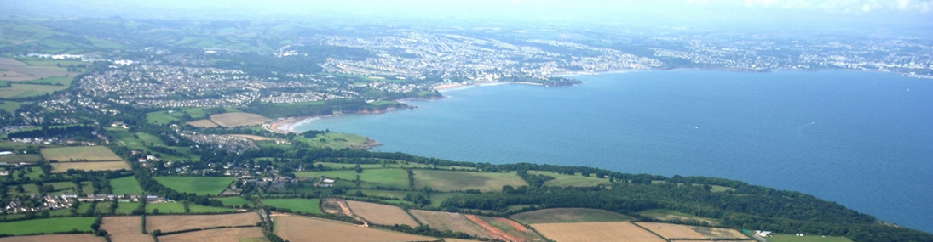

Housing and Economic Needs Assessment

May 2022
Contents
Chapter One: Introduction 3
Chapter Two: Planning Policy context 5
Chapter Three: The Housing Baseline 13
Chapter Four: Demographic profile 29
Chapter Five: Socio-economic profile 40
Chapter Six: The housing market and affordability 50
Chapter Seven: Calculation of affordable housing need 58
Chapter Eight: Specialised housing 79
Chapter Nine: Mix of housing 92

This document can be made available in other languages and formats. For more information please contact the Strategy and Project Delivery Team at future.planning@torbay.gov.uk

Chapter One: Introduction

Background and context
The Torbay Local Plan 2012 to 2030 (“the Plan”) was adopted on 15 December 2015. On 17 November 2020 Council Cabinet took the decision to update the Torbay Local Plan 2012 to 2030 and submit the updated Plan for Examination.
Council Cabinet requested a review and update of the housing elements of the Plan. This includes a review of housing land allocations and housing policies. This necessitates a new Housing and Economic Land Availability Assessment (HELAA) and Housing and Economic Needs Assessment (HENA) without a review of economic land allocation. The HENA will include an updated economic profile in respect of jobs, earnings and the local economy.
A HENA is required as part of the local evidence base supporting the Local Plan Update. The Planning Practice Guidance (PPG) on HENAs sets out the calculation that local planning authorities should follow to calculate local housing need for the purposes of the allocation through local plans that are to be submitted for Examination on or after 24 January 2019. As the Update to the Torbay Local Plan 2012 to 2030 postdates this, it is appropriate to follow HENA in respect of the calculation of the local housing need figure and the annualised affordable housing need figure.
The HENA is required to:
- calculate local housing need for the purposes of the allocation through local plans
- identify the need for different types of housing
- calculate the total annual need for affordable housing
- determine the employment land requirements, although in this instance the Local Plan Update will not include a review of the current economic land allocations.
In respect of the current housing evidence base supporting the Local Plan, the Exeter & Torbay Strategic Housing Market Assessment (SHMA) was published in 2007 and updated for Torbay in 2011. These assessments were produced by Opinion Research Services (ORS). The update in 2011 was prior to the release of the 2011 Census figures. There is no longer a requirement to produce a SHMA as supporting evidence for local planning; the HENA now fulfils that role. Nonetheless parts of this assessment will reference the SHMA for purposes of consistency.

Data sources supporting the assessment.
The majority of the data used for this assessment is available by way of open data provided by public sector agencies. The base data used for all housing market assessment is Census based which for the purposes of this assessment is the Census 2011. The Census data is accessible via the Nomisweb site at www.nomisweb.co.uk. Most population and household estimates and projections are mainly derived from original Census data.
The main repository of opensource data is the Office for National Statistics (ONS), most of which can be accessed via the Nomisweb site. Increasingly the ONS is publishing data that previously was the responsibility of separate agencies or Government departments. The ONS publishes the Annual Population Survey (APS), Annual Survey of Hours and Earnings (ASHE), and population and household estimates and projections.
Other data sources include the Department for Levelling Up, Housing and Communities or DLUHC (formerly the Ministry of Housing and Local Government or MHCLG) which provides Indices of Multiple Deprivation (IMD) and the Local Authority Housing Statistics (LAHS). The Valuation Office Agency provides housing stock information comparable to Census stock and private rental data at the local authority level. The Land Registry provides house price indices and price paid data. The assessment also refers to Department of Work and Pensions (DWP) data in respect of welfare payments and Energy Saving Trust data on energy ratings of the housing stock. The Council has acquired household income data from CACI Ltd. This has been provided at postcode level and is used to underpin the affordability analysis.

Chapter Two: Planning Policy context

National Planning Policy Framework
The National Planning Policy Framework (NPPF) is the overarching document that sets out the government planning policies for England. The NPPF thereby informs and sets the parameters for local plan policy making, which must also take account of statutory requirements and international obligations. The latest iteration of the NPPF was revised in July 2021. This revised Framework replaces the previous National Planning Policy Framework published in March 2012, revised in July 2018 and updated in February 2019.
It is important to state that the NPPF does not replace the statutory basis of the development plan as the legal starting point for decision making. However, Local Plans are assessed for soundness against their consistency with the NPPF.
Paragraph 7 of the NPPF states the purpose of planning is to contribute towards the achievement of sustainable development. Paragraph 7 also goes on to summarise the objective of sustainable development in line with Resolution 42/187 of the United Nations General Assembly as meeting the needs of the present without compromising the ability of future generations to meet their own needs.
The NPPF (paragraph 8) sets out three overarching objectives to achievement of sustainable development. These are an economic objective, a social objective and an environmental objective.
Paragraph 9 states that that planning policies and decisions should play an active role in guiding development towards sustainable solutions, but in doing so should take local circumstances into account, to reflect the character, needs and opportunities of each area.
Key to the NPPF (paragraph 11) is the ‘presumption in favour of sustainable development’ in plan-making and decision-taking. Plan-making should actively pursue opportunities for sustainable development and strategic policies should provide for objectively assessed needs for housing and other uses, as well as needs that cannot be met within neighbouring areas.
Paragraph 20 states that strategic policies should set out an overall strategy for the pattern, scale and design quality of places, and make sufficient provision for housing (including affordable housing), amongst a far broader list of requirements.
The NPPF (paragraphs 24 to 27) also sets out a duty to cooperate between local authorities on strategic matters that cross administrative boundaries. The Duty to Cooperate was introduced in the 2011 Localism Act and is a legal obligation. Strategic policy making authorities should prepare a statement or statements of common ground to demonstrate effective and on-going cooperation.
Paragraph 60 sets out the government’s objective of significantly increasing the supply of homes through the identification of a sufficient amount and variety of developable land. It also iterates how the needs of groups with specific housing requirements also need to be met.
Paragraph 61 states that strategic policies should be informed by a local needs assessment. The housing need figure will be determined by way of the ‘standard method’ as set out in Planning Practice Guidance and is calculated for the purposes of Torbay’s Local Plan Update later in this Chapter (Table 2.1). The paragraph states the ‘standard method’ should be followed “unless exceptional circumstances justify an alternative approach which also reflects current and future demographic trends and market signals.” The HENA will explore the deliverability of the ‘standard method’ housing need figure within the Torbay housing market.
The size, type and tenure of housing needed for different groups should be assessed and reflected in planning policies. Chapter 9 of this document assesses the needs of the groups set out in paragraph 62 of the NPPF.
Paragraph 63 states that where a need for affordable is identified the type of affordable housing required should be set out within planning policies.
The NPPF (paragraph 68) goes on to specify that strategic policy-making authorities should identify a sufficient supply of sites to provide specific deliverable sites for years 1-5 of their plan period, and specific developable sites or broad locations for growth for years 6-10 and where possible for years 11-15 of the Plan. Local authorities are required to maintain a five-year supply of deliverable sites, with a buffer of 5, 10 or 20%. The 20% buffer is required where there is significant under delivery of housing, determined as under 85% of allocated delivery.
A Housing Delivery Test (HDT) looks back and assesses completions over the 3 previous years. Inability to demonstrate a five-year supply, or a shortfall (below 75%) against the Housing Delivery Test or the Plan being out of date for other reasons means the local planning authority (LPA) needs to proactively consider submitted schemes outside of land strategically allocated within the Plan or designated in national policy terms. The result of the HDT also determines the percentage buffer the LPA needs to maintain. Torbay needs to maintain a 20% buffer as the 2021 HDT was 75% of allocated delivery.

The Planning Practice Guidance (PPG)
PPG is issued periodically by Government to provide clarity on the implementation of the NPPF. PPG sets out the standard method formula “to identify the minimum number of homes expected to be planned for, in a way that addresses projected housing growth and historic undersupply.” (Paragraph: 002 Reference ID: 2a-002-20190220). The calculation for Torbay is set out in the next section.
Paragraphs 19 to 24 of PPG set out guidance for the calculation of affordable housing need, which is broadly consistent with previous Strategic Housing Market Assessment (SHMA) guidance. Housing needs assessments will need to consider the need for particular sizes, types and tenures of homes as well as the housing needs of particular groups, which should be considered separately. There is specific PPG on self-build and custom housebuilding and PPG on Build to Rent which should be taken into account when assessing overall housing need.
In June 2019, new PPG on housing for older and disabled people was published which provides guidance for authorities preparing policies on housing for this specific group. This PPG summarises evidence data which can be utilised in assessing older persons’ needs, the different types of specialist housing available and the requirements for accessible housing.
On 24 May 2021 the then Ministry of Housing, Communities and Local Government or MHCLG (recently renamed the Department for Levelling Up, Housing and Communities or DLUHC) issued new PPG on First Homes. First Homes is a major strategic government initiative to facilitate housing market access for first-time buyers. The scheme provides homes for first-time buyers at a discount of at least 30% against the market value of a newbuild home. It effectively replaces the Starter Homes initiative which never delivered due in part to the requirement for secondary legislation which was never enacted. The First Homes product is a discount to market tenure as already set out within Annex 2 of the NPPF.
The publishing of the PPG on First Homes followed a period of consultation on the draft scheme which ran from 7 February 2020 to 1 May 2020, with the MHCLG’s response to the consultation having been included in the ‘Changes to the current planning system’ consultation published in April 2021.
The PPG confirms that First Homes are to be sold to qualifying first-time buyers with a combined household income not exceeding £80,000 (or £90,000 within Greater London). The 30% discount against market value is retained from first to subsequent purchases by way of a restriction on title.
The First Homes will be provided as a planning obligation, as part of the affordable housing obligations of the respective local planning authority, secured under section 106 of the Town and Country Planning Act 1990.
There is a discretion for local authorities and neighbourhood planning groups to require a higher minimum discount of either 40% or 50% against market value if a need on affordability grounds can be demonstrated.
PPG states that “a minimum of 25% of all affordable housing units secured through developer contributions should be First Homes.” Once this 25% First Homes requirement has been accounted for, social rent should be delivered in the same proportion as set out in the local authority’s planning policies. The remaining tenures will be delivered proportionally across the remaining affordable units.
The Council’s Local Plan Policy H2 states that the Council seeks to achieve an affordable housing tenure split of one third (c33.3%) social rent, one third (c33.3%) affordable rent and one third (c33.3%) shared ownership housing. The First Homes PPG will impact new affordable housing schemes delivered through planning obligations in Torbay as such: 25% First Homes, 33.3% social rent, c21% affordable rent and c21% shared ownership housing.

The Standard Method
In February 2019, MHCLG published the outcome of the ‘Technical consultation on updates to national planning policy and guidance’. The Government’s policies were incorporated within an updated version of the Planning Practice Guidance (PPG) on Housing and Economic Needs Assessments (HENA).
Any Local Plans submitted for examination on or after 24 January 2019, which is the case with the Council’s emerging Local Plan Update, will be examined in accordance with the 2021 NPPF. This requires the local planning authority (LPA) to assess local housing need in accordance with the guidance in the PPG on how to conduct a HENA, known as the ‘Standard Method’. This updated guidance clarifies that the 2014-based household projections should be used to set the baseline for Step 1 of the Standard Method.
The PPG on HENAs sets out the calculation that local planning authorities should follow in order to calculate local housing need for the purposes of the allocation through local plans that are to be submitted for Examination on or after 24 January 2019. This should be calculated using the following three steps, and the calculation for Torbay is set out in Table 1.1:
- Setting the baseline using the 2014-based household projections to calculate the average annual household growth over a 10-year period.
- Applying an adjustment to take account of affordability using the median workplace-based affordability ratio; and
- Capping the level of increase at 40% above the higher of the projected household growth over the 10-year period or the average annual housing requirement figure set out in the most recently adopted strategic policies (if a figure exists).
The calculation set out in Table 1.1 provides for a minimum annual local housing need figure of 600.

Table 1.1: Standard Method calculation 2021 to 2031.
Household Growth | Torbay Council
i. 2014-based Household Growth (p.a.) 2022-2032 | (68,475-63,882) = 4,593/10  =459.3 per annum (pa)
ii. Median Workplace-Based Earnings Affordability Ratio, 2021 | 8.9
iii. Adjustment Factor | 1.201875
Calculation | 8.9-4= 4.9; 4.9/4=1.225; 1.225 x 0.25= 0.30625; 0.30625+1= 1.30625
Step Two Housing Need | 600
iv. Is the Local Plan over 5 Years Old? | Yes
v. Housing Requirement in Local Plan | 8,900 dwellings 2012-30 (495 dpa).
vi. Cap 40% above Household Growth | N/A
vii. Cap 40% above Local Plan | N/A

Higher Figure
Minimum Local Housing Need | 600 pa
Source: ONS 2022, DLUHC 2022. N.B. The standard method changes at least annually as new data is published. The most recent (2022) calculation is presented here. At 2021 the figure stood at 559 dwellings a year.
As indicated, the Standard Method is based upon 2014-based household growth projections (Line i Table 1.1). The Office for National Statistics (ONS) has produced two more recent sets of sub national projections, namely the 2016 and 2018 based projections. Interim 2020 based Projections have also been published, and will be finalised when the findings of the 2021 Census are available. It is noted that 2014 based demographic projections are becoming increasingly dated. In contrast the median workplace earnings (Line ii Table 1.1) input to the model is adjusted upon the release of the annual dataset. Changes in affordability ratios on annual basis introduce a degree of volatility to the Standard Method calculation. This provides challenges for strategic plan-making.

The Planning White Paper
The Planning White Paper entitled ‘Planning for the future’ was published on 6 August 2020. This consultation sets out the Government’s plans for making fundamental changes to the current planning system.
The Government has long intimated that the current planning system is not fit for purpose. In fact, the Prime Minister’s foreword to the paper describes the current planning system as “outdated and ineffective”.
The White Paper sets out the Government’s proposals within three pillars:
- Pillar 1: planning for development
- Pillar 2: planning for beautiful and sustainable places
- Pillar 3: planning for infrastructure and connected places

PILLAR ONE: PLANNING FOR DEVELOPMENT
Key proposals within Pillar One involve the simplification of land use plans through the incorporation of a zonal approach to land allocation, categorized as:
- Growth areas, including sub-areas for example for self-build
- Renewal areas
- Protected areas
Pillar One also proposes to refocus local plans towards the identification of land use and away from individual development management policies which will be predominantly established at the national level.
The White Paper proposes that local plans should be subject to a single statutory “sustainable development” test. This would replace existing tests of soundness and abolish the Duty to Cooperate. A statutory timetable of no more than 30 months will be introduced for key elements of the plan-making process.
Proposal 4 is set out as follows: “A standard method for establishing housing requirement figures which ensures enough land is released in the areas where affordability is worst, to stop land supply being a barrier to enough homes being built.” This method would factor in constraints and opportunities in respect of land identification.

PILLAR TWO- PLANNING FOR BEAUTIFUL AND SUSTAINABLE PLACES
The proposals within this Pillar focus upon design quality and the environment. This includes the introduction of locally prepared design codes supported by a new national body and embedding a design champion at a senior level within each local authority. The Government has subsequently appointed Nicholas Boys Smith, Create Streets founder, to head up the national design body.
While supporting high quality and sustainable development in the appropriate location, there will be enhanced protections in respect of environment, ecology and heritage.

PILLAR THREE- PLANNING FOR INFRASTRUCTURE AND CONNECTED PLACES
The Government has proposed the removal of the Community Infrastructure Levy and the planning obligation system and their replacement with a nationally set “value-based flat rate charge (the ‘Infrastructure Levy’)”. This would include homes created through permitted development.
The White Paper states that the new Infrastructure Levy would aim to raise more revenue than the current system. Site specific viability issues and how these would be addressed is not referred within the White Paper.
The White Paper suggests that the Infrastructure Levy would aim to facilitate a higher level of on-site affordable housing, while also proposing that local authorities would have greater powers to determine the use of developer contributions.
While these proposals require primary and secondary legislation, the ambition is to enact these changes and for local planning authorities to have a new Local Plan based on the zoning approach in place by the end of this Parliament.
The 2021 Queen’s Speech originally indicated that a Planning Bill taking forward many of the proposals in the White Paper was likely to be introduced in Autumn 2021. The stated purpose of the Bill is to “modernize the planning system so that more homes can be built”.
However more recently progress on the Bill has stalled. In September 2021 the Cabinet reshuffle saw Robert Jenrick replaced by Michael Gove as new housing secretary. This was followed by confirmation that the Ministry of Housing, Communities and Local Government would become the Department for Levelling Up, Housing and Communities (DLUHC). At the time of writing, DLUHC is now in place and has overseen the allocation of the first £1.7bn tranche of the levelling up fund.
The planning reforms set out in the White Paper were deeply unpopular with some Conservative MPs. Michael Gove has subsequently paused planning reforms and, according to some publications, has ordered a complete review of proposals. Rhetoric from Government, including the Prime Minister, seems to indicate a renewed focus on brownfield sites which would fit with the Government’s levelling up agenda.

Future delivery of housing
As set out previously, the White Paper proposes a “A standard method for establishing housing requirement figures which ensures enough land is released in the areas where affordability is worst, to stop land supply being a barrier to enough homes being built.” The housing requirement would factor in land constraints and opportunities to use land more effectively, including through densification where appropriate, to ensure that land is identified in the most appropriate areas and housing targets are met.
This (new) standard method would be a means of distributing the national housebuilding target of 300,000 new homes annually, and one million homes by the end of the Parliament, which is a Conservative Party Manifesto commitment. The new standard method would potentially be a requirement figure, taking into account constraints as well as need, and possibly the size of the existing settlement.
The White Paper is silent on the fine details of how the housing requirement would be calculated. While there was a possibility of more details in the Devolution White Paper, it was announced in May 2021 that it would be replaced by a “Levelling Up White Paper” led by the Number 10 Cabinet office. The Levelling Up White Paper has since been published on 2 February 2022 but is also silent on the workings of a new housing requirement. It remains possible that some proposals will be set out in the up-coming Planning Bill.
Determining the housing requirement is often the most controversial aspect of the plan-making process. The Standard Method places significant weight upon the affordability ratio for the local authority. It appears from the statement from the White Paper at paragraph 2.45 that this will continue. The assumption that affordability is resolved by increasing supply is based upon economist Kate Barker’s review of housing supply back in 2004. Driving housing numbers has been a key policy for successive governments. While there is clearly a supply/demand imbalance, critics will argue that it is overly simplistic to expect increasing supply alone to resolve the affordability crisis. Further to that an issue that many local planning authorities are grappling with is the deliverability of sites that have been allocated and permitted.

Chapter Three: The Housing Baseline
Initially we set out the key findings of chapter 3. Note that referencing and data sources are provided in the body of the chapter.

Key findings
- The Torbay Housing Market Area (HMA) is substantively contained within the local authority area.
- 8.3% of household spaces have no usual residents.
- Just under 32% of households in Torbay have 2 or more bedrooms than they technically need. Within the owner-occupied sector this rises to just under 43% of households.
- Torbay has a significantly higher proportion of converted flats than comparative geographies.
- Torbay has a significantly higher proportion of bungalows than comparative geographies.
- Torbay has a higher proportion of households in the private rental sector and a significantly lower proportion of households in the social rented sector than comparative geographies.
- 24.5% of Torbay’s housing stock was built pre-1900 while only 13.7% of the housing stock is post-1993 (to 2019) which is higher and lower respectively than comparative geographies.
- Torbay has approximately one tenth of the mandatory licensable HMOs in comparison to both Exeter and Plymouth.
- EPC (Energy Performance Certificate) records indicate that over 70% of Torbay’s stock is SAP rated D or lower.
- Social housing outperforms both the private rented sector and the owner-occupied sector in respect of energy performance.

The Housing Market and sub-Market Areas
As a starting point for setting the housing baseline for Torbay, we consider the functional housing markets of Torbay as determined through previous assessments. The established definition of a functional housing market area is “the geographical area in which a substantial majority of the employed population both live and work and where those moving house without changing employment choose to stay”. (Identifying sub-regional housing market areas (CLG, March 2007); paragraph 1.6.)
The South West Regional Housing Board identified two Housing Market Areas (HMAs) within the Exeter and Torbay housing sub-region. These were the Exeter HMA, which covered the local authority areas of East Devon, Exeter, Mid Devon and Teignbridge, and the Torbay HMA which covered the administrative area of Torbay Council. In effect the Torbay HMA was assessed as being contained within the local authority boundary.
The SHMA 2007 sought to identify functional sub-markets operating within or including the HMA. To do this Opinion Research Services (ORS) analysed individual Census Output Areas (COAs). COAs with strong migration links or strong links in terms of travel to work patterns were merged to form combined areas. This process has been repeated and sub-markets were effectively defined in respect of their commonalities as referred to above. Without delving too deeply into the process, the outcome of this work was that 9 sub-market areas were identified within the two HMA areas of Exeter and Torbay. The Exeter HMA was divided into 8 housing sub-market areas. In contrast the Torbay housing sub-market area was found to contain the local authority area and extending outwards into a small part of Teignbridge to the north-west of its boundary and into a small part of South Hams to the west and south.
The NPPF and the current PPG on the HENA are silent on Housing Market Areas and sub-market areas. The formation of housing market partnerships and the identification of functional HMAs and sub-market areas was key to the development of SHMAs. The mantra of the time was that housing markets do not follow local authority boundaries. Which is clearly true, however planning policies are set at local authority level. Hence it can be speculated that the HMA is only relevant in plan-making terms if the plan-making authorities are able and willing to set consistent policies across the HMA area.
The Torbay Economic Strategy 2017-2022 (Evidence Base) sets out the inflow and outflow of labour in Torbay. This is based upon Census 2011 data which was published after the SHMA update 2011. The table below includes labour flow into and out of local authorities of over 100 workers. The greatest labour flow is to and from Teignbridge, but in net terms the highest outflow is from Torbay to Exeter. Along with East Devon (featured below), Teignbridge and Exeter form part of the Exeter HMA. The local authority with which Torbay has the next highest number of labour flows is South Hams. Along with Plymouth (also featured below), South Hams forms part of the Plymouth and South Devon HMA. These figures support the SHMA assessment of the extent of the Torbay sub-regional HMA.

Table 3.1: Labour inflow and outflow
Local authority | Labour outflow | Labour inflow | Net impact
Teignbridge | 5,192 | 4,736 | -456
South Hams | 2,668 | 1,896 | -772
Exeter | 2,127 | 385 | -1,742
Plymouth | 784 | 675 | -109
East Devon | 415 | 161 | -254
Total | 12,977 | 8,591 | -4,386
Source: Torbay Council (Census 2011 derived)
The next sections set out the details of housing in Torbay, including type, tenure and the profile of occupants. It updates the SHMA by utilising Census 2011 as the base source of data as opposed to the Census 2001. It makes comparisons with the neighbouring ‘urban’/ ‘urban hub’ areas of Exeter and Plymouth, and the national picture (England). For the purposes of this assessment, we refer to the Torbay HMA as an urban hub area due to the fact that the majority of the population live within three connected urban centres, although it should be noted that there is also a significant rural hinterland, part of which falls within a designated Area of Outstanding Natural Beauty.

Household spaces and occupancy rates
Initially we consider occupancy rates of the housing stock at the time of Census 2011. This indicates the proportion and number of the available household spaces that are ‘usually’ occupied at the time of the Census. Table 3.2 below shows that there are 59,010 household spaces with a usual resident. There are 5,360 household spaces with no usual residents which, at 8.3% of total household spaces, is significantly greater than comparative geographies.
Within any functional housing market there will be some unoccupied property on the simple basis that at any point in time there will be properties empty pending sale or properties empty pending probate, as examples. There are referred to as transactional vacancies.
Where the proportion of unoccupied properties is as high as 8% this demonstrates some form of irregularity in the market. This may indicate a relatively high percentage of second homes, a relatively high number of long-term empty properties, or both. We refer to empty homes specifically later in this chapter.
Table 3.2: Housing occupancy
 | Torbay no. | Torbay % | Exeter % | Plymouth % | England %
All: Dwelling type | 63,966 | 100.0 | 100.0 | 100.0 | 100.0
All: Household spaces | 64,370 | 100.0 | 100.0 | 100.0 | 100.0
Household spaces with at least 1 resident | 59,010 | 91.7 | 96.5 | 96.3 | 95.7
Household spaces with no usual residents | 5,360 | 8.3 | 3.5 | 3.7 | 4.3
Source: Census 2011

Occupancy rating
Table 3.3 below considers occupancy rating in respect of the numbers of bedrooms per household. Under-occupation occurs where a household is defined as having one or more bedroom more than their defined need. Occupancy rating gives us an opportunity to look at the efficiency of the current housing stock. The majority may choose to under-occupy own home. However, if under-occupation is caused by a lack of suitable downsizing options, then it is a strategic consideration for the authority.
The table below shows that 42.6% of owner-occupied properties have 2 or more bedrooms in excess of their defined need, while within the social rented and private rented tenures this is 9.2% and 9.0% respectively. Overcrowding is more common within the social rented stock, with 6.8% of social rented properties having an undersupply of bedrooms.

Table 3.3: Occupancy rating
Bedrooms (+/-) | All stock no. | All stock % | Owned % | Social rented % | Private rented or rent free %
+2 or more | 18,738 | 31.8 | 42.6 | 9.2 | 9.0
+1 | 22,137 | 37.5 | 40.8 | 25.3 | 32.4
0 | 16,616 | 28.2 | 15.3 | 58.7 | 54.0
-1 or less | 1,519 | 2.6 | 1.3 | 6.8 | 4.7
Source: Census 2011
The table below compares occupancy rates with the neighbouring urban boroughs. These figures seem relatively consistent aside from the fact there is less overcrowding in Torbay compared to the surrounding areas.

Table 3.4: Comparative occupancy rating of all stock
Bedrooms (+/-) | Torbay % | Exeter % | Plymouth %
+2 or more | 31.8 | 32.2 | 30.0
+1 | 37.5 | 33.8 | 34.9
0 | 28.2 | 30.6 | 31.2
-1 or less | 2.6 | 3.3 | 3.9
Source: Census 2011

Characteristics of the housing stock

House type
Table 3.5 below sets out the number and relative proportions of household spaces by house type. A household space may not refer to a whole dwelling as some dwellings are shared by more than one household. Table 3.2 above sets out both the number of dwellings and the number of household spaces. Within Torbay there are just under 400 more household spaces than dwellings.
The table below compares Torbay with the neighbouring urban areas and England as a whole. Torbay has a higher proportion of detached properties and a lower proportion of terraced houses than its neighbours. Worthy of note, Torbay has a higher proportion of converted flats and flats in commercial premises than neighbouring urban areas.

Table 3.5: Household space by house type 2011
 | Torbay no. | Torbay % | Exeter % | Plymouth % | England %
Whole house/ bungalow- detached | 14,088 | 21.9 | 13.6 | 10.8 | 22.3
Whole house/ bungalow- semi detached | 15,012 | 23.3 | 25.6 | 29.3 | 30.7
Whole house/ bungalow- terraced | 15,143 | 23.5 | 32.7 | 33.5 | 24.5
Flat/apartment- purpose built | 11,409 | 17.5 | 20.3 | 17.0 | 16.7
Flat/apartment- conversion | 7,208 | 11.2 | 5.9 | 8.4 | 4.3
Flat/apartment- in commercial premises | 1,292 | 2.0 | 1.1 | 0.3 | 1.1
Caravan or other temporary structure | 218 | 0.3 | 0.7 | 0.3 | 0.4
Total | 64,370
Source: Census 2011
Table 3.6 utilises data from council tax bandings as published by the Valuation Office Agency (VOA). The data is more up to date than the Census, although the data does not distinguish between occupied and unoccupied property, or where a single property is occupied by more than one household. As such, the Census is used as the base data for examining the functional housing market.
That said, VOA does report a different categorisation of housing type. This provides us additional information through which we can qualify the Census data set out in table 3.5. The table below breaks down the housing stock by house and bungalow, unlike the Census. From this we can see that the housing stock in Torbay consists of a significant number of bungalows which make up 16.1% of the whole housing stock. This is a higher proportion than the comparative geographies. Comparing the profiles in tables 3.5 and 3.6, it is reasonable to assume that bungalows make up approximately half the detached household spaces identified in table 3.5.

Table 3.6: Type of dwelling
 | Torbay no. | Torbay % | Exeter % | Plymouth % | England %
House: detached | 7,010 | 10.4 | 9.9 | 6.6 | 15.6
House: semi-detached | 10,190 | 15.1 | 19.0 | 23.0 | 23.7
House: terraced | 16,970 | 25.1 | 33.5 | 34.8 | 26.3
Flat/Maisonette | 21,630 | 32.0 | 30.7 | 27.6 | 23.2
Bungalow | 10,880 | 16.1 | 5.2 | 7.2 | 9.3
Total | 67,500
Source: Valuation Office Agency 2019

Size of housing
Table 3.7 below sets out the size of household spaces by number of bedrooms both numerically and as a proportion of the available stock. Note that the denominator is occupied household spaces as opposed to all household spaces.
The proportions are relatively consistent across the 3 areas. It is noteworthy that the proportion of larger properties (4 or more bedrooms) in Torbay is consistent with the neighbouring urban areas and yet Torbay has a significantly higher proportion of detached dwellings. This accords with to the findings above (table 3.6) as detached bungalows in Torbay will tend to have no more than 3 bedrooms.

Table 3.7: Size of Dwellings (no. of bedrooms)
 | Torbay no. | Torbay % | Exeter % | Plymouth % | England %
No bedrooms | 157 | 0.3 | 0.2 | 0.3 | 0.2
1 bedroom | 8,729 | 14.8 | 15.5 | 15.1 | 11.8
2 bedroom | 18,626 | 31.6 | 27.6 | 29.6 | 27.9
3 bedroom | 21,802 | 36.9 | 38.8 | 41.00 | 41.2
4 bedroom | 7,334 | 12.4 | 12.7 | 10.3 | 14.4
5+ bedrooms | 2,362 | 4.0 | 5.3 | 3.8 | 4.6
Total | 59,010
Source: Census 2011

Housing tenure
Table 3.8 below considers the tenure mix of the housing stock by occupied household space in Torbay. This is compared with percentage breakdowns in the comparative geographies.
The proportion of social rented housing in Torbay (8.1%) is significantly lower than in the comparative geographies. Clearly the low proportion of social housing stock will mean a lower proportion of social lettings available through relets, and hence a greater reliance on new affordable housing to meet affordable housing need.
The proportion of private rental housing in Torbay (23.2%) is higher than in the comparative geographies, and notably higher than in England as a whole. Given the low supply of affordable housing in Torbay, households on lower incomes are more likely to be reliant upon the private rental sector to meet their needs. We will explore this further in the next section.

Table 3.8: Tenure by household space
 | Torbay no. | Torbay % | Exeter % | Plymouth % | England %
Household spaces | 59,010 | 100.0 | 100.0 | 100.0 | 100.0
Owned | 39,424 | 66.8 | 59.8 | 58.7 | 63.3
Shared ownership | 554 | 0.9 | 1.0 | 0.8 | 0.8
Social (affordable) rent | 4,762 | 8.1 | 17.0 | 19.3 | 17.7
Private rent | 13,696 | 23.2 | 21.0 | 20.2 | 16.8
Living rent free | 574 | 1.0 | 1.2 | 1.1 | 1.3
Source: Census 2011

Age of housing stock
Table 3.9 sets out the age of the dwelling stock in Torbay. This data is informed by the Valuation Office Agency (VOA) data on council tax chargeable properties. This source of data we have referred to in table 3.6.
Torbay is characterised by a higher proportion of pre-1900 stock at 24.5% than its neighbours and England as a whole. With just under 44% of the housing stock having been built before World War 2, this has implications for the overall condition, suitability and energy efficiency of Torbay’s housing stock.
Conversely, the proportion of dwellings dating from 1993 to 2019 is low in Torbay at 13.7%. This is marginally lower than for Plymouth but considerably lower than for Exeter which stands at 24.1%.

Table 3.9: Age of dwelling stock
 | Torbay | Torbay % | Exeter % | Plymouth % | England %
Pre-1900 | 16,570 | 24.5 | 14.9 | 17.8 | 15.6
1900 to 1918 | 2,360 | 3.5 | 6.1 | 6.0 | 5.3
1919 to 1939 | 10,530 | 15.6 | 14.6 | 13.1 | 15.6
1945 to 1964 | 10,840 | 16.1 | 15.4 | 19.8 | 17.0
1965 to 1992 | 17,510 | 25.9 | 23.8 | 28.4 | 26.4
1993 to 2019 | 9,270 | 13.7 | 24.1 | 14.5 | 18.6
Total | 67,500
Source: Valuation Office Agency 2019

Empty homes data
This chapter began by focussing upon the proportion and number of household spaces that were usually occupied or not. In summary, there were 5,360 household spaces at the time of the Census 2011 with no usual residents. At 8.3% of the total household spaces in Torbay, this is a significantly greater proportion than in the neighbouring urban areas and in England as a whole.
Household spaces with no usual residents are usually accounted for by the following factors:
- Second/additional private homes.
- Seasonal letting or holiday accommodation.
- Residential property that can be available to the residential market but are in fact not occupied, usually referred to as ‘empty homes’.
Empty homes are the category of ‘not usually occupied’ property where the local authority has the greatest opportunity to intervene and bring properties back into the active market.
It should be clarified from the outset that properties become empty for many reasons, most of which are legitimate. Examples include properties unoccupied pending sale, unoccupied pending probate or unoccupied for refurbishment. Such properties are part and parcel of a functioning housing market.
If, however, the percentage of empty homes is consistently higher than in corresponding areas, or if the number of long-term vacant dwellings (over 6 months empty) is consistently higher than in corresponding geographies, then this raises questions about the suitability and functionality of parts of the housing market. There is also the concern that properties that could potentially be used to meet the authority’s housing need are not available on the market.
Between 2015-19 an average of 4.31% of Torbay’s housing stock was vacant, compared to 1.74% in the South West and 2.57% in England.
As illustrated in the graph below, Torbay also has had higher than average long-term vacancy rates since records began in their current form in 2004. At 2020 there were 1,134 long term vacant dwellings in Torbay, which represented 1.69% of the housing stock at the time. The overall average proportion of long-term vacant dwellings has fallen since 2011 but remains higher in Torbay at 1.74% of the stock since 2015 to 2019 compared to 0.52% in the South West, and 0.88% in England. This is illustrated below:
Figure 3.1: Long term vacancy rate
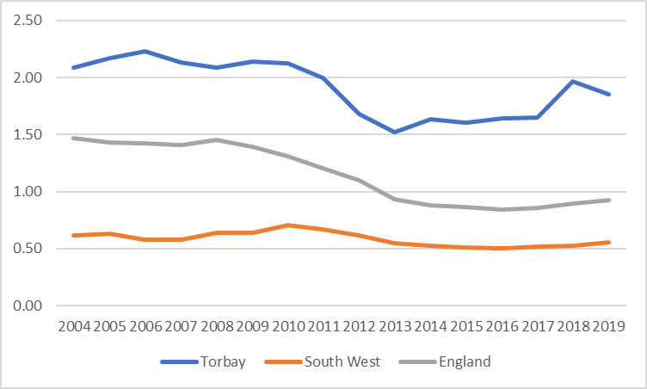
Source: DLUHC 2020
The graph below shows the relationship between council tax bands, long term vacancy rates, and the length of vacancy, with the data reflecting the period up to March 2021. Dwellings within the lower council tax bands, and particularly Band A, are more likely to be vacant and are vacant for longer periods than dwellings within the higher council tax bands. Band A would typically consist of flats in converted houses, other low value flats and some Registered Provider stock.

Figure 3.2: Long term vacant dwellings by council tax band
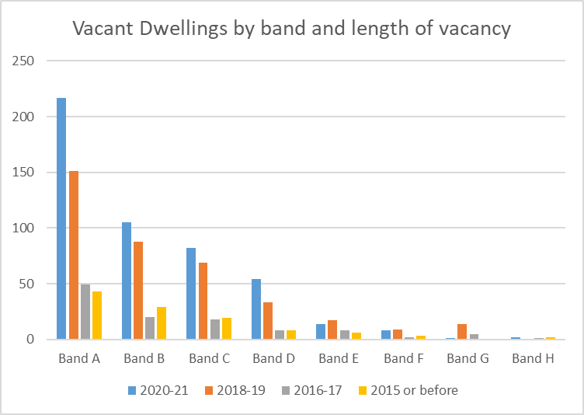
Source: Torbay Council 2021
The Council has a target to bring back into use some 150 empty properties per year. This is reflected in the current Local Plan. A Council report on empty homes “Vacant homes in Torbay” indicates that there is turnover within much of the long-term empty stock, but there is a lag in reoccupation. So the turnover rates are slow, particularly within Band A properties. There is an opportunity for the Council to consider some form of assistance to facilitate a higher turnover rate and thereby increase the overall supply of housing at any one time.

Houses in Multiple Occupation
Houses in Multiple Occupation (HMOs) are dwellings which are shared by multiple households. Typically this will consist of bedsit accommodation with shared kitchen and bathroom facilities.
While HMOs may have a role to play as part of the suite of more affordable housing options servicing certain specific housing needs, HMOs can cause some concerns within communities as often tenants can be quite transitory and not vested into the local community. Certain areas in the country have seen a proliferation of HMOs and significant conversions of single household family accommodation into HMO accommodation. This has caused numerous low level anti-social behaviour issues within those communities.
This has occurred in many areas to accommodate the growth in student demand for accommodation. HMOs have often also become the only accessible accommodation for single people on low incomes or in receipt of benefits in many areas.
As can be seen from table 3.10, the number of both licensable and non-licensable HMOs is significantly lower in Torbay than across the comparative geographies, both in terms of numbers and proportion. Table 3.11 provides the proportion of HMOs within respective geographies relative to the whole housing stock and the private rental stock.
We have undertaken some consultation with the HMO officer to inform our analysis. Clearly one factor explaining the relatively low level of HMOs in Torbay is the lack of a student population. Both Plymouth and Exeter have established universities and are home to large populations of students.
Another important factor is that the lower end of the self-contained rental market in Torbay appears to be within the reach of people on lower quartile incomes, including those in receipt of housing benefit. Analysis within later sections of this assessment highlight that nearly 60% of private sector tenants are in receipt of housing benefit in Torbay compared to 22.6% and 32.2% in Exeter and Plymouth respectively. The previous section on empty homes also highlights the availability of lower value properties and possibly a degree of low demand for such accommodation. As such there is not the likely demand for HMOs given the lack of student accommodation and the relatively low rental costs within the lower quartile rental market. The Council’s HMO officer confirms that there is not much investment interest in the HMO market in Torbay.
While the number of HMOs is relatively lower, Torbay has a far larger proportion of flat conversions than Exeter and Plymouth. The HMO officer indicates that there are significant numbers of ‘section 257’ properties, which refer to properties converted to self-contained flats outside of the prevailing building regulations of the time. Hence while the HMO count may be low, the number of poor quality flat conversions may present the same management challenges. There are clearly areas of the authority that have high proportions of low value rental accommodation which tend to dominate the area.
Table 3.10: Number of HMOs
 | HMOs | Mandatory licensable | Licence issued
Torbay | 1,470 | 120 | 120
Exeter | 4,412 | 1,300 | 1,252
Plymouth | 5,000 | 1,300 | 1,219
England | 510,277 | 134,353 | 77,762
Source: DLUHC Housing Statistical returns 2020.

Table 3.11: HMOs as a proportion of the housing stock
 | HMOs as % of occupied stock | HMOs as % of PRS | Licensed HMOs as % of occupied stock | Licensed HMOs as % of PRS
Torbay | 2.49 | 10.7 | 0.20 | 0.88
Exeter | 8.96 | 42.7 | 2.54 | 12.1
Plymouth | 4.57 | 22.7 | 1.12 | 5.53
England | 2.31 | 13.7 | 0.35 | 2.09
Source: DLUHC Housing Statistical returns 2020; Census 2011.

Environmental quality of the housing stock
This section considers the energy efficiency of Torbay’s housing stock. The Standard Assessment Procedure (SAP) is the methodology used by the Government to assess and compare the energy and environmental performance of dwellings. The SAP assessment is used to calculate the Energy Performance Certificate (EPC) for homes. The EPC comprises a numerical score from 1-100 SAP points. These scores are divided into bands as follows:
- EPC rating A = 92-100 SAP points (most efficient)
- EPC rating B = 81-91 SAP points
- EPC rating C = 69-80 SAP points
- EPC rating D = 55-68 SAP points
- EPC rating E = 39-54 SAP points
- EPC rating F = 21-38 SAP points
- EPC rating G = 1-20 SAP points (least efficient)

Data from EPC records has been collated by the Energy Savings Trust and provided in order to enable an assessment of the energy efficiency of Torbay’s housing stock. The data for Torbay records 181 ‘unknown’ properties. We have discounted these for the purposes of this analysis. The pie chart below (figure 3.3) shows that 70.5% of the housing stock in Torbay is rated band D or lower with just 5.4% of the stock in bands A or B.

Figure 3.3: SAP rating bands Torbay housing stock
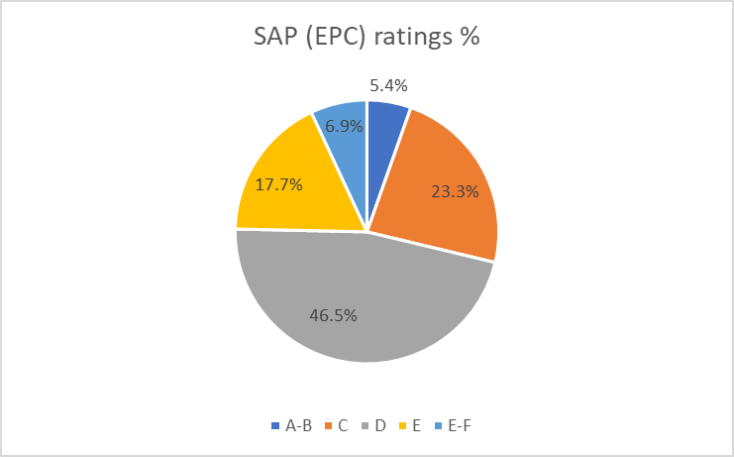
Source: Energy Savings Trust 2021
Figure 3.4 illustrates the proportion of dwellings in each SAP rating band by age of dwelling. Dwellings built post-1996 are weighted toward the higher rated SAP bands, showing the highest proportion of A-B and C rated dwellings. In fact, the dwellings built post-1996 are the only grouping where the highest proportion of dwellings are rated band C. Properties built between 1900 and 1982 all show a similar distribution across the respective bands.
Dwellings built between 1983-1995 and pre-1900 show a different distribution compared to the other groupings of dwellings built pre-1996. While these groupings still have the highest proportion of dwellings in Band D, it is relatively lower than the other pre-1996 groupings and the proportion of dwellings in Band C is relatively higher. The 1983-1995 grouping has the second highest proportion of dwellings in Band A-B after post-1996 dwellings. It is interesting that pre-1900 dwellings outperform some post 1945 groupings.

Figure 3.4 SAP rating band by age of dwelling
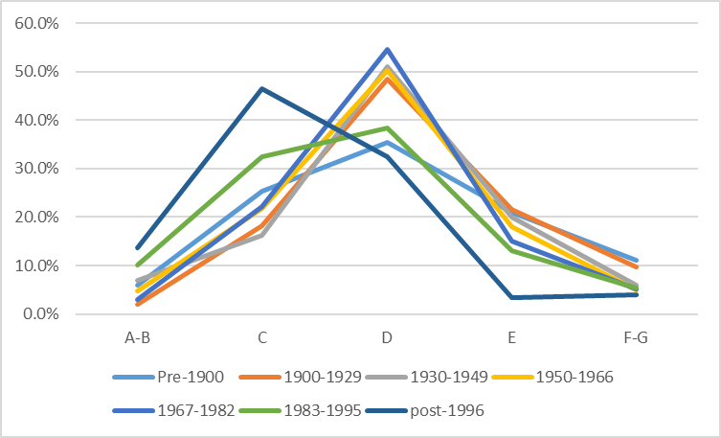
Source: Energy Savings Trust 2021
Figure 3.5 illustrates SAP rating bands by tenure of dwellings. The greatest proportion of Housing Association (or Registered Provider) dwellings, which includes the former council owned stock, sit within SAP banding C. Affordable housing stock is required to a meet a Decent Homes standard and, up until 2015, new affordable housing was required to meet higher environmental standards than market housing. The table below also shows that the private rental sector has a higher proportion of Band A-B and Band C rated dwellings than the owner-occupied sector. Conversely the private rental sector shows a marginally higher proportion of F-G rated properties at just under 10%. All rented properties, with a few exceptions, must meet EPC band E as a minimum. However, there are a small but significant number of rented dwellings that are below EPC band E. All affordable housing stock will need to meet EPC Band C by 2030 and this will be supported by the Social Housing Decarbonisation Fund.
Figure 3.5: SAP rating band by tenure
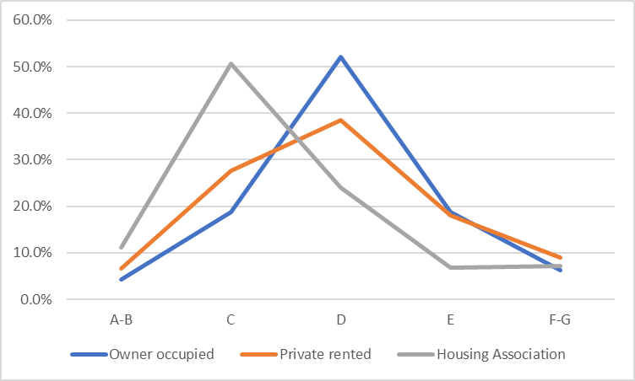
Source: Energy Savings Trust 2021

Chapter Four: Demographic profile

Initially we set out the key findings of chapter 4. Note that referencing and data sources are provided in the body of the chapter.

Key findings
- The latest population estimate for Torbay is 136,218.
- Population numbers have been stable over the last estimated year, although the components of growth have seen a decrease in natural growth (the ratio of births to deaths) compensated by net in-migration.
- Over the last 20 years population growth in Torbay has been noticeably slower than comparator geographies.
- Population is projected to increase by approximately 14,000 people from 2019 to 2039.
- Population increases will be particularly acute in the older age cohorts (75 to 84, and 85 and over), while younger cohorts remain stable.
- Overall population growth over the next 20 years is expected to be driven by net internal migration.
- Migration statistics indicate that younger population cohorts (15 to 19, 20 to 24 and 25 to 29) migrate out from Torbay in net terms. This is particularly pronounced in the 15 to 19 age cohort.
- Conversely for all other age cohorts there is a net in-migration. This is highest in the 55 to 59, 60 to 64 and 65 to 69 age cohorts.
- Household growth is projected to outstrip population growth (2019 to 2039).
- Considering the age cohort of the household reference person (HRP), the highest percentage household growth is projected in cohorts where the HRP age is 75 to 84, and 85 and over.
This chapter examines the population and household profiles within the local authority area, as well as projected changes to both in future. Clearly household growth is a key driver of the need for increasing housing supply. However, the future housing needs of household groups will differ according to their age cohort and composition.

The current population
The mid-2020 population estimates were released in June 2021. The total population of Torbay was estimated at 136,218 people, of which 66,424 were male and 69,794 were female. Population change from the previous estimate (mid-2019) is set out in table 4.1 below. This is also broken down by age group. It is difficult to assess trends over one year and this section will cover population trends later.

Table 4.1: Population estimates mid-2020 and mid-2019
Age cohort | No. | % | No. | %
 | Whole population mid-2020 |  | Whole population mid-2019
Under 16 | 22,748 | 16.7 | 22,865 | 16.8
16 to 24 | 10,901 | 8.0 | 11,139 | 8.2
25 to 34 | 13,691 | 10.1 | 13,926 | 10.2
35 to 44 | 13,471 | 9.9 | 13,308 | 9.8
45 to 54 | 17,987 | 13.2 | 18,631 | 13.7
55 to 64 | 20,277 | 14.9 | 19,783 | 14.5
65 to 74 | 19,273 | 14.1 | 19,299 | 14.2
75 to 84 | 12,596 | 9.2 | 12,125 | 8.9
85+ | 5,274 | 3.9 | 5,188 | 3.8
Total | 136,218 | 100 | 136,264 | 100
Source: Office for National Statistics (ONS) 2021
Table 4.2 below considers the components of population change from mid-2019 to mid-2020 estimates. Torbay’s position is also compared with comparative geographies. Unlike comparative geographies, Torbay sees a fall in its population as a result of ‘natural change’, which refers to the difference between the birth rate and death rate. Conversely Torbay sees an increase of both net internal and ‘external’ migration, where ‘external’ refers to both international and cross-national (between UK nations) migration. Torbay is unique in respect of comparative geographies in that net internal in-migration exceeds net external in-migration. However, for Devon and Cornwall as a whole, it is not uncommon for domestic inward migration to be the main driver of population growth.

Table 4.2: Components of population change mid-2019 to mid-2020
 | Torbay | Exeter | Plymouth | England
Mid-2019 | 136,264 | 131,405 | 262,100 | 56,286,961
Births | 1,111 | 1,145 | 2,590 | 600,708
Deaths | 1,814 | 1,099 | 2,569 | 553,546
Change no. & (%) | -703 (0.51%) | 46 (0.03%) | 21 (0.008%) | 47,162 (0.001%)
Internal migration in-flow | 5,857 | 12,894 | 13,008 | 90,650
Internal migration out-flow | 5,429 | 12,635 | 13,443 | 110,943
Change no. & (%) | 428 (0.31%) | 259 (0.19%) | -435 (0.17%) | -20,293 (0.036%)
External migration in-flow | 475 | 3,087 | 1,910 | 553,116
External migration out-flow | 247 | 1,401 | 929 | 322,002
Change no. & (%) | 228 (0.17%) | 1,685 (1.28%) | 981 (0.37%) | 231,114 (0.41%)
Other | 1 | -62 | 172 | 5,194
Mid-2020 | 136,218 | 133,333 | 262,839 | 56,550,138
Source: Office for National Statistics (ONS) 2021
The table and graph below illustrate population growth over the last 20 years in Torbay and respective geographies. Table 4.3 shows an estimated increase of 6,253 in Torbay’s population between 2001 to 2020. The graph (figure 4.1) illustrates that the rate of population growth in Torbay is far lower than in comparative geographies. In fact, both Plymouth’s and Torbay’s respective population growth rates are lower than the national rate, while Exeter exceeds the national rate. This points to the comparative economic strength and consequent draw of the Exeter HMA.
Table 4.3 Comparative population growth 2001 to 2020
 | Mid-2001 | Mid-2005 | Mid-2010 | Mid-2015 | Mid-2020
Torbay | 129,965 | 132,857 | 131,443 | 133,791 | 136,218
Exeter | 111,180 | 112,970 | 115,712 | 125,679 | 133,333
Plymouth | 240,954 | 247,516 | 254,227 | 261,386 | 262,839
England | 49,449,746 | 50,606,034 | 52,642,452 | 54,786,327 | 56,550,138
Source: Office for National Statistics (ONS) 2021

Figure 4.1: Population growth rates mid-2001 to mid-2020
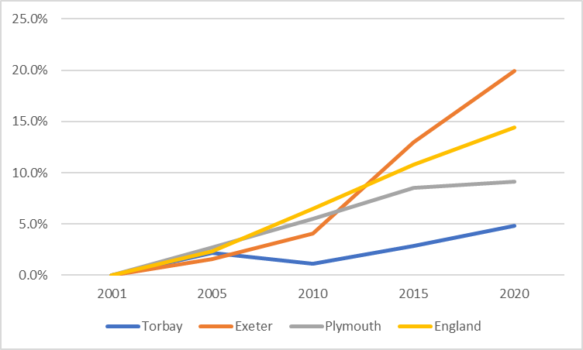
Source: Office for National Statistics (ONS) 2021

Population projections
Table 4.4 below sets out the estimated population by age cohort across the years 2019, 2029 and 2039, and the percentage of the total population of each cohort over the respective years. The total population of Torbay is estimated to increase from 136,646 in 2019 to 150,701 by 2039.
As an overall proportion of the population, all age cohorts below 65 years decrease (although not necessarily numerically) from 2019 to 2039. Conversely all age cohorts 65 and over increase as a proportion of the overall population from 2019 to 2039.
The 75 to 84 and 85+ cohorts increase from 8.8% and 3.8% of the population in 2019 to 12.4% and 5.9% of the population respectively in 2039. This is also within the context of a growing population overall. These projections indicate a growing and ageing population in Torbay.

Table 4.4: Population projections

Year | 2019 |  | 2029 |  | 2039
Age cohort | No. | % | No. | % | No. | %
Under 16 | 22,918 | 16.8 | 21,611 | 15.0 | 21,134 | 14.0
16 to 24 | 11,274 | 8.3 | 12,427 | 8.6 | 11,831 | 7.9
25 to 34 | 14,006 | 10.2 | 12,747 | 8.8 | 14,115 | 9.4
35 to 44 | 13,413 | 9.8 | 15,420 | 10.7 | 14,233 | 9.4
45 to 54 | 18,702 | 13.7 | 16,038 | 11.1 | 18,085 | 12.0
55 to 64 | 19,874 | 14.5 | 21,941 | 15.2 | 19,567 | 13.0
65 to 74 | 19,239 | 14.1 | 21,723 | 15.0 | 24,057 | 16.0
75 to 84 | 12,068 | 8.8 | 16,086 | 11.1 | 18,735 | 12.4
85 + | 5,147 | 3.8 | 6,453 | 4.5 | 8,943 | 5.9
All | 136,646 | 100 | 144,445 | 100 | 150,701 | 100
Source: ONS 2021 (Nomisweb)
The graph below shows the projected percentage growth by age cohort through 2019, 2029 and 2039. It can be seen that the 85+ cohort is projected to increase by over 70% by 2039, likewise the 74 to 84 cohort by 55%.

Figure 4.2: Population growth by age cohort
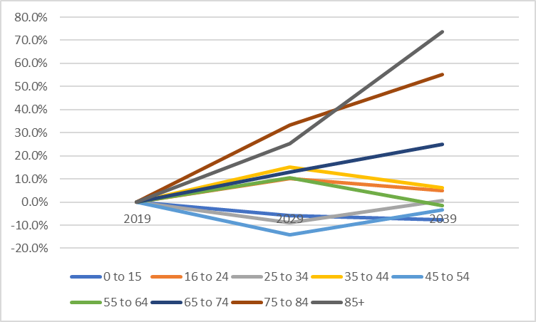
Source: ONS 2021 (Nomisweb)
Next we consider the components of projected population growth as assessed by the 2018-based population projections (components of change). This analysis includes what is described as natural change. This is the difference between the number of births and the number of deaths in the year. It also includes the components of migration, which are provided as the net of in- and out- migration. Components of migration include internal migration, which is migration from and to other parts of England; international migration, which is migration from and to other countries outside of the UK; and cross-border migration, which is migration from and to other nations within the United Kingdom. There is a further migration category referred to as ‘Other’ which accounts for other one-off migration events. The data provides for 7.2 persons in the ‘Other’ category in 2020, so we believe it is not a material consideration in assessing population trends.
We can see from the graph below that the main component of projected population growth is net in-migration. There is also projected net international in-migration, although this reduces and stabilises after 2023. The current resident population of Torbay is projected to reduce as the death rate exceeds the birth rate.

Figure 4.3: Components of population growth

Source: ONS 2021 (Nomisweb)
Net internal migration is the most significant factor in relation to projected population change. What is equally important is the overall number of people projected to internally migrate into and out of Torbay. The table below illustrates the base data that informs the graph above. 13,216 people are projected to move in and out of Torbay to or from somewhere else in England. If those migrating out of Torbay are for example a different age cohort to those migrating in, then this has a far greater impact on the demographic of Torbay than the net figures would suggest. The same is true of differing socio-economic cohorts, family composition and so on.
Table 4.5: Components of population growth
Component | 2019 | 2024 | 2029
Births | 1,247 | 1,183 | 1,169
Deaths | 1,753 | 1,905 | 2029
Internal migration In | 7192 | 7352 | 7541
Internal migration Out | 6024 | 6009 | 6129
International migration In | 476 | 410 | 397
International migration Out | 261 | 241 | 237
Source: ONS 2021 (Nomisweb)
The graph below examines internal migration (inflow and outflow) in a single year. The ONS estimates internal migration in and outflow by age cohort, gender and local authority area. The estimates for 2019 are consistent by data source with the 2019 figures above (table 4.5). The estimates clearly show that the highest net outflow of population occurs in the 15 to 19 age group, with a net outflow of 343 persons. It likely that this age group is leaving Torbay to attend further education. Conversely, the highest net inflow of population is in the 55 to 59 age cohort, with high levels also in the 60 to 64 and 65 to 69 age cohorts. These age groups are either retired or nearing retirement.
The overall impact of net internal migration is to shift the balance from a decreasing population to an increasing population, and the characteristics of age cohorts in-migrating also contributes to the overall ageing of Torbay’s population.
Figure 4.4: Net internal migration in- and out- flow by year ending June 2019
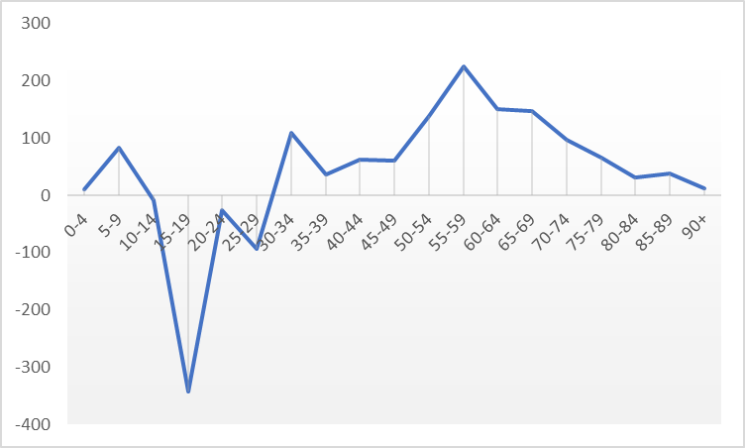
Source: ONS 2021 (Nomisweb)

Household growth
Populations form households so it is important to consider household growth projections when considering future housing needs. The household growth projections are a component of the Standard Method calculation.
In the table below, we show the projected household growth for Torbay in terms of the following three projections:
- Household projections mid-1991 to mid-2039 based upon the 2014 based household projections.
- Household projections mid-2001 to mid-2041 based upon 2016 household projections.
- Household projections mid-2001 to mid-2043 based upon 2018 household projections.
The Standard Method calculation is based upon the 2014 based subnational population projections. These projections are a key component in calculating the housing requirement for the local authority. As the 2014 based projections were taken up to 2039, we have used the same timeline for the 2016 and 2018 based projections.
The projected rate of household growth is slower for the 2016 based projection than for the 2014 based projection. The 2018 based projection reverses the slower rate of growth of the 2016 based projection and in fact projects a higher rate of growth than the 2014 based projection.
Table 4.6: Projected household growth in Torbay by respective household projections
 | 2009 | 2019 | 2029 | 2039
All households 2018 based | 58,482 | 62,088 | 67,619 | 72,531
All households 2016 based | 58,485 | 61,683 | 65,993 | 69,952
All households 2014 based | 59,103 | 62,466 | 67,178 | 71,276
Source: ONS (Nomisweb)

Household growth compared to population growth
The figure below compares projected household growth against projected population growth. Household growth is projected to increase at a higher rate than population growth. It is household growth that determines the required increase in the supply of housing. The reasons why household growth often outstrips population growth include the increasing trend in single person households, people living longer and net in-migration of single households. Figure 4.5: Household v population growth (%)
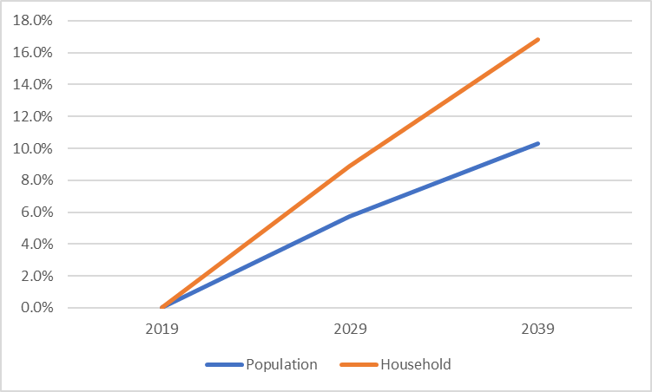
Source: ONS 2018 based household projections (Nomisweb)
The table below considers projected household growth by age cohort of Household Reference Person (HRP), with HRP being the nominated adult in the household. The table provides projections from 2018 to 2043. The pattern that emerges with respect to projected household growth across the age cohorts is broadly consistent with that which is shown for projected population growth in figure 4.1, with household growth rates being fastest in the older cohorts much like in figure 4.2. However, the faster growth rates in the older cohorts is noticeably more pronounced when looking at projected household growth than when looking at projected population growth.
Table 4.7: Projected increase/decrease in households by age cohort of the Household Reference Person (HRP).

 | 2018 | 2043 | % incr/dr
Under 25 | 1,601 | 1,524 | (4.8)
25-34 | 5,988 | 6,215 | 3.8
35-44 | 7,543 | 8,129 | 7.8
45-54 | 11,625 | 11,165 | (4.0)
55-64 | 11,527 | 12,408 | 7.6
65-74 | 11,557 | 13,305 | 15.1
75-84 | 8,284 | 15,002 | 81.1
85+ | 3,371 | 6,516 | 93.3
Source: ONS 2018 based household projections (Nomisweb)

Household composition
Household composition is a fundamental factor driving the size of housing needed in any local authority area in the future. In the table below, we can see that 34.2% of Torbay’s households are single person households which is slightly higher than comparative proportions for Exeter and Plymouth. The proportion of single households that are 65 or over in Torbay is 16.4% which is 3+ percentage points higher than in Exeter and Plymouth.
The percentage of one family households that are all 65 and over is 10.8% in Torbay which is noticeably higher than the neighbouring urban areas. In fact, the total percentage of age 65 and over households in Torbay at 27.8% is significantly higher than the corresponding percentage figures for Exeter and Plymouth.
Families with dependent and non-dependent children are a minority in all comparator areas. Torbay does not have a student population of any note, unlike its neighbours.

Table 4.8: Household composition

 | Torbay |  | Exeter | Plymouth | England
 | No. | % | % | % | %
1 person household (of which) | 20,192 | 34.2 | 33.6 | 31.4 | 30.2
Aged 65 and over | 9,679 | 16.4 | 13.1 | 12.3 | 12.4
One family household (of which) | 35,024 | 59.4 | 55.7 | 60.5 | 61.8
All aged 65 and over | 6,402 | 10.8 | 7.4 | 7.9 | 8.1
With dependent children | 13,192 | 22.4 | 22.8 | 25.1 | 26.5
Other household types (of which) | 3,794 | 6.4 | 10.7 | 8.1 | 8.0
With dependent children | 1,226 | 2.1 | 1.9 | 1.9 | 2.6
All aged 65 and over | 298 | 0.5 | 0.3 | 0.3 | 0.3
Other household types | 2,253 | 3.8 | 5.6 | 4.2 | 4.5
Full time students | 17 | 0.0 | 2.9 | 1.6 | 0.6

All households
with dependent children | 14,418 | 24.4 | 24.7 | 27.0 | 29.1
All aged 65 and over | 16,379 | 27.8 | 20.8 | 20.5 | 20.7
Source: Census 2011

Chapter Five: Socio-economic profile
Initially we set out the key findings of chapter 5. Note that referencing, data source and context is provided in the body of the chapter.

Key findings
- Of the working age population of Torbay (16 to 64), 76.6% are economically active and 23.4% are economically inactive, the latter of which is a couple of % higher than comparator geographies.
- Torbay has a higher % of residents who are ‘Managers, Directors and Senior Officials’ and a significantly lower % of residents who are in ‘Professional Occupations’. There is a similar profile for the workforce.
- The workforce of Torbay contains a higher % of those working in ‘Caring, Leisure and Service occupations’ and ‘Elementary occupations’ than surrounding geographies.
- Resident earnings underperform against the national lower quartile and median rates.
- All workforce income groups follow a similar trajectory which sees little or minimal growth from 2010 to 2018, in fact all groups see a dip from 2017 to 2018.
- Torbay ranks the 48th most deprived local authority in England out of a total of 317 local authorities, according to the Indices of Multiple Deprivation 2019.
- In both the 2016 and 2019 Indices of Multiple Deprivation, 16% of Torbay’s lower super output areas were in the 10% most deprived areas of England.

Economic activity in Torbay
The table below sets out the economic activity rates for the working age population in Torbay and comparative geographies based on the year until September 2021. The economic activity rate and the employment rate in Torbay is relatively consistent with the national picture.
Table 5.1 Population economic activity rates working age population (16-64) Oct 2020 to Sep 2021.
 | Torbay | Exeter | Plymouth | England (‘000s)
Economic activity rate | 78.9% | 73.4% | 80.8% | 78.8%
Employment rate | 76.7% | 73.0% | 77.2% | 74.9%
Source: ONS Annual Population Survey (Nomisweb) 2022

The table below shows the profile of economically active residents by occupational group within Torbay and surrounding geographies. The analysis is derived from the Annual Population Survey for the year covering Oct 2020 to Sep 2021. This data considers the occupation of residents of Torbay irrespective of the geographical area within which they work. The number of economically active residents in Torbay at the time of the survey was estimated at 59,900.
Torbay’s proportion of residents working in occupational group 1 (Manager, Directors and Senior Officials) is consistent with than the national profile but lower than Exeter.
Conversely Torbay exhibits a lower proportion of residents in occupational group 2 (Professional occupations) than comparative geographies. The proportion of Torbay residents in group 3 is also lower than for comparative geographies.
Aside from Plymouth, Torbay has a higher proportion of residents in occupation group 5 (Skilled Trades Occupations). Torbay’s working residents are weighted toward the lower occupational groups when compared to both surrounding urban areas and nationally. It would be reasonable to assume that this would impact negatively on average resident earnings in Torbay. We will explore earnings later in this chapter.

Table 5.2 Occupational group (residents) 2020-2021 (Oct to Sep) (SOC 2010)
 | Torbay no. | Torbay % | Exeter % | Plymouth % | England %
1 Managers, Directors and Senior Officials | 6,400 | 10.7 | 14.7 | 8.3 | 10.9
2 Professional occupations | 9,300 | 15.5 | 25.4 | 17.8 | 23.4
3 Associated Prof. & Tech. Occupations | 5,900 | 9.9 | 11.3 | 16.7 | 15.6
4 Administrative and Secretarial Occupations | 6,300 | 10.5 | 7.7 | 8.9 | 10.3
5 Skilled Trades Occupations | 7,300 | 12.5 | 6.6 | 12.5 | 8.8
6 Caring, Leisure and Other Service Occupations | 6,200 | 10.3 | 13.5 | 12.2 | 9.0
7 Sales and Customer Service Occupations | 5,800 | 9.7 | 5.7 | 8.6 | 6.9
8 Process, Plant and Machine Operatives | 3,600 | 6.0 | n/a | 6.0 | 5.6
9 Elementary Occupations | 9,100 | 15.2 | 14.7 | 9.0 | 9.2
Source: ONS Annual Population Survey 2022
The table below explores the profile of population working in Torbay by occupational group. It should be noted that these are workers that work in Torbay but do not necessarily live in Torbay. The analysis is derived from the Annual Population Survey for the year covering Oct 2020 to Sep 2021 as with the resident workforce.
The Torbay workforce consists of 58,200 persons according to the Annual Population Survey. This is slightly lower than the working or economically active population resident in Torbay at 59,900, hence Torbay is a net exporter of labour. This concurs with the findings in chapter 3 with reference to travel to work analysis (refer table 3.1).
In respect of its workforce, Torbay has a lower proportion of professional occupations (group 2) and associated professional and technical occupations (group 3) than surrounding geographies. Torbay also has a lower proportion of sales and customer service occupations than surrounding geographies.
Other areas of note are the higher proportion of Caring, Leisure and Other Service Occupations, and Elementary occupations in Torbay. Torbay is perceived as a relatively low wage economy which would chime with the proportions of the workforce in these lower occupational groups.

Table 5.3: Occupational Group (workforce) Oct 2020 to Sep 2021 (SOC 2010)
 | Torbay no. | Torbay % | Exeter % | Plymouth % | England %
1 Managers, Directors and Senior Officials | 6,600 | 11.3 | 11.5 | 8.3 | 11.0
2 Professional occupations | 11,500 | 19.8 | 29.0 | 23.3 | 23.5
3 Associated Prof. & Tech. Occupations | 5,800 | 10.0 | 13.5 | 14.1 | 15.6
4 Administrative and Secretarial Occupations | 6,700 | 11.5 | 7.5 | 7.9 | 10.3
5 Skilled Trades Occupations | 5,900 | 10.1 | 8.9 | 12.7 | 8.8
6 Caring, Leisure and Other Service Occupations | 6,800 | 11.7 | 11.2 | 10.3 | 9.0
7 Sales and Customer Service Occupations | 4,300 | 7.4 | 7.7 | 8.6 | 6.9
8 Process, Plant and Machine Operatives | 2,800 | 4.8 | 2.9 | 6.3 | 5.6
9 Elementary Occupations | 7,800 | 13.4 | 7.8 | 8.5 | 9.3
Source: ONS Annual Population Survey 2022
The graph below compares the number of Torbay residents in occupational groups (1 to 9) with the number of Torbay’s workforce in the respective occupational groups. Where the graph shows that there are greater numbers of residents in an occupational group than the workforce, this indicates than Torbay is a net exporter of its labour within these occupational groups, and vice versa.
The graph shows that there are greater numbers of residents in occupational groups 5,7,8 and 9, the latter three traditionally being the lower waged occupational groups. This means a net number of the resident population of Torbay in these occupational groups will be working outside of the local authority area. The converse is true for occupational group 2, which is professional occupations, which indicates that Torbay imports more professional workers than it exports. The remainder show a similar number of residents and workforce.

Figure 5.1: Comparative no. of resident workers and workforce by occupational group.

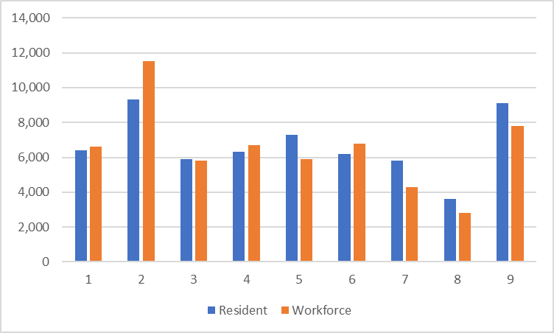

Source: ONS Annual Population Survey 2022

Earnings
We now consider the incomes of both the residents and workforce of Torbay. The data for this section is derived from Annual Survey of Hours and Earnings (ASHE) produced by the ONS which provides a snapshot of earnings in April of each year. The graph below shows the full-time incomes of the resident population across income ranges and the rate of increase over the last ten years. Earnings have been increasing steadily across the mean, median and lower quartile range since 2016. The lower quartile income range has jumped by over £2,000 from 2019 to 2020. This may have been prompted by the 6.2% National Living Wage increase which came into effect on 1 April 2020. Conversely tenth percentile earnings have plateaued from 2019 to 2020.

Figure 5.2 Full-time workers weekly pay gross- resident earnings
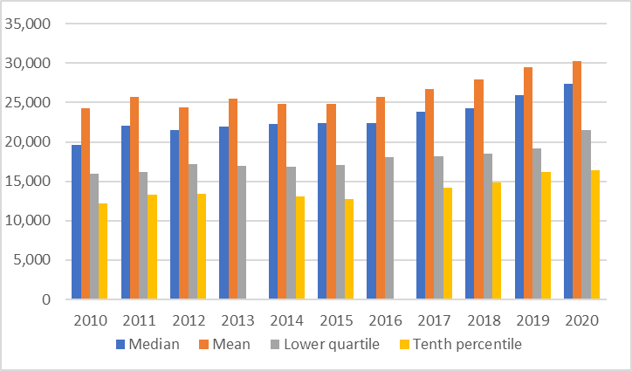
Source: ONS Annual Survey of Hours and Earnings 2021

The graphs (figures 5.3 and 5.4) below compare resident full-time annual earnings with comparative geographies and nationally. Resident earnings underperform against the national lower quartile (LQ) and median rates, as do Exeter and Plymouth, excepting Exeter exceeded the national LQ rate in 2019. Torbay lags Exeter over the ten-year period at both lower quartile and median income levels, excepting LQ rates in 2020. Over the period Torbay’s income levels have been lower than those in Plymouth, although the differentials have become far closer in recent years, and in 2020 Torbay LQ rates were higher than for Plymouth as well as for Exeter. The reasons for this reversal in 2020 are not clear. 2020 has seen the impact of lockdowns and Government support packages, the full impact of which has yet to play out.
Figure 5.3 Resident lower quartile full time earnings
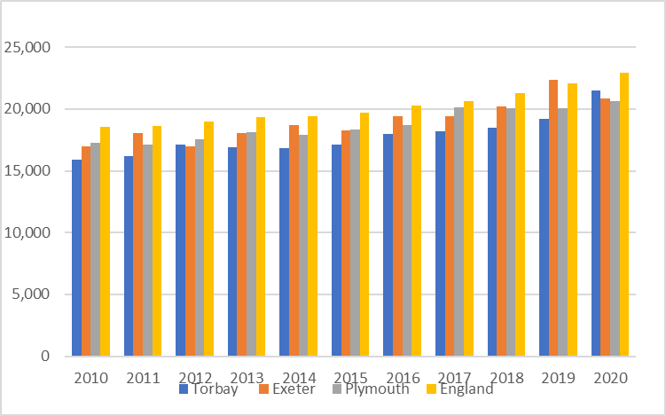
Source: ONS Annual Survey of Hours and Earnings 2021

Figure 5.4: Resident median full time earnings
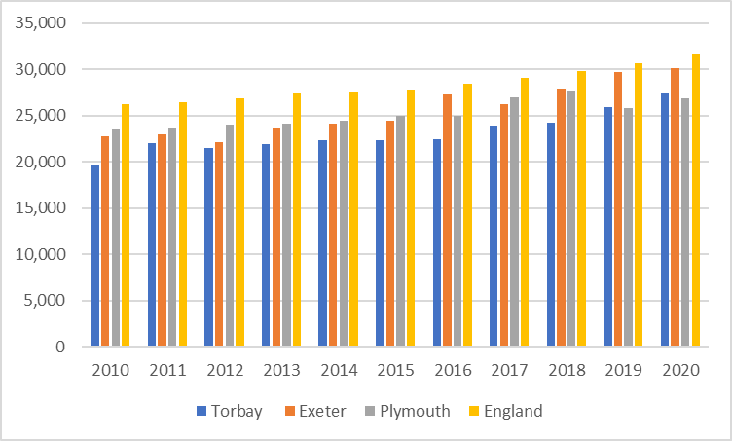
Source: ONS Annual Survey of Hours and Earnings 2021

The figure below shows ranges of annual earnings for the workforce in Torbay. These are across the median, mean, lower quartile (LQ) and tenth percentile ranges. There are some values missing from the ASHE data thereby explaining some missing columns most noticeably in 2016. All workforce income groups follow a similar trajectory which see little or minimal growth from 2010 to 2018. In fact all groups see a dip from 2017 to 2018. However, 2019 and 2020 see consistent increases.
Figure 5.5: Workforce full time incomes
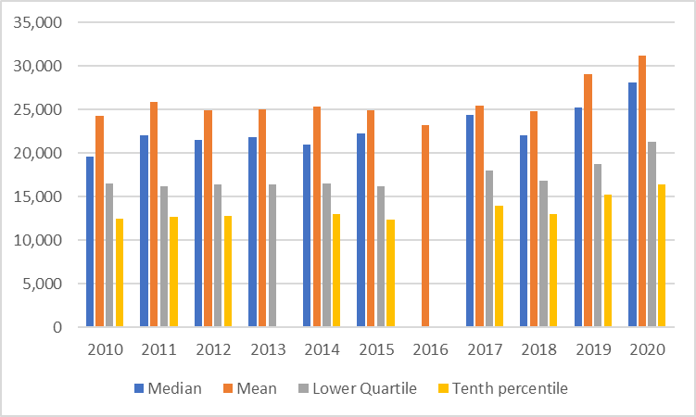
Source: ONS Annual Survey of Hours and Earnings 2021

Figure 5.6 compares workforce and resident full-time earnings in Torbay. Some housing market areas will see significant differentials between workforce income and resident incomes. For example in a commuter belt region outside of major conurbations, many residents will tend to commute to high paying positions in the neighbouring urban area, while workforce in the housing market area is likely to be heavily focussed on the service sector. This will lead to higher income ranges for residents than for the workforce. Conversely if a housing market area has a high wage employer, then the income range for the workforce may well exceed that of residents. Each housing market area can have a differing dynamic.
For Torbay, income ranges across the median, mean and lower quartile are relatively consistent across workforce and residents. This indicates that there is not a significant economic draw in or out of Torbay. Although we have established that Torbay is a net exporter of labour this may simply be due to the availability of employment as opposed to the draw of higher paid work.

Figure 5.6: Comparison between resident worker and workforce incomes
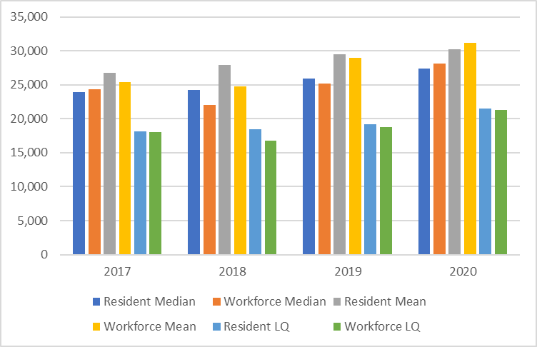
Source: ONS Annual Survey of Hours and Earnings 2021

Indices of multiple deprivation (IMD)
Torbay ranks the 48th most deprived local authority in England out of a total of 317 local authorities, according to the IMD 2019. Torbay also ranks 58th of 317 in terms of the proportion of lower super output areas (LSOAs) in the IMD first decile (most deprived). Torbay has significant deprivation in the town centre wards, particularly in Torquay and Paignton. In both the 2016 and 2019 IMD, 16% of lower super output areas (LSOAs) were in the 10% most deprived areas of England. As indicated in figure 5.7 the most deprived areas are in the Torquay and Paignton town centres, due in part to the significant numbers of low value private rented units in these areas.
In terms of the individual indices, income and employment deprivation are significant, with 11% of Torbay’s LSOAs being in the 10% most income deprived, and 17% being in the 10% most employment deprived LSOAs in England in the 2019 Index. Living environment deprivation improved somewhat between the 2015 and 2019 Index with 10% of Torbay’s LSOAs being in the 10% most deprived areas nationally in 2019, compared to 20% in 2015.

Figure 6.7: Indices of Multiple Deprivation 2019
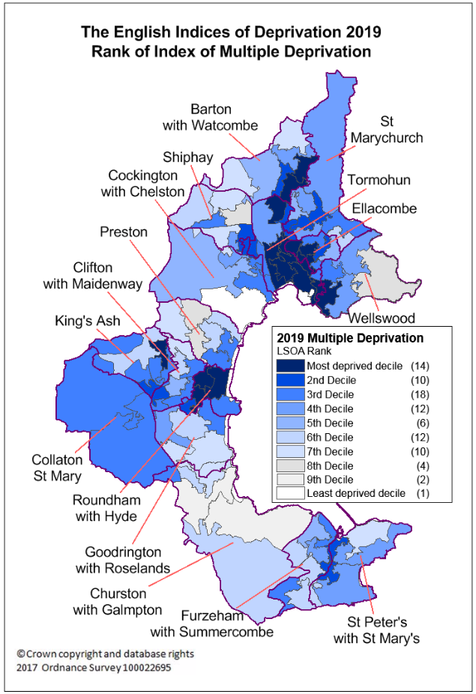
Source: ONS, Crown Copyright 2021

CACI Paycheck Data
The table below uses CACI paycheck data to compare household earnings in IMD deciles 1 and 2 with household earnings across Torbay as a whole, at the lower quartile (LQ), median and mean averages. It should be noted that CACI paycheck data reports gross household earnings whereas ASHE reports worker earnings. The table below indicates that gross LQ household income in LSOAs decile 1 and 2 is £14,600 and £16,079 respectively compared to a LQ household income across the whole of Torbay of £17,557. Proportionally LQ income in LSOAs in deciles 1 and 2 are 16.85% and 8.4% lower respectively than LQ income for Torbay as a whole. Proportionally median income in LSOAs in deciles 1 and 2 are 18.59% and 9.24% lower respectively than median income for Torbay as a whole.
Table 5.4: Comparative gross household income Torbay.
LSOA Torbay | IMD Decile | Count | CACI LQ | CACI Median | CACI Mean
001B, 001E, 004A, 004D, 006A, 008A, 008B, 008C, 008D, 010A, 013G, 014B, 014C, 014D | 1 | 11,494 | £14,600 | £24,758 | £30,469
001A, 002D, 004C, 005C, 006C, 013E, 014E, 017D, 018E, 019B | 2 | 6,472 | £16,079 | £27,601 | £33,521
Torbay All | All deciles | 62,913 | £17,557 | £30,411 | £37,068
Source: CACI Ltd 2021

Chapter Six: The housing market and affordability
Initially we set out the key findings of chapter 6. Note that referencing, data source and context is provided in the body of the chapter.

Key findings
- Average (mean) house prices have risen by 32% from 2010 to 2020.
- The increase in the value of flats has lagged behind that of other house types over the period with a 21% increase.
- In 2020/21 the lower quartile rent, considered the entry level to the private rental market, was £495 pcm.
- The lower quartile rate is significantly lower for rooms in shared houses and studio flats, making these properties affordable for smaller households, including single adult households on the lowest incomes.
- There is reported information from the Housing Options team that the private rented sector has seen exceptional increases in rent, particularly in respect of larger family accommodation. These reported increases have not filtered through to official datasets as yet, but there is some evidence at a national level to support a particular impact on private rents in seaside and holiday locations.
- In 2018 nearly 60% of private sector tenants in Torbay were in receipt of housing benefits, which is significantly higher than comparator geographies.
The chapter considers the affordability of the housing stock in Torbay in terms of both the sales and rental market. This builds the picture of the affordability of housing for both the resident and working populations, having considered both resident and workforce earnings within the last chapter. It also provides some comparative information.
First we consider house prices and house price trends over the last 10 years. The table below reports sales volumes in Torbay from 2011 to 2019. Sales as a percentage of stock have increased relatively consistently from 2011 to 2017 with a slight fall back in 2018 and 2019. Increased sales volumes tend to indicate a more buoyant market with higher demand. More recently sales volumes dipped during lockdown, but in the last six months anecdotally sales demand recovered and is high post lockdown.

Table 6.1 Sales volumes
 | Torbay | % stock
2011 | 1948 | 3.05
2012 | 2033 | 3.18
2013 | 2418 | 3.78
2014 | 2825 | 4.42
2015 | 3097 | 4.84
2016 | 3000 | 4.69
2017 | 3167 | 4.95
2018 | 2862 | 4.47
2019 | 2722 | 4.26
Source: Land Registry 2021
Tables 6.2, 6.3 and Figure 6.1 illustrate average house price values as determined by the Land Registry’s house price index (HPI) over the last 10 years. The average house price in December 2010 was £159,121. In December 2020 this stood at £210,160. This represents an increase of 32% over the last 10 years.
Detached and semi-detached dwellings saw the greatest increase in values with terraced dwellings not far behind. The increase in the value of flats was a lot lower than other dwelling types at just under 21%. House values experienced a particular jump between 2014 and 2015.

Table 6.2 Average house price values 2010 to 2020
Dec. of | All (£) | Detached (£) | Semi-detached (£) | Terraced (£) | Flat (£)
2010 | 159,121 | 257,556 | 173,819 | 136,322 | 113,157
2011 | 158,776 | 258,595 | 174,046 | 135,639 | 112,239
2012 | 158,309 | 257,926 | 173,860 | 136,727 | 110,387
2013 | 161,092 | 263,155 | 177,568 | 138,787 | 111,938
2014 | 163,376 | 268,528 | 180,171 | 140,850 | 112,670
2015 | 181,506 | 301,375 | 201,020 | 156,362 | 123,690
2016 | 185,961 | 309,305 | 205,565 | 158,788 | 127,857
2017 | 196,920 | 326,000 | 218,364 | 168,314 | 135,512
2018 | 199,999 | 333,373 | 223,049 | 171,602 | 135,688
2019 | 201,942 | 336,934 | 226,964 | 174,160 | 135,281
2020 | 210,160 | 357,219 | 237,759 | 182,851 | 136,771
Source: Land Registry 2021

Table 6.3: % increase in values from 2010 to 2020
All | Detached | Semi-detached | Terraced | Flat
32% | 38.7% | 36.8% | 34.1% | 20.9%
Source: Land Registry 2021

Figure 6.1: House value increases 2010 to 2020
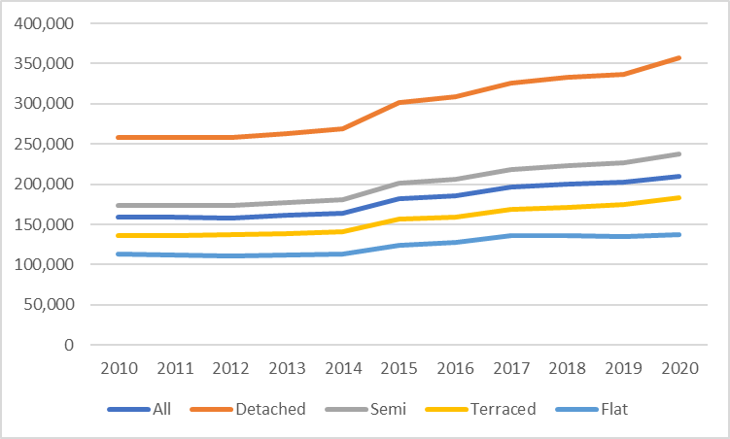
Source: Land Registry 2021

The private rental market
The private rental sector is becoming an increasingly important part of the housing market. As we have explored in chapter 2 (table 3.6), 23.2% of Torbay households were living in the private rental sector at the time of the Census 2011. This was slightly higher than corresponding percentages in the neighbouring urban areas of Exeter and Plymouth. This contrasts with only 8.1% of households living in the social (affordable) rented sector, which is considerably lower than neighbouring urban boroughs.
Average rental prices for Torbay over the 2020/21 financial year are set out in table 6.4 below. Overall, a lower quartile (LQ) market rent, which is considered an entry level price point, is £495 pcm. LQ rates for rooms, studio and 1 bedroom properties are lower than overall LQ rates. However, family accommodation consisting of 2 or more bedrooms at the LQ rate has a higher entry level.
We have also included, within the table below, the Lower Housing Allowance (LHA) rates at March 2021 for consistency with the rental averages timeline. LHA determines the ceiling amount of Housing Benefit or the housing element of universal credit that will be paid based upon a tenant’s bedroom need. Torbay falls within the South Devon Broad Rental Market Area. LHA is provided at a weekly rate, so we have calculated the equivalent monthly rate for comparative purposes. LHA rates are above lower quartile rent prices for all property sizes excepting room only. The next section considers the prevalence of housing benefit supported tenants within the private rental sector.

Table 6.4: Rental averages per calender month (pcm) April 2020 to March 2021.
 | Count | Lower quartile (£) | Median (£) | Mean (£) | LHA rates (£)
Room | 70 | 329 | 347 | 357 | 281.00
Studio | 60 | 375 | 415 | 419 | 448.76
1 bed | 460 | 433 | 475 | 488 | 448.76
2 bed | 600 | 585 | 650 | 654 | 598.35
3 bed | 360 | 675 | 750 | 761 | 728.00
4 bed | 80 | 895 | 995 | 1,042 | 897.52
All | 1,580 | 495 | 610 | 634
Source: Valuation Office Agency 2021
Department of Work and Pensions (DWP) data is provided on the number of housing benefit (HB) claimants in the rented sector in its entirety. We have mentioned the importance of the private rental sector (PRS) in Torbay and table 6.5 shows that the PRS provides accommodation for a significant number of households in receipt of HB. Nearly 60% of tenants in the PRS are in receipt of HB, compared to 22.6% and 32.2% in Exeter and Plymouth. This places a significant reliance on the PRS to meet the needs of households on lower incomes who are eligible for HB.
This may be due in part to the smaller number of social housing tenancies in Torbay, although it should be noted that the proportion of tenants in receipt of HB in social housing is also higher than in the corresponding areas. In fact the proportions of tenants overall on HB is higher in Torbay than comparative geographies (refer table 6.6). Table 6.4 above highlights that rental cost at the lower quartile level, aside from the room rate, is below the LHA level. As such the lower end of the private rental sector is affordable to low-income households on housing benefits.
An issue with a large number of HB eligible households being reliant on the PRS is that if there is a change in demand or supply, these households will tend to be squeezed out and left with no other options but to present to the Council. Supply issues may be caused if a significant number of landlords decide to leave the market, and demand issues may be caused if there is an increasing demand from the workforce. The Housing Options service has reported upward pressure on rents, particularly in respect of family accommodation. These observations have yet to feed through statistically and are thought to relate both to the increasing holiday sector demand for short term lets and to households relocating from other areas with a view to purchase.

Table 6.5: Number of Housing Benefit (HB) Claimants
 | All HB Claimants | Social Rented | Private rented
Torbay | 12,298 | 4,128 | 8,171
Exeter | 7,975 | 5,645 | 2,333
Plymouth | 20,547 | 13,454 | 7,095
Source: DWP 2018
Table 6.6: % of HB claimants
 | All HB Claimants as % of population | Social Rented as % of stock | Private Rented as % of stock
Torbay | 9.0% | 86.7% | 59.7%
Exeter | 6.1% | 67.3% | 22.6%
Plymouth | 7.8% | 63.8% | 32.2%
Source: DWP 2018

Affordability
The ONS produces affordability ratios for each local authority. Affordability ratios are the ratio of average house prices to average incomes, with a higher ratio meaning that housing is less affordable. The whole dataset ranges from 2002 to 2020. The earnings data is from the Annual Survey of Hours and Earnings consistent with the source of the analysis of earnings earlier in chapter 5. Earnings relate to gross full-time individual earnings on a place of residence basis. The house price statistics come from the House Price Statistics for Small Areas, which is based upon the median and lower quartile price paid for residential property and refers to a 12 month period with April in the middle (year ending September). These statistics are sourced by way of the Land Registry.
The information in figure 5.1 has already revealed that income differentials between residents and the workforce is not significant. Tables 6.8 and 6.9 show that the resident affordability ratio in Torbay has been relative stable across the median and lower quartile range over the ten year period from 2010 to 2020. There has not been an overall upward trajectory for Torbay residents in contrast to the comparative areas. In 2010 Torbay’s median resident affordability ratio was higher than the comparative geographies, whereas in 2020 Torbay’s ratio was lower than the ratios for England and Plymouth. Over the ten year period median affordability ratios in England have increased by one multiple (c14%) compared to Exeter (c7%) and Plymouth (c11%). The same trend is apparent with lower quartile affordability ratios.

Table 6.8: Median house price to median gross annual earnings: Residents
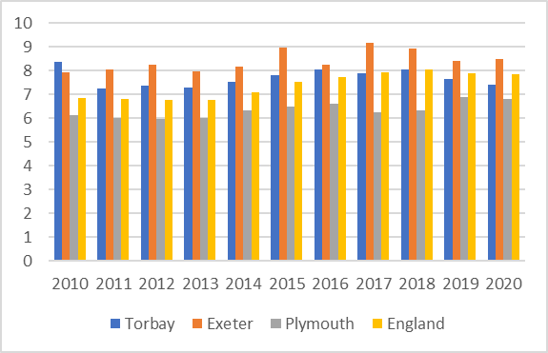
Source: DLUHC 2021
Table 6.9: LQ house price to LQ gross annual earnings: Residents
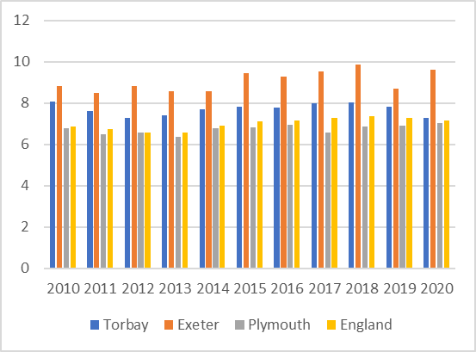
Source: DLUHC 2021

Tables 6.10 and 6.11 illustrate the median and LQ affordability ratios for Torbay’s workforce. We have established that there is not a significant divergence between workforce and resident affordability ratios. The workforce affordability ratios in Plymouth, Exeter and nationally have increased over the period while Torbay’s affordability ratio has seen a relatively level trajectory. Plymouth’s workplace affordability ratio is slightly lower than its resident affordability ratio which suggests higher earners commute into the city. Torbay’s median workplace affordability ratio is lower than the national average, but the LQ ratio is slightly higher than the national average. Across comparative geographies affordability ratios are highest in Exeter.
Table 6.10: Median house price to median gross annual earnings: Workforce
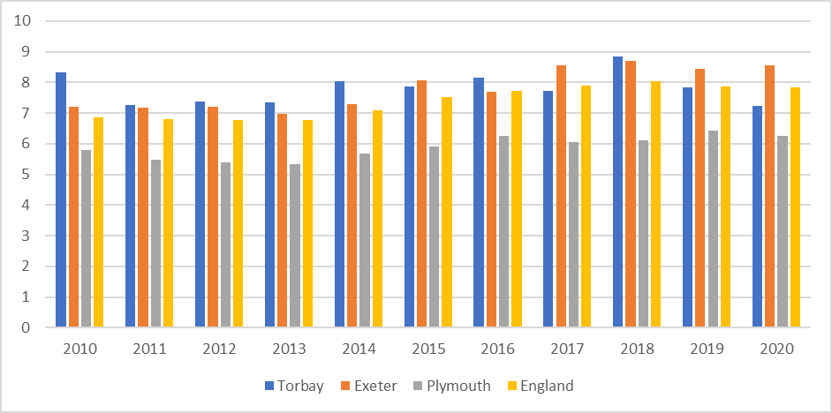
Source: DLUHC 2021
Table 6.11: LQ house price to LQ gross annual earnings: Workforce
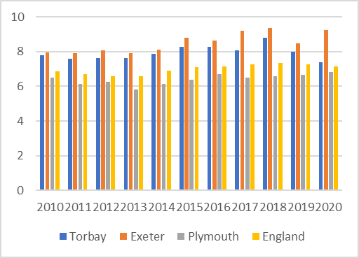
Source: DLUHC 2021

Chapter Seven: Calculation of affordable housing need
Initially we set out the key findings of chapter 7. Note that referencing, data source and context is provided in the body of the chapter.

Key findings
- Calculations indicate that a gross household income of £36,000 is required to access lower quartile market housing in Torbay.
- A gross household income of just over £18,500 is required to access lower quartile market rent.
- Gross household incomes of £25,334 and £26,600 will enable access to shared ownership and First Homes properties at 50% and 30% discounts respectively.
- The gross annual number of households in need of Affordable Housing for Rent is 733. This breaks down as 164 households in existing housing need, 536 new forming households and 33 existing households falling into need.
- The gross need will in part be met by an annual projected supply of 257 providing for a net annual unmet need of 455 Affordable Housing for Rent dwellings.
- The net annual unmet need for Affordable Housing for Sale is 443 dwellings per annum. This figure has been boosted by the new housing need category of household of households who aspire to rent or own whatever their current housing situation.
- The annual unmet need for affordable housing for rent and affordable for sale is on a par. However in policy terms the Council needs to consider the relative impact of a households’ housing situation. It is clear that homeless households are impacted by their housing situation to a greater extent than a household living in the private rental sector who aspire to ownership.
- In order to facilitate access to the Affordable Housing for Sale market for households able to access the private rented sector at the entry level (£18,500), a discount of just over 50% is required on a First Homes product and the minimum share sale on a shared ownership property would be 36.5%.

Introduction
This chapter assesses the need for affordable housing in the Torbay local authority area over the ten year period from 2021 to 2031. The PPG sets out guidance for the assessment of affordable housing need within paragraphs 18 to 24 of the HENA guidance.
PPG states “all households whose needs are not met by the market can be considered in affordable housing need” (Paragraph 018 Reference ID: 2a-018-20190220). Plan-making authorities will need to estimate the current and future affordable housing need within their local area. It goes on to state “strategic policy-making authorities will need to estimate the current number of households and projected number of households who lack their own housing or who cannot afford to meet their housing needs in the market” (Paragraph 019 Reference ID: 2a-019-20190220).
The PPG method for assessing the need for affordable housing is set out as follows:
A Calculation of gross unmet current affordable housing need: this is an estimate of the number of households who have an affordable housing need at the point of the assessment.
The NPPF 2019 has expanded the definition of those in affordable housing need to include households who may be able to afford to rent privately but whose preference is to buy a home but cannot do so without some form of subsidy. The PPG on Housing and Economic Needs Assessments supports the NPPF expanded definition by also including households that “cannot afford their own homes, either to rent, or to own, where that is their aspiration” (Paragraph 020 Reference ID: 2a-020-20190220). The inference from this is that those who can afford to rent but not to buy, but aspire to buy should be considered in housing need. PPG does not provide specific guidance as to how to assess the needs of such households who can rent but not buy and who are referenced at bullet 6 below. We will refer to methodology to calculate the extent of this group on page 66.
Prior to this the ability of households to afford housing in the private rental sector determined whether or not they were considered in need of affordable housing.
This data to support this assessment should include trends and current estimates of the following as set out in paragraph 20 of the PPG:
- The number of homeless households;
- The number of those in priority need who are currently housed in temporary accommodation;
- The number of households in over-crowded housing;
- The number of concealed households;
- The number of existing affordable housing tenants in need (i.e. in unsuitable dwellings); and
- The number of households from other tenures in need and those that cannot afford their own homes, either to rent, or to own, where that is their aspiration.

B Newly arising households likely to be in affordable housing in need: this includes the proportion of newly forming households unable to buy or rent in the local market, and an estimate of the number of existing households falling into need every year.
C Supply of affordable housing: an estimate of the likely current and future supply of housing stock that will be available to meet the needs of households in affordable housing need. This includes:
- Lettings from the existing social/affordable housing stock;
- Suitable vacant dwellings; and
- The committed net new supply of affordable dwellings.

The estimates derived by way of steps A to B above are added together to identify a gross need. The supply of affordable housing (step C) is then subtracted to identify a net annual need for additional affordable housing.

Entry levels
Prior to the calculation itself, entry-level costs of housing to buy and rent are assessed. This is to establish the proportion of households that can meet their needs in both the purchase and rental market, and consequently the proportion that require subsidy to do so. Steps A and B above are calculated at a gross level and then those that are estimated to be able to afford to meet their housing needs are discounted from the final assessment. As we are assessing household income as opposed individual earnings, we use CACI Paycheck (gross household income) data for this purpose.
The analysis below considers the entry-level costs of housing both to buy and to rent in Torbay. An analysis of Land Registry and Valuation Agency Office data has been carried out to establish lower quartile house prices and rents. Using a lower quartile figure as the entry-level point is consistent with the PPG on Housing and Economic Needs Assessments. We have also reported both the mean and median figures for comparison with lower quartile house prices as set out in Table 7.1 below.
Table 7.1 uses price paid data from Land Registry for Torbay over the period April 2020 to March 2021. The lower quartile (LQ) price paid across all dwellings is £160,000. The LQ price for terraced housing is closest to the overall LQ price at £163,000. The LQ price for flats is £95,000 which is considerably lower than the LQ price overall. In fact the median price for flats is also lower than the LQ price for all dwellings.

Table 7.1 Torbay average sales price by house type 2020/2021.
 | Flats | Terraced | Semi-detached | Detached | All
Lower quartile (£) | 95,000 | 163,000 | 195,000 | 330,000 | 160,000
Median (£) | 134,000 | 189,000 | 230,000 | 338,000 | 214,000
Mean (£) | 154,696 | 199,646 | 245,335 | 392,809 | 247,818
Count | 500 | 558 | 426 | 513 | 1997
Source: Land Registry 2021
A similar analysis has been carried out for private rents using Valuation Office Agency data for lettings over the 12-month period to March 2021. The analysis shows a lower quartile (LQ) cost (across all dwelling sizes) of £495 per month and a median cost of £600. LQ rates for studios and for rooms are cheapest at £325 and £347 respectively. The LQ rental price of accommodation for households of more than 2 people, traditionally family accommodation, is higher than the average LQ price across all dwellings. This table is also referred to in the previous chapter in which the report considers the private rental sector.
Table 7.2: Lower Quartile Market Rents, April 2020 to March 2021
 | Count | Lower quartile (£) | Median (£) | Mean (£)
Room | 70 | 329 | 347 | 357
Studio | 60 | 375 | 415 | 419
1-Bedroom | 460 | 433 | 475 | 488
2-Bedroom | 600 | 585 | 650 | 654
3-Bedroom | 360 | 675 | 750 | 761
4-Bedrooms | 80 | 895 | 995 | 1,042
All Homes | 1,580 | 495 | 610 | 634
Source: ONS 2021

Local incomes
Household income impacts the ability of households to make choices in the housing market. The second part of the affordability equation indicates the ability of a household to afford to buy or rent housing in the market without the need for any kind of subsidy. Data on household income has been modelled using CACI Paycheck data which provides both average gross household income and distribution of income. Table 7.3 sets out average household income for Torbay.

Table 7.3: Estimated Household Income Torbay 2020-2021
 | Mean | Median | Lower Quartile
Torbay | £37,068 | £30,411 | £17,557
Source: CACI Ltd 2021
The graph below shows gross household income distribution by 5 thousand (k) income bands by proportion of overall households. The overall number of households identified is 62,913. The salary band with the highest proportion of residents is the 15k to 20k cohort at 11.3% of all households (7,114 households), followed by the 10k to 15k cohort at 10.3% of all households (6,456 households). Nearly 50% of Torbay households earn 30k or less.

Figure 7.1: Estimated Household Income Torbay 2020-2021
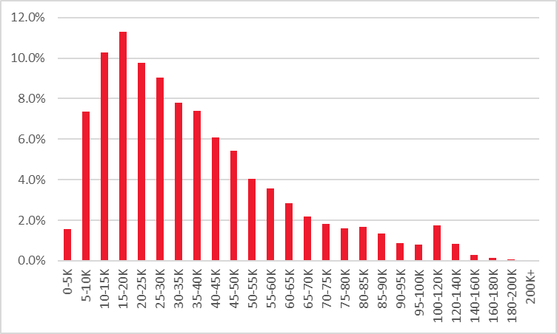
  - Source: CACI 2021

Affordability thresholds

Market purchase
Affordability thresholds are assessed in relation to accessing both the rental and sales market, and the income gap between the two. We have reviewed typical gross household income multiples accepted for lending purposes with the presumption of a 10% deposit. For the purposes of this we have assumed that a household will be able to borrow four times their household income with a 10% deposit.

Market rent
Assessing if a household can afford market rented housing is slightly more complex as we need to establish what percentage of gross income is considered affordable for a household to be spending on housing rent. Strategic Housing Market Assessment guidance from 2007 suggests that 25% of gross income spent on housing rent costs should be considered affordable, although the guidance notes that this threshold should be determined locally. This 25% figure was used within the Exeter and Torbay SHMA 2007 (update 2011).
Other studies looking at the rental housing market indicate that households are committing a far greater proportion of their income to rent without attracting housing subsidy. The latest English Housing Survey report 2019-2020 (Private rented sector) indicates that on average households commit 32% of their household income, including Housing Benefit, on rent. This accords with our understanding of the private rental market in Torbay.
Affordable Housing for Sale (AHS)
First Homes is a discount to market housing tenure. Discounted market housing has been previously delivered in Torbay as an AHS tenure. Shared ownership is the historically predominant form of AHS in Torbay and the product that is most familiar to the housing sector in general. As such we will focus upon First Homes and shared ownership as the only AHS relevant to Torbay.
As covered in Chapter 2 First Homes is a new discounted market product that the Government has introduced through PPG. It is to be sold at a minimum discount of 30% of market value of the property. First Homes will be provided as new build, although as with other Affordable Housing for Sale (AHS) dwellings, a resale market will develop over time. Resales will be restricted by covenant in respect of retention of the discount to market value.
Shared ownership is sold on a leasehold basis where the lessee acquires a proportion of the dwelling, between 25% to 75%, but commonly between 40% to 50%, and is charged a subsidised rent on the unowned proportion. This is usually levied at 2.5% of the unowned equity annually. Unlike First Homes, the lessee usually has the right to buy the unowned equity, known as staircasing.
To consider access thresholds for market housing we apply 4 x salary plus 10% deposit to assess the entry level thresholds. To consider access thresholds for First Homes we apply 4 x salary plus 5% deposit. The 5% deposit is included because lenders are only exposed to a percentage of the dwelling’s value and yet they will have first charge on the value of the whole dwelling.
To consider access thresholds for shared ownership we apply 3 x times salary plus 5% deposit to assess the entry level thresholds. The reason for the lower salary multiple is that the rental element needs to be accounted for within the overall affordability assessment hence more income needs to be retained to meet on-going rental payments. The 5% deposit is included because lenders are only exposed to a percentage of the dwelling and yet they will usually have first charge on the whole dwelling.
Table 7.4 below sets out the gross household income required to access housing at various entry levels.

Table 7.4 Entry level gross household income
Tenure | Calculation | Household income required
Market purchase LQ | £160,000 – 10% = £144,000;  144,000/4 = £36,000 | £36,000
Market rent LQ | £495/0.32= £1,546.90;  £1,546.9 x 12= £18,562.50 | £18,562.50
First Homes (30%) discount | £160,000 x 70% = £112,000;  £112,000 – 5% = £106,400;  £106,400/4 = £26,600 | £26,600
Shared ownership (50%) discount | £160,000 x 50%= £80,000;  £80,000 – 5% = £76,000;  £76,000/3 = £25,334. | £25,334

With all categories of households in existing housing, newly arising need or falling into housing need (A&B), a gross number within each category is established and then an assessment is carried out to establish how many of these households can afford to meet their needs in the housing market without subsidy. The steps are set out below in the next section.

Data calculation to assess affordable housing need

A Calculation of gross unmet current affordable housing need
First let us recap on the categories of households that constitute the gross unmet current affordable housing need. These are:
- The number of homeless households;
- The number of those in priority need who are currently housed in temporary accommodation;
- The number of households in over-crowded housing;
- The number of concealed households;
- The number of affordable housing existing tenants in need (i.e. in unsuitable dwellings); and
- The number of households from other tenures in need and those that cannot afford their own homes, either to rent, or to own, where that is their aspiration.
The first step is to establish the total number of households who have a housing need irrespective of whether they can afford to resolve their housing problem. The ‘current housing need’ categories and the data source through which we establish a gross figure are set out in the table below.

Table 7.5: Current households in affordable housing need (gross): data source
 | Source | Notes
Homeless households (and those in temporary accommodation) | DLUHC Live Table 784 | Total where a duty is owed but no accommodation has been secured PLUS the total in temporary accommodation
Households in overcrowded housing | Census table LC4108EW | Analysis undertaken by tenure and updated by reference to national changes from the English Housing Survey
Concealed households | Census table LC1110EW | Number of concealed families
Existing affordable housing tenants in need | Waiting list data- DLHUC | Excludes overcrowded households
Households from other tenures in need | Census DC4601EW, English Housing Survey

Households from other tenures in need
As set out in the introduction to this chapter the NPPF 2021 expanded the definition of those in affordable housing need to include the number of households from other tenures in need and those that cannot afford their own homes, either to rent, or to own, where that is their aspiration. There is no specific guidance or established practice as to how to assess this figure.
So, for the purposes of this assessment, we have considered households who are currently renting privately (and can afford to do so without subsidy) and whose preference is to buy a home but cannot afford to do so. Those who cannot afford to rent irrespective of their aspirations are assessed through other categories of existing housing need. Likewise, the aspiration of ownership for those in social housing is addressed through the Government’s policies on right to acquire and right to part own for social housing tenants.
This category of households is referred to in the table above as ‘households from other tenures in need’. The English Housing Survey (Private Rented Housing) 2019/20 report indicates that 59% of private renters expect to buy a property. This figure is far higher in the younger rental cohorts with 77% of renters aged 25 to 34 and 65% of renters aged 35 to 44 expecting to buy a property.
Of those private renters who do not expect to buy, the majority cite the cost of buying as the main reason. It should also be noted that a proportion of those not expecting to buy were happy to rent privately, giving reasons such as being happy with their current situation and preferring the flexibility of renting.
The number of private renter households in Torbay at the time of the Census 2011 was 13,696. In 2018, 59.7% of private sector tenants were in receipt of housing benefit. As set out in the paragraph above we will discount these households as, at the point of the assessment, these households are unlikely to afford a mortgage and may be to be accounted for within the other categories of affordable housing need. This creates a residual cohort of 5,519 households.
We have assumed that 59% of this cohort expect to buy a property in line with the English Housing Survey (EHS) findings. In the absence of local data we can only revert to the national dataset.
Of the 41% who do not expect to buy, a proportion report that they are satisfied in the PRS and as such need to be discounted from the calculation. The EHS provides the proportion of respondents who are satisfied with their current situation and/or prefer to rent privately yet responses are potentially double counted. Reviewing the responses within the context of the overall responses as to the question of barriers to ownership we have assumed that 35% of renters choose to live in the PRS. We also discount those households identified as overcrowded in the PRS as these households are already accounted for.
Hence the calculation is as follows:
5,519 x 41% = 2,263; 2,263 less 35% = 1,471; 1,471 less 667 = 804.

The assessment
Table 7.6 sets out the numbers in each category derived by way of the data analysis set out in table 7.5 and as described in the text above. These figures represent current need before an assessment of the household’s ability to financially meet their own needs without intervention and the net impact on overall. This initial stage is set out in table 7.7 and thereupon the resultant numbers are taken forward for affordability testing (table 7.8). These steps will establish the number of households in current housing need and that require subsidy to access housing.
Table 7.6: Current gross affordable housing need by category and tenure.
Current accommodation type | Homeless or living in temp. accommodation | Concealed Households | Households in Overcrowded Housing | Existing affordable housing tenants in need | Households from other tenures in need | Total
Torbay | 263 | 1,222 | 1,519 | 81 | 804 | 3,889
Owner-occupied | n/a | n/a | 529 | n/a | n/a | 529
Private rented | n/a | n/a | 667 | n/a | 804 | 1,471
Affordable rented | n/a | n/a | 323 | 81 | n/a | 404
Source: Census 2011, TC waiting list data, DLUHC.
Table 7.7 determines the gross number of households with unmet housing need that will be taken forward for an income-based affordability assessment. However, the affordability assessment differs per cohort, as some income assumptions have already been made and a number of households are excluded from the affordability assessment on the basis of their net impact on housing need and assumptions on the households’ ability to meet their immediate needs through the release of capital. As such:
- The affordability assessment excludes 90% of owner-occupiers (table 7.7 ref. no. 1) under the assumption that the vast majority of existing owner-occupiers will be able to afford housing within the private sector without subsidy once savings and equity are taken into account.
- The affordability assessment analysis also excludes ‘existing affordable housing tenants in need’ and ‘overcrowded households in affordable rented housing’ (table 7.7 ref. no. 2) because if said household’s need is met then a unit of affordable rented housing would be released, so there is no net effect on the overall calculation. The figures are included for the purpose of identifying the number of affordable housing tenants in unsuitable housing.
- The affordability assessment for ‘households from other tenures in need’ (table 7.7 ref. no. 3) will be assessed against the entry level incomes for the PRS and above, as we have already discounted private sector tenants in receipt of housing benefit.
The table below shows it is estimated that there are 3,889 existing households in housing need, of which 1,672 will be taken forward for affordability testing as explained.
Table 7.7: Existing households in need and to be assessed on affordability grounds
Ref. no. | Cohort/ tenure where applicable | Existing housing need (gross) | No. for Affordability Testing (whole income distribution) Group A
1 | Owner-Occupied | 529 | 53
2 | Affordable Housing | 404 | 0
3 | Private Rented Housing: Households from other tenures in need | 804 | 804
4 | Private Rented Housing: Overcrowded | 667 | 667
5 | No Housing (Homeless/Concealed) | 1,485 | 1,485
 | Total | 3,889 | 3,009
Source: DLUHC, Census 2011, English House Condition Survey

Having established the gross figure in the final of table 7.7, it is important to establish how many of these households might be able to afford market housing without the need for subsidy.
Data on household income has been modelled using CACI Paycheck data which provides both average gross household income and distribution of income.
We use this base again CACI household income data has been used to calculate the affordability numbers currently in need who can afford to meet their own needs without subsidy. To achieve this a gross household income distribution is applied across the identified household groups. For the purposes of the affordability assessment, it is assumed that the gross household income of existing households in need will be lower than for Torbay overall. Hence the distribution must be adjusted to reflect a lower average income amongst households with an existing housing need as compared to all Torbay households.
So for the purposes of the income modelling for households currently housed (categories 1, 3, and 4 of table 7.7 above) household income distribution has been reduced to 85% of the distribution for all households. We refer to these categories as Group A in table 7.8 below. For households with no housing (category 5 of table 7.7 above) their average household income distribution has been reduced to 45% of the distribution for all households. We refer to this category as Group B in table 7.8 below.
These two percentage figures have been based on analysis of the English Housing Survey with reference to the relative incomes of households in the private and social rented sectors) as well as consideration of local intelligence from Devon Home Choice and information from local private letting agents. The analysis has also cross references CACI Paycheck data comparing household income distribution in the wards within the lowest two deciles of the Indices of Multiple Deprivation in relation to the income distribution of the population as a whole. These assumptions are in line with the assumptions used within comparable housing needs assessments.
The original SHMA guidance 2007 states that existing housing need should be met within 5 years of the Plan. Subsequently housing needs assessment have extended the time taken to clear existing housing need. For Torbay’s purposes, due to the high-level homelessness indicated within the existing housing need calculation and the increasing problem of homelessness documented within the local authority area, it is important to address existing housing need with a degree of urgency. Hence for the purpose of this assessment, existing housing need is addressed over 5 years.

Table 7.8: Estimated Current Affordable Housing Need
Affordability category | Group A  % | Group A no. | Group B % | Group B no. | Total | Annualised 5 years (rounded)
% Unable to afford market rent | 33.90 | 517 | 75.00 | 1114 | 1631 | 326
% able to afford market rent but not Affordable Housing for Sale or Market Sale | 15.19 | 231 | 18.39 | 273 | 504 | 101
% able to afford shared ownership (and market rent) but not First Homes or Market Sale | 2.00 | 30 | 1.64 | 24 | 54 | 11
% able to afford First Homes (and shared ownership and market rent) but not Market Sale | 15.49 | 236 | 7.30 | 108 | 344 | 69
% able to afford Market Sale (and other tenures) | 32.52 | 496 | 3.90 | 58 | 554 | 111

B Newly arising households likely to be in affordable housing need

New forming households
Analysis of 2018 based household projections and 2018 based subnational population projections allows us to assess household formation rates of the population under 45, that being the ceiling age for the purposes of this calculation in accordance with accepted guidance. We have calculated that 844 households will form annually between 2021 and 2031.
Having established newly arising housing need, we assess these households on affordability grounds. As with Group A within the existing housing need calculation we utilize the household income distribution for deciles 1 and 2 to reflect the lower salaries of new forming households at the start of their employment trajectory.

Table 7.9: Estimated Newly Arising Affordable Housing Need- Affordability test
Affordability Category | % | Annualised number of households (rounded)
% Unable to afford market rent | 33.90 | 286
% Able to afford market rent but not Affordable Housing for Sale or Market Sale | 15.19 | 128
% Able to afford shared ownership (and market rent) but not First Homes or Market Sale | 2.00 | 17
% Able to afford First Homes (and shared ownership and market rent) but not Market Sale | 15.49 | 131
% Able to afford Market Sale (and other tenures) | 32.52 | 274

Existing households falling into need
The second element of newly arising need is existing households that fall into need. To quantify the net flow of households the assessment looked at households who have been housed in general need housing within the year over the past three years. This excludes new forming households, who are accounted for as a forward projection within the first part of this calculation. New forming households from a waiting list perspective are those applicants living within an existing household, which is usually their family. Similarly, those transferring from an existing social/affordable rented property are also excluded as, when transferring, they will in turn release a unit of affordable rented housing and hence will have no net impact on overall need. From this we create an annualised estimate of existing households falling into need.
This approach is consistent with the 2007 SHMA guidance which states that “Partnerships should estimate the number of existing households falling into need each year by looking at recent trends. This should include households who have entered the housing register and been housed within the year as well as households housed outside of the register (such as priority homeless household applicants).”
The same affordability test has been applied to households falling into need as for existing households in housing need (Group A) and new forming households. It is assumed that existing households falling into need will have a lower household income profile based upon the fact that they have fallen into housing need. Table 7.10 below sets out the number of households falling into need over the past 3 years who have been housed within the year.
Table 7.10: Existing households falling into need and housed within 1 year.
 | Waiting list
2020/2021 | 99
2019/2020 | 97
2018/2019 | 89
Annualised | 95
Source: Devon Home Choice 2021

Table 7.11: Estimated existing households falling into housing need: affordability test
Affordability category | % | Annualised number of households (rounded)
% Unable to afford market rent | 33.90 | 32
% able to afford market rent but not Affordable Housing for Sale or Market Sale | 15.19 | 14
% able to afford shared ownership (and market rent) but not First Homes or Market Sale | 2.00 | 2
% able to afford First Homes (and shared ownership and market rent) but not Market Sale | 15.49 | 15
% able to afford Market Sale (and other tenures) | 32.52 | 31

Bringing together the data

The need for affordable housing for rent (A + B)
Having carried out the analysis to estimate gross unmet housing need, the report considers the net need for new affordable dwellings.
Calculations A (current housing need) and B (newly arising housing need & existing households falling into need) together produce the gross annual need for affordable rented housing in Torbay.

This is calculated as:
- 644 households per annum requiring Affordable Housing for Rent.
Table 7.12: Total households estimated to require affordable rented housing per annum.
A: Households in current housing need per annum | B: Newly forming households per annum | B: Existing households falling into need per annum | Total
326 | 286 | 32 | 644

Having established gross annual affordable housing need we estimate the supply of affordable housing by looking retrospectively at historic delivery.

C Supply of affordable housing
PPG HENA guidance states: “There will be a current supply of housing stock that can be used to accommodate households in affordable housing need as well as future supply. Assessing the total affordable housing supply requires identifying:
- the number of affordable dwellings that are going to be vacated by current occupiers that are fit for use by other households in need;
- suitable surplus stock (vacant properties); and
- the committed supply of new net affordable homes at the point of the assessment (number and size).”

Vacations and lettings
The table below sets out the supply of affordable rented housing through reletting of the existing stock that has been vacated by the previous tenant. To calculate the likely supply within the existing stock we consider historic lettings data over the last five years. The figures are for general needs lettings only and exclude lettings of new properties and transfers from other social rented homes, although we include the net position for social housing transfers in and out of the local authority area. These exclusions are made to ensure that the figures presented reflect relets from the existing stock.
To create the annual lettings figure, excluding newbuild properties let for the first time, it is usual to utilise historic data to provide an average annual figure. The Table below shows affordable rental lettings over the past five years. For the purposes of the assessment we will utilise the average (mean) lettings of existing affordable housing 2016/17 to 2019/20 as last year’s activity was noticeability restricted by the impacts of coronavirus.

Table 7.13: Relets of affordable (social) rent
 | Social housing relets all stock | Of which, newbuild for rent | Net social housing relets existing stock
2016/17 | 244 | 11 | 233
2017/18 | 219 | 14 | 205
2018/19 | 292 | 33 | 259
2019/20 | 243 | 31 | 212
2020/21 | 166 | 25 | 141
Average (2016/17 to 2019/20) |  |  | 227
Source: Devon Home Choice letting statistics 2021, TDA, Torbay Council

Suitable surplus stock

There is no suitable surplus stock identified within Torbay for the purposes of reprovision as affordable housing.

Committed future supply
The committed future supply of affordable housing has been assessed as any site with a current permission that will yield affordable housing or where an application has been submitted and a permission is anticipated. This information is taken from the council’s records. Where the affordable housing tenure split has not been stipulated, we have applied the Policy H2 split of 2/3 affordable/ social rent and 1/3 shared ownership, although the policy does provide for some negotiation on a site by site basis.
This provides a total committed supply of 303 affordable rented dwellings (social rent or affordable rent) which, annualised over the timeline of the Local Plan Update, provides for a supply of 30 rented dwellings per annum. This is relatively consistent with the historic supply as set out in Table 7.13.
It is important to note that the committed supply arose under the policy framework set by Policy H2 of the Torbay Local Plan 2012-30 and so does not represent a “policy off” position for the number of affordable houses that would arise outside of the planning framework.

Table 7.14: Committed newbuild for affordable rent
Site | No. of affordable/social rent | Estimated completion
Luscombe Lane | 9 | 2021/22
Yalberton Road | 38 | 2023/24
Inglewood | 81 | TBC
Collaton St. Mary | 19 | TBC
Hatfield House | 35 | TBC
286/288 Totnes Road | 9 | 22/23
Crossways | 89 | 23/24
St. Kildas | 23 | 22/23
Total | 303
Source: TDA 2021
In conclusion, table 7.15 below sets out an annual unmet need for Affordable Housing for Rent of 387.
Table 7.15: Summary of calculation of total unmet affordable rented housing need
Total households requiring affordable rented housing | Less relets in existing stock | Less committed future supply | Net need for affordable rent housing per annum
644 | (227) | (30) | 387
Table 7.12 | Table 7.13 | Table 7.14

The need for Affordable Housing for Sale
Table 7.16 below summarises the gross number of households requiring Affordable Housing for Sale. This includes existing households in the private rented sector who aspire to own but cannot afford to do so. The methodology to assess this category is set out on pages 66 and 67.
However new forming households and existing households falling into need are not considered in affordable housing need is they are able to afford market rent.
Drawing together those whose housing needs could be met by Affordable Housing for Sale, we arrive at a gross figure of 346.
Table 7.16: Total households estimated to require Affordable Housing for Sale (AHS)
 | A: Households in current housing need per annum | B: Newly forming households per annum | B: Existing households falling into need per annum | Total
PRS | 101 |  |  | 101
Shared ownership only @ 50% | 11 | 17 | 2 | 30
First Homes @ 30% | 69 | 131 | 15 | 215
 |  |  |  | 346

In respect of the supply side (C), resales are not considered as the existing stock of intermediate housing is too limited for this to be significant. The table below sets out the committed supply of newbuild Affordable Housing for Sale. This provides a total committed supply of 116 Affordable Housing for Sale dwellings which, annualised over the timeline of the Local Plan Update, provides for a supply of 12 dwellings per annum.

Table 7.17: Committed newbuild for Affordable Housing for Sale
Site | No. of Affordable Housing for Sale | Estimated completion
Luscombe Lane | 5 | 2021/22
Yalberton Road | 18 | 2023/24
St. Peter’s Close | 3 | 2021/22
Inglewood | 40 | TBC
Collaton St. Mary | 9 | TBC
Hatfield House | 18 | TBC
St. Kildas | 23 | 22/23
Total | 116
Source: TDA 2021
Table 7.18: Summary of calculation of total unmet need for Affordable Housing for Sale
Total households requiring Affordable Housing for Sale | Less relets in existing stock | Less committed future supply | Net need for Affordable Housing for Sale per annum
346 | 0 | 12 | 334
Table 7.16 |  | Table 7.14

The PRS category in table 7.16 includes those assessed to aspire to home ownership but only being able to afford private rent. It also includes other categories of households in need who can afford private rent but not an intermediate or market tenure. The affordability assessment for households to access First Homes and shared ownership was set at 30% discount and 50% share respectively. These discounts or shares can be increased or reduced respectively to lower the access thresholds required. Table 7.19 sets out the entry thresholds that would offer the opportunity for all private renters to access Affordable Housing for Sale.

Table 7.19: % discount to enable access to AHS from the PRS
Tenure | Calculation | Discount/ Share
First Homes | £18,562.50 x 4 = £74,250;  £74,250 + 5%= £77,962.5  £77,962.50 as % of £160,000=  48.7% | 51.3% discount
Shared ownership | £18,562.50 x 3 = £55,687.50;  £55,687.50 + 5%= £58,472  £58,472 as % of £160,000= 36.5% | 36.5% share

Conclusion and implications for policy

Hierarchy of housing need
The annual unmet housing need for Affordable Housing for Rent and Affordable Housing for Sale is on a relative par. The calculation of unmet housing need for Affordable Housing for Sale has been increased by the most recent NPPF and PPG statements on household aspiration to buy or rent irrespective of their current housing situation.
However meeting unmet housing aspiration (or unmet housing need) is not always possible at a micro level given other constraints to the local housing market. In policy terms the Council needs to consider the relative impact of a household’s housing situation. It is clear a homeless household is impacted by their housing situation to a greater extent than a household living in the private rental sector who aspire to ownership. This is reflected in the Council’s allocations policies.
This should also be reflected in the Council’s affordable housing planning policies and there is a strong argument to weight affordable housing provision delivered by way of planning obligation toward Affordable Housing for Rent as these tenures meet the needs of those in greatest housing need.

Need for social rent v affordable rent
The projection relating to the annual unmet need for Affordable Housing for Rent is derived from those households who cannot afford to rent privately or buy an Affordable Housing for Sale product or market product without subsidy.
The net annual number of new affordable rented dwellings required to meet projected unmet housing need per annum is 385 as set out in Table 7.15.
The prevailing NPPF definition for Affordable Housing for Rent includes both Social Rent and Affordable Rent. Social Rent is the traditional form of subsidised rented housing and the majority of local authority and Registered Provider housing stock will be let as Social Rent. Affordable Rent was introduced in 2010. Affordable Rent is tied at a discount to market rent level, namely no more than 80% of equivalent market rents. Social Rent on the other hand is set by way of a standard formula which includes an assessment of historic stock value, number of bedrooms and comparative local factors, such as relative wage levels. Another important distinction to make is that Affordable Rent is always charged inclusive of service charges, while service charges can be charged in addition to Social Rent.
As Affordable Rent is pegged at market rent levels, the rent level charged can vary significantly by area and by property type. In fact most Registered Providers tie their Affordable Rent levels to Local Housing Allowance (LHA). This negates very localised variations and ensure a minimum level of affordability.
There is less variation between property type and area with Social Rent. In fact the current rent regime sets a formula or target rent for Social Rent which provides equivalence across the local authority area by property type. This regime, known as rent restructuring, was introduced in the early 2000s.
A review of lettings data from Devon Home Choice indicates that there are some disparities between Social Rent and LHA derived Affordable Rent in Torbay. These disparities are pronounced with larger, higher rental valued properties, while Social and Affordable rent levels are more consistent with smaller properties, in particular flats.
However for working families on low incomes and not in receipt of housing benefits who need a larger properties, the difference between Social Rents and Affordable Rents can be prohibitive. The Government has recognised in some areas that Affordable Rents have become a disincentive for households looking to move into fulltime work. In higher value areas, Homes England grant will be made available at a higher rate to support Social Rent during the 2021/2026 programme. Torbay is one of these designated areas, so grant is available to support Social Rent in Torbay.
This supports the case for continuing a required mix of both Social and Affordable Rent within affordable housing policies.

Chapter Eight: Specialised housing
Initially we set out the key findings of chapter 8. Note that referencing, data source and context is provided in the body of the chapter.

Key findings
- The private rented sector (PRS) as a % of Torbay’s housing stock rose from 13.5% in 1991 to 23.22% in 2011.
- ONS projections indicate that the PRS then rose to over 27% of stock in 2015 and 2016, before dropping to just over 25% in 2019.
- In respect of the age of the Household Reference Person (HRP), unsurprisingly households with a younger HRP are far more prevalent in the PRS. Circa 74% of households where the HRP is under 25 are living in the PRS. Circa 55% of households where the HRP is between 25 and 34 are living in the PRS.
- Historically, younger households tend to start renting privately and then move onto owner occupation or some form of more secure affordable provision. With market housing continuing to become less affordable in comparison to incomes, the transition from the PRS to owner occupation is becoming more problematic.
- Although the PRS is still typically a younger cohort market, there are still households renting privately where the age of the HRP is much older. 8.8% of households (635 households) where the HRP is between 75 and 84 rent in the PRS. 9.3% of households (312 households) where the HRP is 85 years or over rent privately.
- Torbay Council is required to keep and maintain a register of individuals or associations of individuals who are interested in self-build housing. At the time of writing there are 52 households who have expressed an interest in self-build and custom-build housing.
- In the Census 2011, 13,941 persons in Torbay reported having a long-term health problem or disability that limits their day-to-day activities a lot. Of these, 7,375 were 65 years old or over, which comprises 25.3% of the 65+ population.
- A Housing Learning and Improvement Network (LIN) commissioned report highlighted a lack of both age-suitable housing designated specifically for older people and innovative housing with care options that is adapted/adaptable for later life in Torbay.
- The Housing LIN report set out the following need for older persons’ accommodation to 2035: 848 units of specialist housing for older people (424 for rent and 424 for sale); 276 units of housing with care (138 for rent and 138 for sale); a reduction of 188 residential care beds and an increase of 370 beds for nursing care.
- The Council’s Adult Services department have identified a need to allocate an additional 12 units per annum for persons with a Learning Disability and 3 bespoke units of accommodation per annum.
- The Council’s Adult Services department state that they require an allocation of 15 units per annum to meet the needs of clients with an enduring mental health.
- The Devon Gypsy and Traveller Accommodation Assessment identified a need for 2 pitches in Torbay within the plan period.
- There is currently no measurable student population in Torbay.

PPG on HENA refers to ‘identifying the housing needs of different groups’ and the ‘housing needs of older and disabled people’, and defers to existing PPG.

Identifying the housing needs of different groups
PPG on ‘Advice on addressing the need for different types of housing’ was published on 22nd July 2019 and updated on 24th May 2021. This guidance focusses upon:
- The private rental sector
- Self-build and custom housing
- Student housing

The private rental sector
The private rental sector (PRS) is a key element of the housing market in Torbay. The report examines the PRS in Chapter 3 (the Housing Baseline) and more comprehensively in Chapter 6 (the housing market and affordability), and the PRS also forms a key part of the calculation of affordable housing need set out in Chapter 7. This section will refer to the previous information as required without repeating the previous narrative. Nationally the PRS has grown over 20 plus years and since 2011 the private rental sector has been the second largest housing tenure in England behind owner-occupation. This is the case in Torbay at 23.2% (plus 1% living rent free) as outlined in Figure 3.5.
The table below demonstrates the growth in the PRS from the Census 1991 to the Census 2011.
Table 8.1: PRS as a proportion of stock 1991 to 2011
Year | 1991 | 2001 | 2011
% housing stock | 13.5 | 15.1 | 23.22

The ONS provides dwelling tenure estimates at the local authority area for 2012 to 2019. These estimates are derived from a series of datasets, namely the 2011 Census, the Annual Population Survey household datasets, the English House Condition Survey and the annual DLUHC live tables of dwelling stock. It can be seen from the graph below that it is estimated that the sector grew from 2011 to a peak in 2015 and 2016, before dropping back. There is some anecdotal evidence that tax changes, proposed changes in tenancy rights and more robust legislation has led to a departure of some landlords from the sector.

Figure 8.1: PRS as a proportion of Torbay housing stock 2012 to 2019
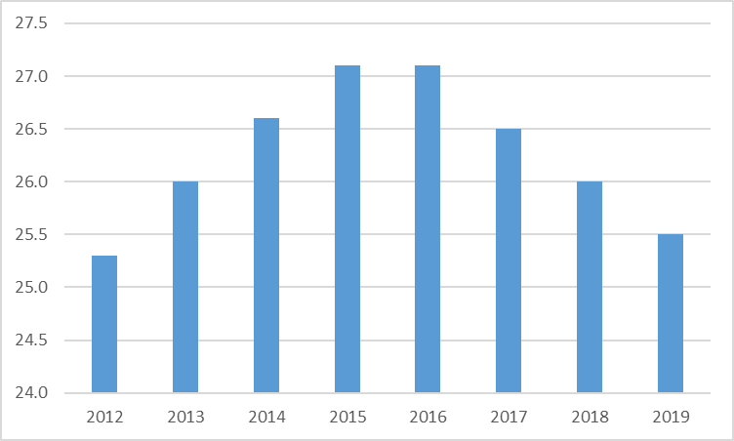
Source: ONS 2021

Demographics of those living in the PRS
The table below sets out the percentage of households living in the private rental sector by the age of the household reference person (HRP) at the time of the Census 2011. Within this assessment, we include those living rent free as these households will have an equivalent security of tenure. The ‘living rent free’ category represents 1.0% of the total number of households.
Unsurprisingly the highest proportions of households living in the PRS are within the younger age cohorts. However, renting privately is not limited to younger aged cohorts by HRP and possibly somewhat surprising is the number of households renting privately whose HRP is 65 and over. It has to be caveated that renting privately may be a choice for some households and may also be a temporary solution while they seek to buy a property.

Table 8.2: Percentage of households living in PRS by age of HRP
Age cohort | Number of households | % of households in that HRP age cohort
Age 24 and under | 1,325 | 73.8
Age 25 to 34 | 3,275 | 55.4
Age 35 to 49 | 4,492 | 30.2
Age 50 to 64 | 3,072 | 18.7
Age 65 to 74 | 1,159 | 12.3
Age 75 to 84 | 635 | 8.8
Age 85 and over | 312 | 9.3
All age categories | 14,270 | 24.2
Source: Census 2011
Table 8.3 sets out the percentage of households living in the PRS by household composition. 43% of one person households under the age of 65 rent privately in Torbay. As can be seen from the table above this is likely to be weighted toward the younger cohorts.
41.2% of co-habiting couples rent privately compared to 13.4% of married couples or those within a civil partnership. Couples in legal relationships will tend to have an older age profile than co-habiting couples which again reflects the greater prevalence of renting privately amongst younger cohorts. 41% of lone parent households live in the private rented sector.

Table 8.3 Percentage of households living in PRS by household composition
Household composition | Number of households | % of households
One person household: 65 and over | 1,390 | 14.4
One person household: Other | 4,525 | 43.0
One family only: All 65 and over | 353 | 5.5
One family only: Married or same sex civil partnership | 2,300 | 13.4
One family only: Co-habiting couple | 2,211 | 41.2
One family only: Lone parent | 2,514 | 41.0
Other household types: With dependent children | 293 | 23.9
Other household types: All full-time students | 16 | 94.1
Other household types: All aged 65 and over | 31 | 10.4
Other household types: Other | 637 | 28.3
Source: Census 2011
The private rented sector plays a crucial role in Torbay’s housing market for both younger and low-income households. In 2018 the DWP reported that just under 60% of Torbay’s private renters were in receipt of housing benefit. This is significantly higher than comparative areas.
Due to the reliance on the PRS for many low-income households, these households are vulnerable to any demand changes within the sector. For example, if demand for PRS accommodation from working adults increases or there is an increase in demand from a new source, for example students or an overseas workforce, then supply in some areas or some property types may be constrained for low-income households. The Council’s Housing Options team indicate that they are struggling to place homeless households in the private sector due in part to a recent overall increase in demand in Torbay for accommodation. Currently there is much as yet unquantified anecdote about the ‘flight to the provinces’ as much of the workforce seek to work from home on a more permanent basis. The step change in working habits and the impact on the housing market has yet to be fully understood.
The Council would be prudent to consider how it can strategically support and improve the sector in order to support low-income households who have limited or no alternative options.

Self-build and custom housing
The Self-build and Custom Housebuilding Act 2015 (as amended by the Housing and Planning Act 2016) provides a legal definition of self-build and custom housebuilding and does not distinguish between the two. It defines both as “where an individual, an association of individuals, or persons working with or for individuals or associations of individuals, build or complete houses to be occupied as homes by those individuals.”
The Act sets a requirement for relevant authorities, which includes Torbay Council, to keep and maintain a self-build register of interested individuals or associations of individuals. Currently there are 52 households who have expressed an interest in self-build and custom-build housing.
The Council is reviewing its sites that may be suitable for self-build allocation by way of its site assessments within the Local Plan Update process.

Student housing
There is no bespoke student accommodation in Torbay and an inconsequentially small number of students living in the local authority area.

Housing needs of older and disabled people

Housing for older people
PPG emphasises that the need to provide housing for older people is critical. PPG goes on the state that the population is living longer and the proportion of older people within the population is thereby increasing. Linked to the ageing of the population is the greater likelihood and prevalence of emerging physical disabilities, dementia and other age-related conditions.
Of the 13,941 persons who, in the Census 2011, reported having a long-term health problem or disability that limits their day-to-day activities a lot, 7,375 were aged 65 or older. This amounts to a quarter (25.3%) of the 65 and older cohort, and 5.8% of the population. A similar number of this age cohort (7,835) reported a long-term health problem or disability that limits their day-to-day activities a little. PPG suggests that “they (plan-making authorities) could also provide indicative figures or a range for the number of units of specialist housing for older people needed across the plan area throughout the plan period.”
PPG states that in mid-2016 there were 1.6 million people aged 85 and over, with this number projected to reach 3.2 million by mid-2041. In this assessment, population and household age is referenced in detail in Chapter 4: Demographic profile. In line with national trends, the rate of population growth is far higher in older cohorts. The graph below from Chapter 4 illustrates this.
Figure 9.2: Population growth by age cohort
Source: ONS 2021 (Nomisweb)
Torbay Council has produced a Strategy for Housing in Later Life (2020 – 2025). The research to inform this strategy was carried out by the Housing Learning and Improvement Network (Housing LIN). This Strategy is summarised within this assessment. The Strategy and the research that supports it should provide the base evidence for a policy response. The key points of this research are extracted below.
The Housing LIN research highlights that the housing offer for later life in Torbay is currently skewed towards traditional social housing sheltered schemes and private sector leasehold schemes. The report also highlights a lack of both age-suitable housing that is not designated for older people specifically and innovative housing with care options that is adapted/adaptable for later life. In particular there is a lack of housing with care options and sheltered housing for owner occupiers and private renters to reflect the current housing profile in Torbay.
Currently Torbay has only two Extra Care Housing schemes offering rental and shared ownership apartments to people who qualify for affordable housing. Extra Care Housing in Torbay is not only for older people as schemes are open to people over 18 who have an assessed need for housing with care in order to live independently. There is very limited provision of private sector housing with care for older people. Housing that is specifically designed for older people is concentrated in Torquay and Paignton. There is no housing with care on-site in Brixham. The figure below sets out the numbers of older persons’ housing by type and tenure.

Figure 9.3: Current Older Persons’ housing in Torbay
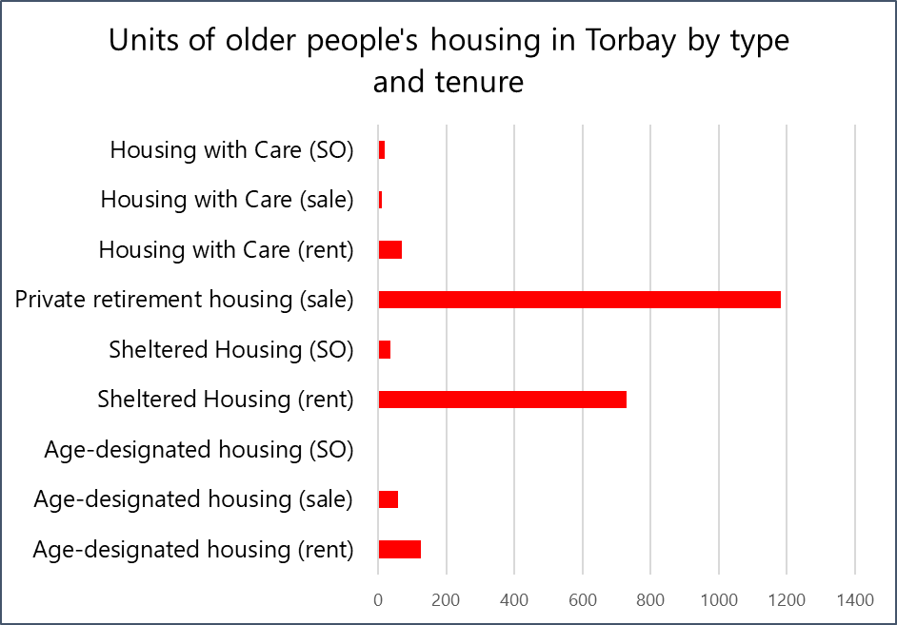
Source: Torbay Council, Housing LIN report
Housing LIN were commissioned to apply their ‘Strategic Housing for Older People’ (SHOP@) approach to model future need for specialist housing for older people in Torbay up to 2040. SHOP@ was originally developed with the Association of Directors of Adult Social Services (ADASS) and Elderly Accommodation Counsel (EAC) for the Department of Health’s Market Development Forum to support local authorities with forecasting demand for older people’s housing. The SHOP@ housing need assessment tool has been updated to refine the previous use of national generic ‘benchmarks’ to predict future need at local authority level. The comparative analysis applied compares the current supply or ‘prevalence’ of different types of housing and accommodation for older people in Torbay with comparator local authorities (i.e. similar unitary local authorities) as well as with the average supply of older people’s housing and accommodation across England as a whole.

Table 9.4: Estimated need for older persons’ housing and accommodation to 2035 in Torbay
Housing/accommodation type | 2019 current provision  (units/beds) | 2035 estimated need | 2035 net need  (units/beds)
Housing for Older People | 2128 | 2976 | 848
Housing with Care | 100 | 376 | 276
Residential Care | 1267 | 1079 | -188
Nursing Care | 508 | 878 | 370
Source: Torbay Council, Housing LIN report
In summary this indicates that the estimated net requirements for Torbay to 2035 are:
- Housing for older people: 848 units of which 424 for rent and 424 for sale.
- Housing with care: 276 units of which 138 for rent and 138 for sale.
- Residential care: a reduction of 188 beds.
- Nursing care: 370 beds.
Hence in light of PPG the local plan-making authority can set indicative annual figures for specialist older person over the plan period.
Housing for people with disabilities
PPG states that “the provision of appropriate housing for people with disabilities, including specialist and supported housing, is crucial in helping them to live safe and independent lives.” Lack of suitably adapted or appropriate housing can lead to mobility issues inside and outside the home, and difficulties for carers. This leads to poorer outcomes and opportunities for many disabled people with consequent impacts on the mental health and well-being of the disabled person, their families and carers.
The provision of more suitable accommodation can enable disabled people to live more independently and safely, and provides them with greater choices and control over their lives. The ageing of the population will lead to greater numbers of disabled people. PPG stresses the importance of planning for the provision of suitable housing to meet the needs of disabled people throughout their lifetime.
PPG goes on to state: “Plan-making authorities should set clear policies to address the housing needs of groups with particular needs such as older and disabled people. These policies can set out how the plan-making authority will consider proposals for the different types of housing that these groups are likely to require.”
The Census 2011 identified 13,941 persons in Torbay who reported a long-term health problem or disability that limits their day to day activities a lot. That amounts to 10.9% of the overall population. A further 15,490 (12.1%) persons reported a long-term health problem or disability that limits their day to day activities a little.
Of those whose condition limits their day-to-day activities a lot, the age distribution is set out in the table below. This clearly shows a relationship between ageing and the prevalence of disability and long-term ill-health. It needs to be noted that some of the most severe forms of disability are congenital from birth and often this cohort faces the greatest challenges in terms of housing.
Table 9.5: Numbers and % (by respective age cohort) of persons with a significant long-term health problem or disability
Age category | No. | % of age cohort
0 to 15 | 386 | 1.79
16 to 49 | 2,817 | 5.60
50 to 64 | 3,363 | 12.53
65 and over | 7,375 | 25.26
Total | 13,941 | 10.9
Source: Census 2011
The Projecting Adult Needs and Service Information (PANSI) system is produced by the Institute of Public Care at Oxford Brookes University and is seen as the key information source for projections relating to the housing needs of adults with a disability or special need. The following sections set out projected numbers of Torbay’s population with a disability or special need.
The table below shows the proportion of the population projected to have a severe or moderate learning disability. 2.3% of all adults and 2.4% of adults between the ages of 18 and 64 are projected to have a learning disability. The proportion of adults with a learning disability is weighted towards the lower age cohorts, which demonstrates that learning disabilities are not linked to ageing in the way that some other disabilities or long-term health problems are.
The Council’s Adult Services department have identified a need to allocate an additional 12 units per annum for persons with a Learning Disability and 3 bespoke units of accommodation per annum.

Table 9.6: Total population aged 18 and over predicted to have a learning disability
 | 2020 | % of age cohort | 2030 | Growth
18-24 | 224 | 2.70 | 249 | 25
25-34 | 349 | 2.49 | 316 | (33)
35-44 | 335 | 2.46 | 382 | 47
45-54 | 428 | 2.35 | 387 | (41)
55-64 | 468 | 2.27 | 486 | 18
Total 18-64 | 1804 | 2.41 | 1820 | 16
65-74 | 421 | 2.18 | 487 | 66
75-84 | 252 | 2.02 | 327 | 75
85 and over | 100 | 1.95 | 132 | 32
Total | 2,577 | 2.31 | 2,765 | 188
Source: PANSI 2021
For many categories of special needs, the Projecting Adult Needs and Service Information (PANSI) reports on prevalence only within the sector of the population that is aged 18-64. This is the case with the population projected to have impaired mobility. Tables 9.7 and 9.8 set the projected growth in the number of adults under 65 with impaired mobility or a moderate or serious personal care disability. Overall mobility and care needs should also be viewed in the context of the ageing population needs referenced in the previous section. Policy H6 (Housing for people in need of care) of the current Local Plan sets out a number of criteria that facilitate the delivery of a proportion of dwellings built in accordance with Part M4(2) (accessible and adaptable dwellings) of the Building Regulations. The evidence indicates that Policy H6 should be maintained as a minimum and that increased provision could be considered as part of an authority wide viability assessment.

Table 9.7: Total population aged 18-64 projected to have impaired mobility.
 | 2020 | % of age cohort | 2030 | Growth
18-24 | 83 | 1.00 | 93 | 10
25-34 | 140 | 1.00 | 127 | (13)
35-44 | 680 | 5.00 | 770 | 90
45-54 | 910 | 5.00 | 815 | (95)
55-64 | 2,884 | 14.00 | 2,996 | 112
Total | 4,697 | 4.21 | 4,801 | 104
Source: PANSI 2021
Table 9.8: Total population aged 18-64 predicted to have a moderate or serious personal care disability.
 | 2020 | % of age cohort | 2030 | Growth
18-24 | 83 | 1.00 | 93 | 10
25-34 | 252 | 1.80 | 229 | (26)
35-44 | 476 | 3.50 | 539 | 63
45-54 | 1092 | 6.00 | 978 | (114)
55-64 | 2163 | 10.50 | 2247 | 84
Total | 4066 | 5.44 | 4086 | 20
Source: PANSI 2021
Table 9.9 below excludes what are described as common mental disorders, such as depression or anxiety, which are commonly treated through general practice. It also excludes dementia related mental health issues which are predominantly associated with ageing, although not exclusively. The Council’s Adult Services department state that they require an allocation of 15 units per annum to meet the needs of clients with an enduring mental health issue, although some of these units can be sourced within the existing housing market. The table below indicates the total projected number of persons with these disorders listed in Torbay.

Table 9.9: People aged 18-64 predicted to have a mental health problem
 | 2020 | % of age cohort (18-65) | 2030 | Growth
Borderline personality disorder | 1,799 | 2.41 | 1,799 | 0
Anti-social personality disorder | 2,493 | 3.34 | 2,516 | 23
Psychotic disorder | 524 | 0.70 | 525 | 1
Two or more psychiatric disorders | 5,388 | 7.21 | 5,399 | 11
Source: PANSI 2021

Gypsies and Travellers
The accommodation needs of Gypsies and Travellers are typically considered within a bespoke assessment. The Devon Gypsy and Traveller Accommodation Assessment (GTAA) 2015 is the most recent study for the purposes of assessing Gypsy and Traveller accommodation needs. There are currently no pitches either permanent or transit within Torbay. However, the GTAA identified 13 gypsies and travellers in living in mainstream ‘bricks and mortar’ accommodation. The GTAA follows the latest government guidance in calculating the future requirement for pitches. This assessment identifies the need for 2 pitches in Torbay within the plan period. It also identifies a housing (bricks and mortar) need for 4 households. There is also an identified need for 4 to 5 transit sites across the County without specific location being referred to.

Chapter Nine: Mix of housing
Initially we set out the key findings of chapter 9. Note that referencing, data source and context is provided in the body of the chapter.

Key findings
- In the owner-occupied sector the average size of accommodation rises with Household Reference Person (HRP) age to typically reach a peak around the age of 50; a similar pattern (but with smaller dwelling sizes) is seen in both the social and private rented sector.
- The projected future mix of housing needed within the owner-occupied sector is as follows: 6.5% 1 bedroom dwellings; 31.7% 2 bedroom dwellings; 41.6% 3 bedroom dwellings and 20.2% 4+ bedroom dwellings.
- The projected future mix of housing needed within the affordable rented sector is as follows: 40.1% 1 bedroom dwellings; 29.3% 2 bedroom dwellings; 41.6% 3 bedroom dwellings and 20.2% 4+ bedroom dwellings.

Background
This chapter draws on previous analysis to assess the appropriate mix of housing across the Torbay HMA. This chapter should be considered in tandem with chapter 3 to understand the housing profile of the HMA.
As a snapshot of the housing profile expanded upon in chapter 3, tables 9.1 and 9.2 below set out the breakdown of housing stock by size of dwelling (assessed as number of bedrooms). Across the HMA the largest number of dwellings are 2 and 3 bedroomed properties. This varies significantly by tenure with larger housing predominating in the owner-occupied sector and with significantly higher proportions of one bedroom dwellings in the rented sector.
Table 9.1: Torbay dwellings by no. of bedrooms
 | 0 bedrooms | 1 bedroom | 2 bedroom | 3 bedroom | 4 bedroom | 5+ bedroom
No. | 157 | 8,729 | 18,626 | 21,802 | 7,334 | 2,362
% | 0.3 | 14.8 | 31.6 | 36.9 | 12.4 | 4.0
Source: Census 2011

Table 9.2: % of dwellings by no. of bedrooms by tenure
 | 1 bedroom | 2 bedroom | 3 bedroom | 4+ bedroom
Owner-occupied | 5.8% | 29.6% | 42.9% | 21.7%
Social rented | 36.7% | 30.3% | 29.5% | 3.5%
Private rented | 33.7% | 37.6% | 22.8% | 5.9%
Source: Census 2011
In terms of assessing the appropriate mix of housing into the future, we can review the demographic projections to provide a good indication of how the population and household structure will develop. This is covered in depth in Chapter 4. Simply translating the growth in households into a projected profile of additional housing is not straightforward.
The reason is that, particularly in the private market sector, a household’s selection of a property is not always based upon their defined bedroom need, it is also based upon their aspirations as to the size of the property they can afford. For example, a couple without children may in fact buy a four bedroomed property if they can afford this for numerous reasons such as: they may plan a family in the future, or they may need extra bedrooms to use as a home office, as storage, or as rooms for friends to stay. Choice in the housing market is often determined by a household’s finances. A lower salaried couple without children may aspire to live in a four bedroomed property, but that is simply not possible given affordability ratios in Torbay.
Constraints in the supply of certain property types can restrict movement within the market sector. For example, the lack of suitable downsizing options may restrict elderly households from releasing larger properties which they are under-occupying.
There is less choice in the affordable/social rented sector where households are allocated properties in accordance with their defined bedroom need. However, many long-standing tenants are under-occupying as their children have left the family home and they have remained in the larger property originally allocated to them, which is their entitlement under their tenancy agreement. There is a financial penalty for working age households in receipt of housing benefits who under-occupy, known as the ‘under-occupation charge’ or ‘bedroom tax’, to discourage under-occupation within the sector. This does not apply to pensioner households.

The methodology to assess housing type requirements
Having considered the element of choice, the methodological approach to estimate a profile of the type of housing needed is to first ascertain the number of household reference persons (HRPs) in defined age cohorts by tenure and the profile of housing type occupied (by bedroom size) within these cohorts. The data for this analysis has been provided by way of a commissioned table by ONS (Table CT0621) provided at local authority level based upon the Census 2011.
The next step is then to consider predicted household growth within each age cohort. The growth or decrease in each cohort is applied to the profile of current household occupation by housing type and by tenure to estimate the proportionate housing type requirements over the next ten years. We apply the 2018 based household projections to assess household growth as these are the latest projections of household growth by age of HRP.
Table 9.3: Household growth by age of HRP 2018 to 2043
Age cohort of HRP | Under 35 | 35-44 | 45-54 | 55-64 | 65-74 | 75-84 | 85+
Growth rate (%) | 1.98 | 7.77 | (3.96) | 7.64 | 15.13 | 81.10 | 93.30
Source: ONS household projections 2018
The sections below show an estimate of how the average number of bedrooms varies by the age of HRP and by tenure for Torbay.

The owner-occupied dwelling stock
In the owner-occupied sector the average size of accommodation rises with HRP age to typically reach a peak around the age of 50 for 4 bedroom dwellings and circa 60 years for 3 bedroom dwellings. A similar pattern (but with smaller dwelling sizes) is seen in both the social and private rented sector. After peaking, the average dwelling size decreases – as typically some households downsize as they get older.
Figure 9.1: Owner occupation total dwellings by age cohort
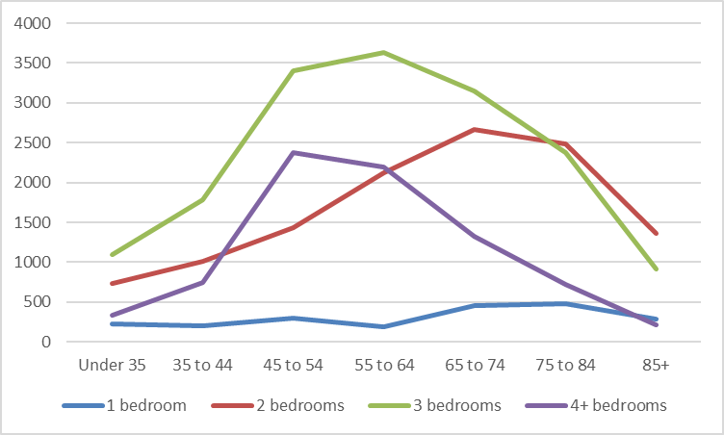
Source: ONS 2021

Figure 9.2: Owner occupation % dwelling size occupied by age cohort
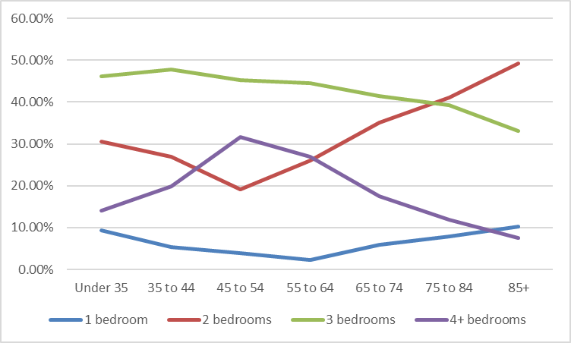
Source: ONS 2019
Applying the household growth rates by age cohort of HRP to the current size of dwellings that are owner occupied, this provides an projected future mix of housing as shown below.
Table 9.4: estimated owner occupied housing size requirements (%)
 | 1 bed | 2 bed | 3 bed | 4+ bed
% | 6.5 | 31.7 | 41.6 | 20.2

The social/affordable rented housing stock
Figure 9.3: Social/affordable total dwellings by age cohort
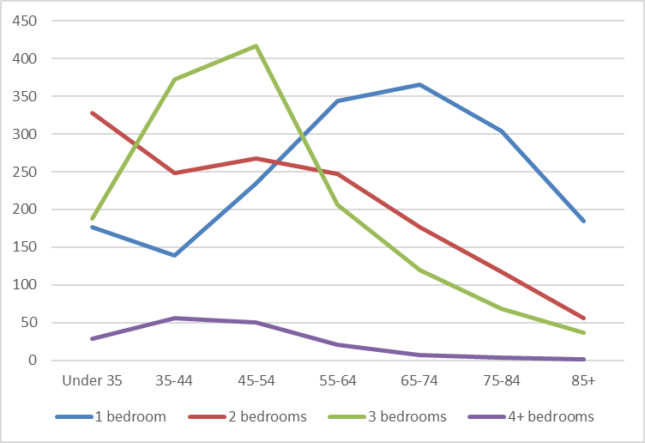
Source: ONS 2019
Figure 9.4: Social/affordable % dwelling size occupied by age cohort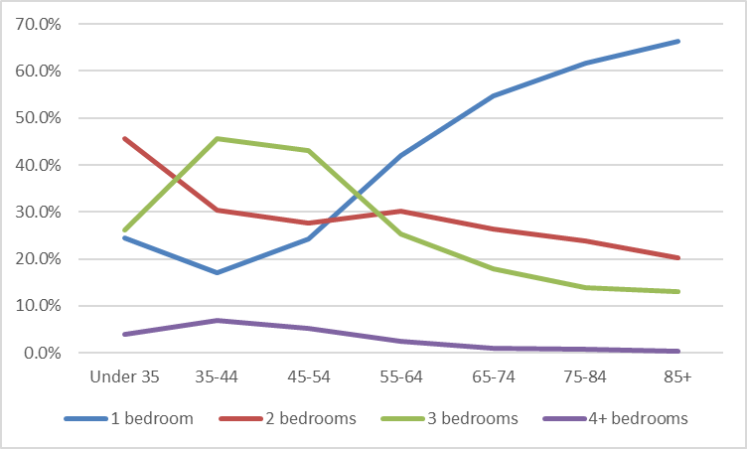
Source: ONS 2019
Applying the household growth rates by age cohort of HRP to the current size of dwellings that are rented as affordable or social rent, this provides an estimated future mix of housing as shown below.
Table 9.5: estimated affordable rent housing size requirements (%)
 | 1 bed | 2 bed | 3 bed | 4+ bed
% | 40.1 | 29.3 | 27.5 | 3.1

