SITE OVERVIEW
Town | Torquay
Site Name | Land rear of Castle Circus House including CDT office
HELAA Reference no. | 21T146
Approx. yield | 30
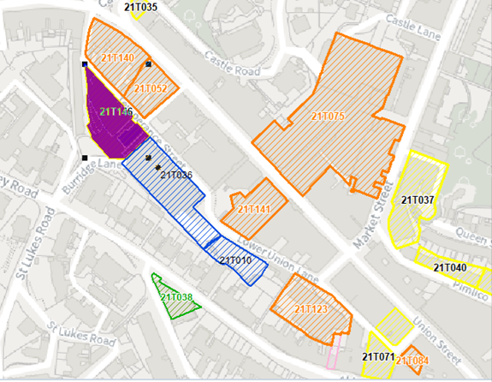
Suitable | Yes, highly sustainable brownfield site within Torquay’s town centre. Area is in need of investment and upliftment. Subject to SFRA and management of flood risks, although housing would be likely to be sited at upper levels.  The site, together with the Lower Union Lane car park to the south east, are allocated in the Torquay Neighbourhood Plan (TNPH25)
Available | Council-owned land being leased privately. The building in the southeastern part of the site is in use as the Torbay Community Development Trust office and is therefore not currently available (but may have potential to become available in the future).
Achievable | In the current market the site is likely to lack viability, but in the longer term (11+ years) may be achievable as part of a wider mixed-use redevelopment incorporating housing.
Customer Reference no.
Source of Site (call for sites, Local Plan allocation etc.). | Post Panel Additions.
Current use | The building in the southeastern part of the site is in use as the Torbay Community Development Trust office. The vacant land in the central and northern part of the site is currently used for parking.
Site descriptions | Town centre site located southeast of the junction of Factory Row and Temperance Street and northwest of the Lower Union Lane multi-storey car park, comprising of vacant, dilapidated hardstanding in the central and northern part of the site with a double-storey building in use as an office in the southeastern part of the site. Temperance Street forms the eastern site boundary while a retaining wall adjacent to Factory Row forms the western site boundary.
Total site area (ha) | Approximately 0.2ha.
Gross site area (ha)

SUITABILITY ASSESSMENT: STAGE A

Strategic potential: | As an individual site no, but taken together with adjacent sites as part of a comprehensive town centre regeneration the site would have strategic potential.
Housing? | Yes
Employment? | Mixed use also comprising office/retail.
Other Use? | Mixed use also comprising parking.
Biodiversity- Within SAC/SSSI | No
Flood Zone 3b | The eastern part of the site falls within Flood Zone 3.
Other NPPF Showstoppers (not policy constraints) | No
Conclusion

SUITABILITY ASSESSMENT: STAGE B

Access | Existing site access onto Temperance Street (which is one lane wide). Proximity to public transport.
Flood risk, water quality and drainage | The eastern part of the site falls within Flood Zone 3.
Heritage and Archaeology (including distance from assets). | The site forms part of the setting of the Abbey Road, Upton, and Tormohun Conservation Areas.  Grade II* Listed Church of St Mary Magdalene approx. 135m to the northwest. Grade II listed buildings to the north including 2 Tor Hill Road (approx. 30m away) and the Town Hall (approx. 70m away), and to the south including 85 Abbey Road and the Church of the Assumption of Our Lady (each approx. 80m away).
Infrastructure | Town centre site with access to existing infrastructure.
Landscape | No significant constraints.
Ecology | Within consultation zone for Greater Crested Newts (although unlikely to be a constraint given the site’s town centre location).
Safety related constraints | Any scheme would need to incorporate ‘designing out crime’ measures.
Soils (Agricultural Land classification) and contamination
Local Plan | Torquay Town Centre (Policy TC1)  Community Investment Area (Policy SS11)  Flood Risk (Policy ER1)
Neighbourhood Plan | Site forms part of TNPH25 (Lower Union Lane, Temperance Street Regeneration)
Development progress (where relevant) | None.
Other
HELAA Panel Summary
Site potential

AVAILABILITY ASSESSMENT
Reasonable prospect of delivery (timescale):

The next 5 years
A 6-10 year period
An 11-15 year period | 30
Later than 15 years

