SITE OVERVIEW
Town | Torquay
Site Name | Grand Hotel garage site, Hennapyn Road, Torquay.
Map (if needed)
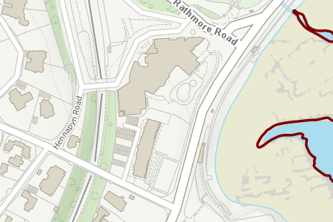

Allocation or HELAA Reference no. | 21T138
Approx. yield | 10
Suitable: How the principle of development is established | Prominent building in Chelston Conservation area. Likely to be scope to extend above garage block, subject to suitable design
Available: Any change in circumstances since principle established | Has been promoted.
Achievable | Subject to suitable design.
Customer Reference no.
Current use | Garage and valet service ancillary to the hotel.
Site description | Single storey garage block adjacent to Grand Hotel.
Total site area (ha) | 0.08ha (garage block only)

AVAILABILITY ASSESSMENT
Reasonable prospect of delivery (timescale):
Appears suitable subject to appropriate design that conserves or enhances the character and appearance of the Conservation Area
The next 5 years
A 6-10 year period | 10
An 11-15 year period
Later than 15 years

