SITE OVERVIEW: Yellow Site – minor constraints
Town | TORQUAY
Site Name | Westhill garage, Chatto Road
HELAA Reference no. | CDST11 R754 (housing monitor ref)
Approx. yield
Suitable
Available
Achievable
Customer Reference no. | Leave Blank for now
Source of Site (call for sites, Local Plan allocation etc.). | NP Allocation/LP
Current use | Garage
Site descriptions | Existing garage located on the east side of Chatto Road, south of the junction with Westhill Road.
Total site area (ha) | 0.16 ha
Gross site area (ha) | 0.16ha
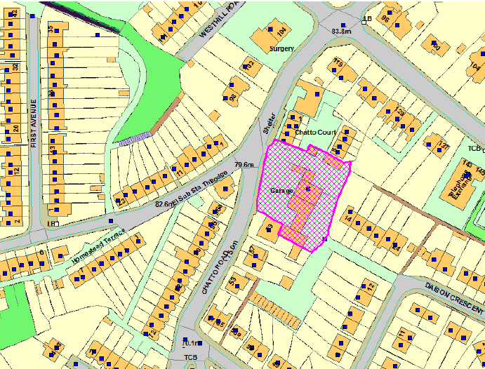
SUITABILITY ASSESSMENT: STAGE A

Strategic potential: No
Housing? | Yes
Employment? | No
Other Use? | Yes – Class E (other than main town centre uses), C2, B2, B8
Biodiversity- Within SAC/SSSI | None
Flood Zone 3b | No
Other NPPF Showstoppers (not policy constraints) | None
Conclusion | Suitable if available

SUITABILITY ASSESSMENT: STAGE B

Access | Unclassified road, access opposite a junction but in use as existing access for garage.
Flood risk, water quality and drainage | N/A
Heritage and Archaeology (including distance from assets). | N/A
Infrastructure | N/A
Landscape | N/A
Ecology | N/A
Safety related constraints | Land contamination – garage.
Soils (Agricultural Land classification) and contamination | N/A
Local Plan | CDST11
Neighbourhood Plan | N/A
Development progress (where relevant) | P/2009/0422  P/2012/0078
Other
HELAA Panel Summary | To be completed later
Site potential | Leave blank until after HELAA Panel

AVAILABILITY ASSESSMENT
Reasonable prospect of delivery (timescale):
The next 5 years | Yield 15
A 6-10 year period
An 11-15 year period
Later than 15 years

