SITE OVERVIEW: Yellow site – minor constraints
Town Torquay
Site Name Hatchcombe Lane AKA Land adj Beechfield Avenue and Beechfield Place
HELAA Reference no. | 21T129
Customer Reference no.
Source of Site (call for sites, Local Plan allocation etc.). | Committed site. CDST4
Current use | Field (committed development land)
Site descriptions | Land north of Beechfield Avenue and south of Hatchcombe Lane,
Total site area (ha)
Gross site area (ha)
Approx. yield | 50 dwellings as per planning permission.
Map

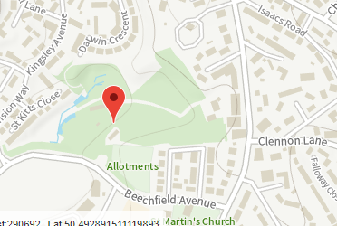
SUITABILITY ASSESSMENT: STAGE A

Strategic potential: 50+ dwellings
Housing? | Yes – with contribution for employment
Employment? | B Class
Other Use? | Retail/G&T/C2
Biodiversity- Within SAC/SSSI | Ecology report will be needed, but no showstopping issues expected
Flood Zone 3b | No
Other NPPF Showstoppers (not policy constraints) | No
Conclusion | Site had permission in 2010. New planning application in preparation.

SUITABILITY ASSESSMENT: STAGE B

Access | Access head is in existence from Beechfield Ave
Flood risk, water quality and drainage | No significant constraints
Heritage and Archaeology (including distance from assets). | No significant constraints
Infrastructure | Highways:  Education: IF PARTICULAR ISSUE eg C St M Sewer issue
Landscape | Landscape Sensitivity Level – AONB/ULPA/LCA
Ecology | LP – OSWI/CWS/SSSI etc. GHB/Cirl Buntings Sustenance Zone/Pinch Points
Safety related constraints
Soils (Agricultural Land classification) and contamination
Local Plan | Committed site CDST4
Neighbourhood Plan | Committed Site
Development progress (where relevant) | P/2008/1534 Formation of 46 dwellings Approved 10 March 2010  P/2010/0452 Formation of 50 dwellings approved 27/09/2011  Longstanding applicationd for residential P/1981/0156, P/2006/1340, P2008/1534  New application pending
Other
HELAA Panel Summary
Site potential

AVAILABILITY ASSESSMENT

The site promoter(s) has confirmed that the site will be available for development within:
The next 5 years
A 6-10 year period | 50
An 11-15 year period
Later than 15 years

