SITE OVERVIEW : Yellow site – minor constraints
Town | Torquay
Site Name | Land off Montserrat Rise
HELAA Reference no. | 21T128
Approx. yield | 10
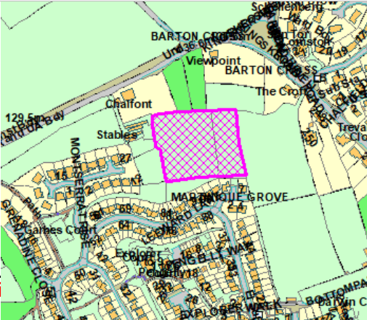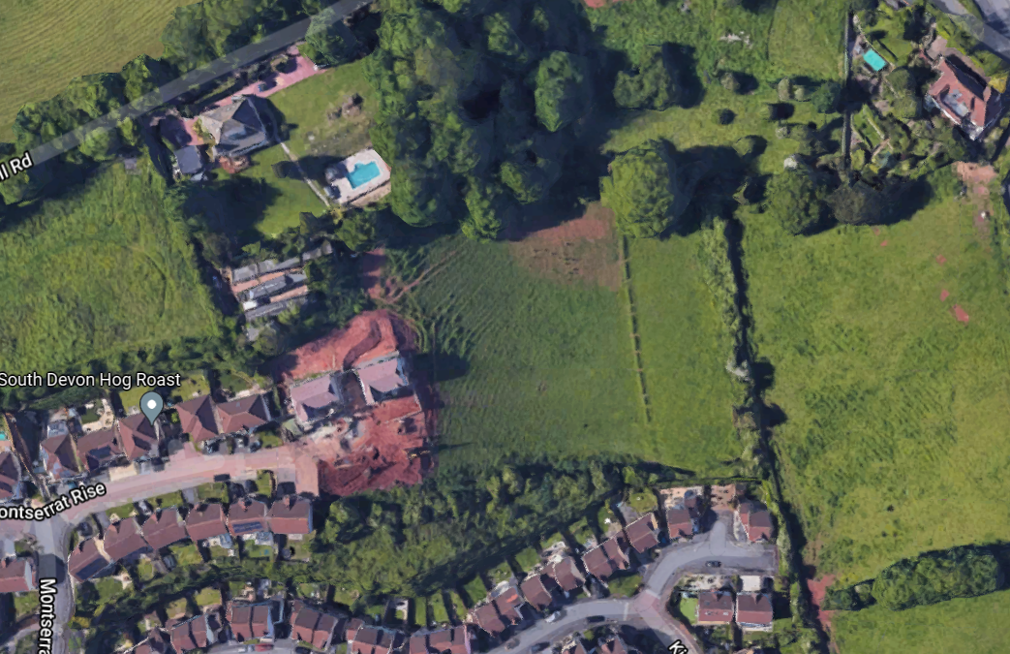
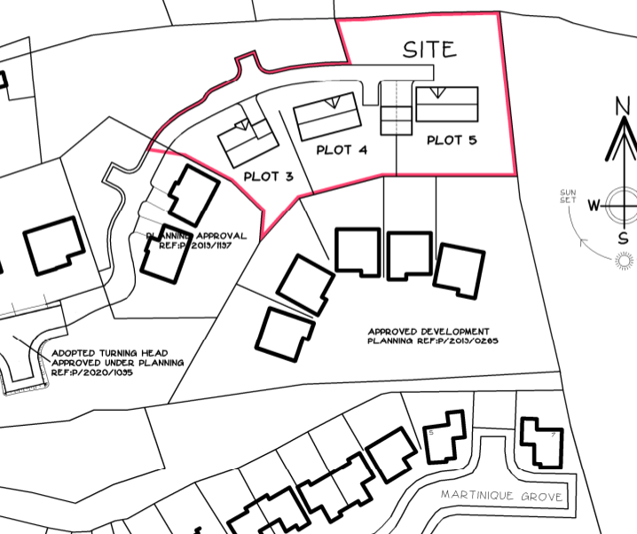
Suitable | The principle of residential development has been established through the granting of planning permissions in 2019, 2020 and 2021.
Available | Yes.
Achievable | Due to the steepness of the land, it is likely that the capacity of the site would be slightly lower than typically expected for 0.5ha. Space needed for an internal access road and possibly retaining structures.
Customer Reference no.
Source of Site (call for sites, Local Plan allocation etc.).
Current use | Agricultural fields.
Site descriptions | The site comprises a steeply sloping area of land which forms part of a roughly square semi-improved grassland field to the east of Montserrat Rise on the northern edge of Torquay. Access to the site is via a private driveway off Monserrat Rise. The site is partly within an Urban Landscape Protection Area (ULPA). To the east of the site there are further fields which extend down to the south and this land is allocated for possible future housing development.
Total site area (ha) | Approx. 0.7ha
Gross site area (ha) | Approx. 0.56ha

SUITABILITY ASSESSMENT: STAGE A

Strategic potential: | No
Housing? | Yes
Employment? | No
Other Use? | No
Biodiversity- Within SAC/SSSI | No
Flood Zone 3b | No
Other NPPF Showstoppers (not policy constraints) | None

SUITABILITY ASSESSMENT: STAGE B

Access | Via Montserrat Rise – Private road which is not currently at adoptable standards
Flood risk, water quality and drainage | No
Heritage and Archaeology (including distance from assets). | No significant heritage constraints.
Infrastructure | The site is located at the edge of the built-up area with access to infrastructure connections.
Landscape | The part of the site is within the Scotts Bridge/Barton Urban Landscape Protection Area.
Ecology | The site is located within the Consultation Zones for Cirl Buntings and for Greater Crested Newts.
Safety related constraints | No
Soils (Agricultural Land classification) and contamination
Local Plan | Urban Landscape Protection Area (Policy C5)  Trees, hedgerows and natural landscape features (Policy C4)  Biodiversity and Geodiversity (Policy NC1)
Neighbourhood Plan | Green Corridors (Policy TE4)
Development progress (where relevant) | Extant planning permissions:  P/2021/600 – 3 dwellings; P/2020/1095 2 dwellings; P/2019/1197 – 2 dwellings , P/2019/0265 – 5 dwellings P/2018/0992 and P/2106/0787 “ erection of dwelling”
Other
HELAA Panel Summary
Site potential

AVAILABILITY ASSESSMENT
Reasonable prospect of delivery (timescale):

The next 5 years | 10
A 6-10 year period
An 11-15 year period
Later than 15 years

