SITE OVERVIEW: Yellow site – minor constraints
Town: Torquay
Site Name: Sheddon Hall Hotel
HELAA Reference no. | Torquay NP allocated site TNP32  DE/2020/0079
Customer Reference no.
Source of Site (call for sites, Local Plan allocation etc.). | Pre app for 35 apartments
Current use | Partly vacant site following destruction of derelict Victorian building in a fire in 2019.
Site descriptions | Former Victorian Villa and hotel on west side of Sheddon Hill.
Total site area (ha)
Gross site area (ha)
Approx. yield | 14
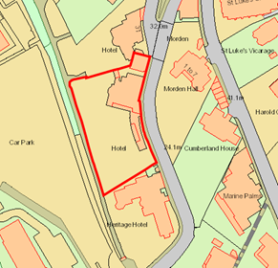
SUITABILITY ASSESSMENT: STAGE A

Strategic potential: 50+ dwellings
Housing? | Housing or hotel/leisure
Employment?
Other Use? | Leisure/hotel
Biodiversity- Within SAC/SSSI
Flood Zone 3b | No
Other NPPF Showstoppers (not policy constraints) | No
Conclusion | Sustainable urban brownfield site. Should permission require reinstatement of historic building form; or could a larger building be developed circa 35 apartments?

SUITABILITY ASSESSMENT: STAGE B

Access | Access from Sheddon Hill Road, or limited pedestrian access from rear lane
Flood risk, water quality and drainage | No
Heritage and Archaeology (including distance from assets). | Belgravia Conservation Area. Former Victorian Villa that became vacant and derelict circa 2012 and derelict and seriously fire damaged in 2019.
Infrastructure | No significant issues –urban site
Landscape | Significant site within CA
Ecology | Turkey Oak on site
Safety related constraints
Soils (Agricultural Land classification) and contamination | Not agricultural land
Local Plan | TNPH36
Neighbourhood Plan | TNP32 – allocated for 14 dwellings
Development progress (where relevant) | P/2016/0305- demolition of later additions and 11 dwellings, approved 31 May 2017  P/2011/0227 – 7 flats and 7 apartments in new build block. Approved 3 May 2013.  DE/2020/0079 -35 apartments
Other
HELAA Panel Summary
Site potential

AVAILABILITY ASSESSMENT

The site promoter(s) has confirmed that the site will be available for development within:
The next 5 years
A 6-10 year period | 14
An 11-15 year period
Later than 15 years

