SITE OVERVIEW: Yellow site – minor constraints
Town | Torquay
Site Name | R/O Edinburgh Villas, off McKay Avenue & Newton Road
Site Description | Vacant site
Total site area (ha) | 0.29ha
Map (if needed)
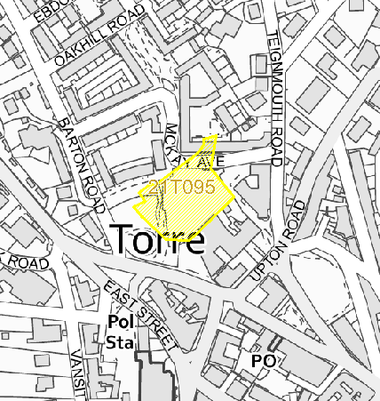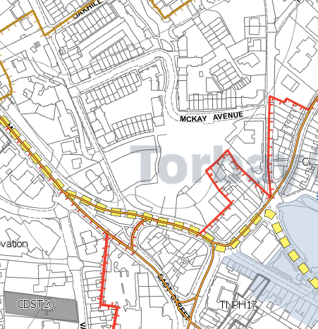

HELAA Reference no. | 2021T095
Approx. yield | 75
Suitable: Previous assessment of suitability | P/2012/1264: Development of site comprising 25 Retirement Living Apartments and 50 Assisted Living Extra Care Apartments with associated parking, landscaping and servicing and communal and care facilities.  Permission with Legal Agreement Feb 2013 (McCarthy & Stone)  Torre Marine, Torquay P/2016/1047 | Construction of new building to provide up to 75 one and two bedroom apartments. | Land At Barton Road Torquay permission 17.11.17 Committee Report:
Any Change in circumstances to consider suitable? | Yes 2012 application by McCarthy & Stone. Site now owned TBC. Taken forward by TDA/Tor Vista on 5YLS
Available? | yes
Achievable | yes
Customer Reference no.
Current use | Vacant clear site
Assess in 2021 HELAA? | 75 units identified in 5YLS 23/24

AVAILABILITY ASSESSMENT
Reasonable prospect of delivery (timescale):

75 units (P/2016/1047 permitted 17.11.17). Site has extant planning permission for a flatted development. Likely to start on site within the next financial year. Council owned. SJ (TDA) advised appl will be for 78 units. 75 used due to previous permitted apps at this level.
The next 5 years | 0
A 6-10 year period | 75
An 11-15 year period
Later than 15 years

