SITE OVERVIEW: Yellow site – minor constraints
Town | Torquay
Site Name | Imperial Hotel, Park Hill Road
Allocation or HELAA Reference no. | 21T093  Planning application P/2021/0120
Approx. yield | 50
Suitable: How the principle of development is established | Suitable in principle: brownfield site close to town centre. Conservation and coastal ecology issues.  51 apartments are being promoted as part of refurbishment of hotel. There are objections on amenity grounds and hence the site cannot be “green” until these are properly considered through the planning application.
Available: Any change in circumstances since principle established | Application being pursued (P/2021/0120) so good evidence of availability.
Achievable | Yes- being promoted by the owner. Part of a scheme to renovate the hotel.
Customer Reference no. | P/2021/0120
Current use | Hotel
Site description | Imperial Hotel
Total site area (ha) | 2.47ha
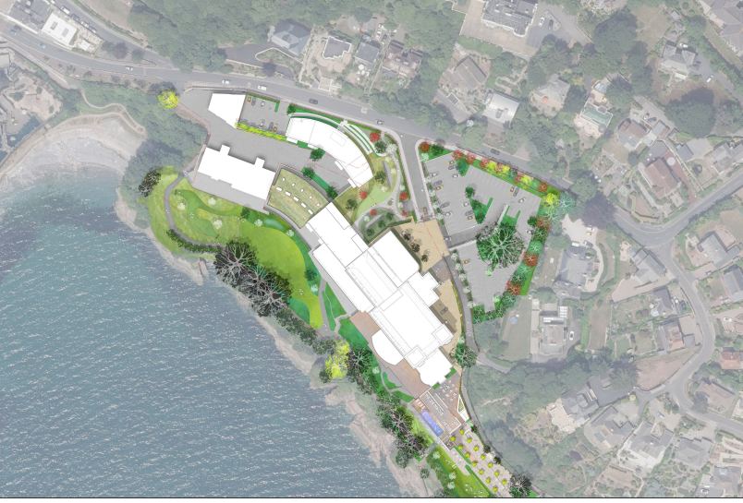

AVAILABILITY ASSESSMENT
Reasonable prospect of delivery (timescale):

Confirmation of availability needed from owners.
The next 5 years
A 6-10 year period | 50
An 11-15 year period
Later than 15 years

