SITE OVERVIEW: Yellow site – minor constraints
Town | Torquay
Site Name | Former St Georges Hall (Working Links) , Lower Union Lane
Allocation or HELAA Reference no. | 21T084
Approx. yield | 6
Suitable: How the principle of development is established | Yes - very sustainable town centre site.
Available: Any change in circumstances since principle established | Not clear – knowledge site. Not being actively promoted
Achievable | Yes. Need to include flood resilience on ground floor but otherwise a very sustainable site.
Customer Reference no.
Current use | Class E (p/2009/0950: change of use to employment agency.
Site description | Former Hall/ job centre/shop off Union Street.
Total site area (ha) | 0.01
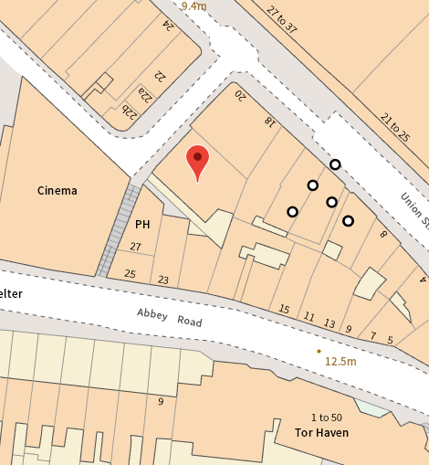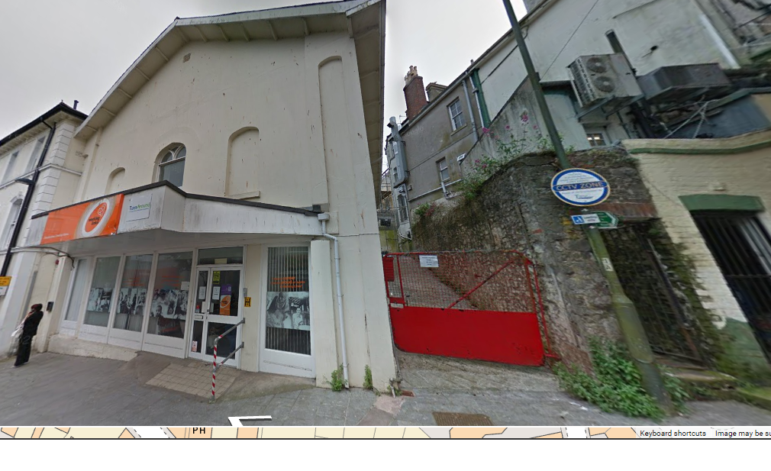

AVAILABILITY ASSESSMENT
Reasonable prospect of delivery (timescale):

Confirmation of availability needed from owners.
The next 5 years
A 6-10 year period | 6
An 11-15 year period
Later than 15 years

