SITE OVERVIEW: Yellow site – minor constraints
Town | Torquay
Site Name | Babbacombe Business Park, Babbacombe Road
HELAA Reference no. | 21T072
Approx. yield | 12
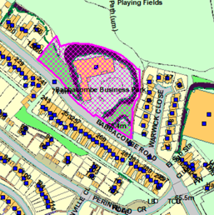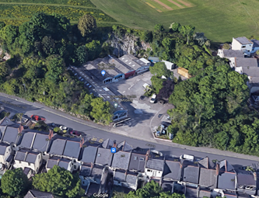
Suitable | Yes, the site is in a sustainable location with respect to local amenities, public open space, and bus stops, and is suitable for residential redevelopment subject to assessment and any necessary mitigation of impacts on geology and ecology.
Available | Notwithstanding that there is an existing retail use operating from the site, given that there has recently been a pre-app for redevelopment of the site for residential (either open market or older persons’ housing), the site would appear to be available.  The site also hosts telecommunication apparatus.
Achievable | Yes.
Customer Reference no.
Source of Site (call for sites, Local Plan allocation etc.). | Pre Apps Pending Consideration
Current use | Retail
Site descriptions | A small business park located within a former quarry at the northeastern edge of Torquay’s built up area, accessed from Babbacombe Road. The business park comprises of single storey warehouse structures currently in retail use, with an area of hardstanding for vehicular parking. The site is bounded by sections of rockface with mature trees and shrubs.
Total site area (ha) | Total site area = approx. 0.58ha  Developable area = approx. 0.27ha
Gross site area (ha)

SUITABILITY ASSESSMENT: STAGE A

Strategic potential: | No
Housing? | Yes
Employment? | Yes – the site could continue to be used for commercial uses.
Other Use? | Social housing, older persons’ housing.
Biodiversity- Within SAC/SSSI | No, although the Walls Hill SSSI is located approximately 100m to the east.
Flood Zone 3b | No
Other NPPF Showstoppers (not policy constraints) | None

SUITABILITY ASSESSMENT: STAGE B

Access | Existing site access onto Babbacombe Road. The width of this part of Babbacombe Road is constrained by on-street parking along the southern side of the road, and there is a bus stop opposite the site access. There is a pedestrian footpath along the eastern site boundary leading from Babbacombe Road to Walls Hill.
Flood risk, water quality and drainage | Surface water flood risks along Babbacombe Road adjacent to the site.
Heritage and Archaeology (including distance from assets). | The ‘Prehistoric Field System at Walls Hill’, located approximately 200m to the east, is a Scheduled Monument.  The site may to some extent form part of the broader setting of the Babbacombe Downs Conservation Area.  Given the site’s previous use as a pottery, the site may have some potential archaeological significance. Former quarry, but unquarried areas, if affected, require evaluation to inform programme of archaeological mitigation.
Infrastructure | The site forms part of the built up area and has existing infrastructure connections.
Landscape | In terms of the Torbay Landscape Character Assessment, the site is located within the built up area but close to the Landscape Character Type 5: Open Coastal Plateau.  The northern site boundary abuts the ‘Undeveloped Coast’ designation, and any impact on the coastal landscape (including in terms of views from Walls Hill and the South West Coast Path) would need to be carefully considered.
Ecology | Need for a geological survey to assess the geological value of the site in relation to the UNESCO Geopark.  The Hopes Nose to Walls Hill SSSI is located approximately 100m to the east, and the land immediately to the north is the Walls Hill ‘Unconfirmed Wildlife Site’.  Demolition/redevelopment would need to be subject to a Bat and Breeding Bird Survey.
Safety related constraints | Highway safety would need to be carefully considered as part of the design of the site access due to the constrained width of this part of Babbacombe Road as well as the location of the bus stop.
Soils (Agricultural Land classification) and contamination | Contamination is a possibility, however given that the site was formerly a pottery and has subsequently been predominantly in retail use, this is less likely to be a significant constraint.
Local Plan | While the site itself is not subject to any specific Local Plan designations, the adjacent land at Walls Hill is subject to:  - Policy SS10 (in relation to the scheduled monument)  - Policy NC1 (in relation to the SSSI and the Unconfirmed Wildlife Site)  - Policy C2 (Undeveloped Coast)
Neighbourhood Plan | Not subject to any specific designations in terms of the Torquay Neighbourhood Plan, although Walls Hill to the north is a Local Green Space (Policy TE2).
Development progress (where relevant) | Pre-app was submitted on 06.03.2020:  DE/2020/0024: Change of use to approximately 30 residential units (open market and age restricted options).  The written response to the pre-app indicated a preference for open market residential units (as opposed to age restricted), recommended a reduction in the number of units (so as to enable sufficient space for outdoor amenity space and for on-site parking and manoeuvring), and recommended more of a mix of tenures (as opposed to solely 1 and 2-bedroom flats as proposed in the pre-app).
Other
HELAA Panel Summary
Site potential

AVAILABILITY ASSESSMENT
Reasonable prospect of delivery (timescale):

The next 5 years
A 6-10 year period | 12
An 11-15 year period
Later than 15 years

