SITE OVERVIEW: Yellow site – minor constraints
Town | Torquay
Site Name | Central Cinema  29 Abbey Road  Torquay  TQ2 5NQ
HELAA Reference no. | P/2019/0359
Approx. yield | 12
Suitable | Yes
Available | No currently- depends upon replcement site on Union Street.
Achievable | If it becomes available
Customer Reference no.
Source of Site (call for sites, Local Plan allocation etc.). | Withdrawn application/knowledge site
Current use | Cinema
Site descriptions | Central Cinema, Abbey Road, Torquay
Total site area (ha) | 0.7ha Floor area stated as 740 sq m
Gross site area (ha)
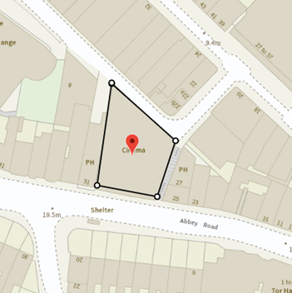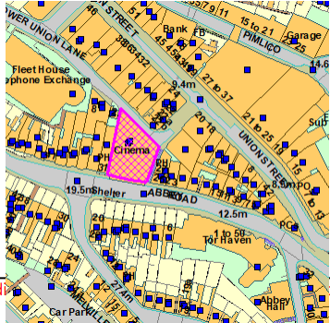
SUITABILITY ASSESSMENT: STAGE A

Strategic potential: | No
Housing? | Yes- redevelopment as apartments.
Employment? | Within Class E
Other Use? | Yes – Class E
Biodiversity- Within SAC/SSSI | No –town centre site
Flood Zone 3b | No- but flooding issues on the rear (Union Street side) of the site.
Other NPPF Showstoppers (not policy constraints) | None
Conclusion | Suitable if available

SUITABILITY ASSESSMENT: STAGE B

Access | Via Lower Union Lane
Flood risk, water quality and drainage | Part of site falls within surface water flooding area
Heritage and Archaeology (including distance from assets). | Abbey Road CA. Main issue is likely to be whether the building needs to be retained or could be redeveloped. Likely that the early C20th façade should be retained. The Conservation Area Appraisal (Hal Bishop, 2005) notes the building as being 1870-1915 (and mapped but not photographed or described as being of architectural importance).  Next door building no.37 Abbey Road is a Grade 2 Listed Building
Infrastructure | Within built up area.
Landscape | No – built up area.
Ecology | Urban brownfield site.
Safety related constraints | No
Soils (Agricultural Land classification) and contamination | Need Mapinfo to check
Local Plan | Torquay Town Centre, Abbey Road CA
Neighbourhood Plan | Torquay NP TS4 Support for brownfield sites
Development progress (where relevant) | P/2019/0359  DE/2019/0011  Conversion of exiting building to form flats.
Other
HELAA Panel Summary
Site potential

AVAILABILITY ASSESSMENT
Reasonable prospect of delivery (timescale):

Currently operating as a cinema. Would become available if Merlin Cinema relocate to Union Street.
Conversion could create circa 8 apartments. Redevelopment would make more efficient use of internal space and could create circa 15 apartments.

The next 5 years
A 6-10 year period | 8
An 11-15 year period
Later than 15 years

