SITE OVERVIEW: Yellow site – minor constraints
Town Torquay
Site Hatfield House, Hatfield Cross
HELAA Reference no. | 21T069  DE/2018/0070
Customer Reference no.
Source of Site (call for sites, Local Plan allocation etc.). | Pre-app
Current use | Site of Care home and Registered Provider’s Offices (Westcountry). Site now demolished.
Site descriptions | Vacant site, former Westcountry Offices and associated sheltered units. Site history suggests Class C2 (care home)
Total site area (ha) | 0.63 ha
Gross site area (ha)
Approx. yield | As per pre-app 50 units - 19 net
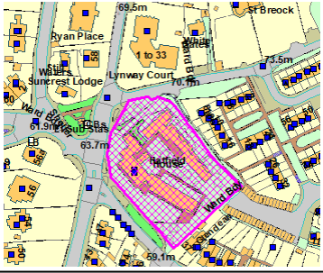
SUITABILITY ASSESSMENT: STAGE A

Strategic potential: 50+ dwellings
Housing? | Yes
Employment? | Offices as part of mixed use development.
Other Use?
Biodiversity- Within SAC/SSSI | No
Flood Zone 3b | No
Other NPPF Showstoppers (not policy constraints) | No
Conclusion | Brownfield redevelopment of existing residential site.

SUITABILITY ASSESSMENT: STAGE B

Access | Existing accesses on Hatfield Road and Bronshill Road.
Flood risk, water quality and drainage | Flood risk zone 1.
Heritage and Archaeology (including distance from assets). | Not significant. Adjacent Upton CA is on the W side of St Marychurch Road.
Infrastructure | Urban brownfield site
Landscape | Not significant
Ecology | Not significant
Safety related constraints | Not significant
Soils (Agricultural Land classification) and contamination | Not agricultural
Local Plan | Community Investment Area
Neighbourhood Plan | No specific proposalsd – TH5 – Sustainable later life homes, TH8 may be relevant in relation to height.
Development progress (where relevant) | DE/2018/0070 Redevelopment of 21 apartments and office building with 50 affordable dwellings and associated access and parking. ZP/01/10/2019  2006/0331 Formation of additional office .
Other
HELAA Panel Summary
Site potential | 50 aparments minus 31 = 19 net new

AVAILABILITY ASSESSMENT

The site promoter(s) has confirmed that the site will be available for development within:
The next 5 years
A 6-10 year period | 19 (net)
An 11-15 year period
Later than 15 years

