SITE OVERVIEW: Yellow Site – minor constraints
Town Torquay
Site Name Sladnor Park, Maidencombe
HELAA Reference no. | 21T064  ZP/1888/0024
Customer Reference no. | Leave Blank for now
Source of Site (call for sites, Local Plan allocation etc.). | Call for sites
Current use | Vacant former holiday camp
Site descriptions | Former holiday camp and estate on the east side of Teignmouth Road, Maidencombe. The holiday use ceased in the late 1980s and the site is predominantly greenfield due to the passage of time.
Total site area (ha) | 22 ha
Gross site area (ha) | 22ha
Approx. yield | 120 units (and care home?)
Map
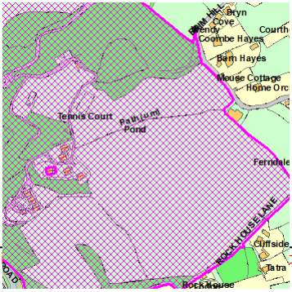

SUITABILITY ASSESSMENT: STAGE A

Strategic potential: 50+ dwellings
Housing?
Employment? | B Class
Other Use? | Retail/G&T/C2
Biodiversity- Within SAC/SSSI | TPOs
Flood Zone 3b | Small part of the site
Other NPPF Showstoppers (not policy constraints)
Conclusion

SUITABILITY ASSESSMENT: STAGE B

Access | Existing access off Teignmouth Road (A379). Potential for secondary access from Rock House Lane.
Flood risk, water quality and drainage | Some drainage issues on the site. Drainage and flood risk cited as a reason for refusal of P/2018/1053 , but previous permissions on the site.
Heritage and Archaeology (including distance from assets). | Listed buildings and Maidencombe Conservation Area in the vicinity. On-site Scandinavian style lodges and c19th folly are unlisted heritage assets.  Archaeology: Potential for medieval archaeology. Requires programme of archaeological mitigation.
Infrastructure | Healthcare/NHS  Drainage/ sewerage infrastructure needed.
Landscape | Landscape Sensitivity Level – Undeveloped coast. Landscape Character Assessment AOLC8B Maidencombe: “highly sensitive”.  Extensive tree cover and TPOs on site.
Ecology | LP – OSWI/CWS/SSSI etc. GHB/Cirl Buntings Sustenance Zone/Pinch Points
Safety related constraints | No
Soils (Agricultural Land classification) and contamination | Not agricultural land
Local Plan | C1 Countryside area –outside a Future Growth Area (SS2)  C2 undeveloped coast  OSWI – SS8 and NC1
Neighbourhood Plan | TH12 Maidencombe- the site is outside of the Village Envelope.
Development progress (where relevant) | Extensive Planning history:  AP/2020/0042 Lawfulness of commencement of 188 unit retirement village (P/2008/1418 and P/2009/0240/MRM dismissed. 3/03/2021) Application P/2020/0315  P/2018/1053 Continuing care retirement village (149 units) refused 7 January 2021.  P/2007/1410 Retirement Village (116 units +90 bed care home) Approved 29/11/2007  P/2006/0474 outline approval for care village approved 21/06/2006.
Other
HELAA Panel Summary | Maidencombe Residents Association will be in opposition to this site.  Lack of pavements for pedestrians along public highway.  Rural character, but schools and amenities are relatively close by.  Potential for rural exception site.  Discussions regarding affordable housing – some noted the limited suitability for households that are not car owners, others countered that affordable housing caters to a broad range of housing needs including some households that would own cars.  Issue of foul drainage is a challenge but not insurmountable.
Site potential

AVAILABILITY ASSESSMENT

The site promoter(s) has confirmed that the site will be available for development within:
The next 5 years
A 6-10 year period | Circa 130 units- if principle of development accepted.
An 11-15 year period
Later than 15 years

