SITE OVERVIEW: Yellow site - minor constraints
Town | Torquay
Site Name | Conway Court Hotel
HELAA Reference no. | 21T060  CDST31 / T807
Customer Reference no.
Source of Site (call for sites, Local Plan allocation etc.). | NP Sites
Current use | Vacant land. Formerly a hotel.
Site descriptions | Site is vacant and overgrown following the demolition of the previous hotel after fire damage in 2011.
Total site area (ha)
Gross site area (ha)
Approx. yield | 14
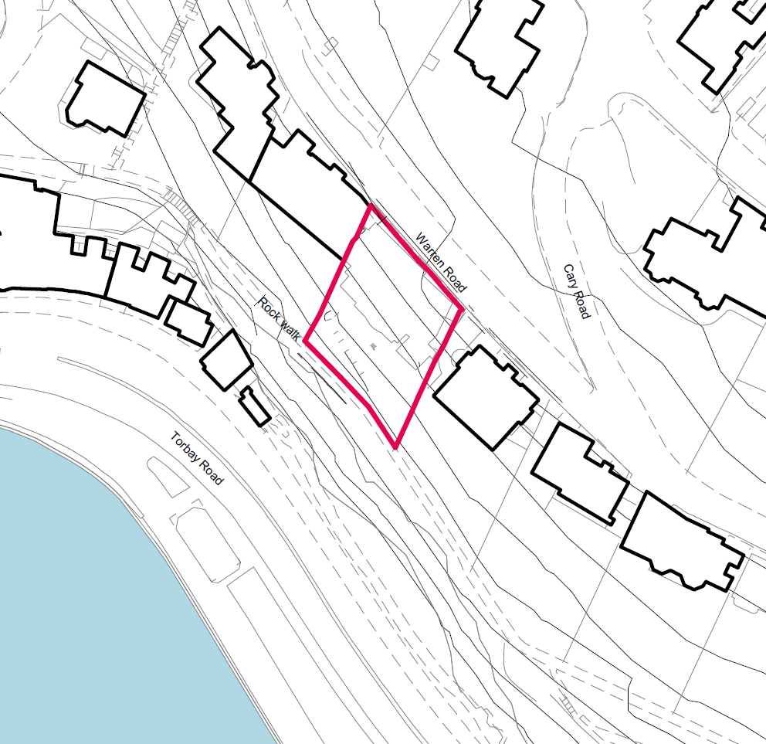
SUITABILITY ASSESSMENT: STAGE A

Strategic potential: No
Housing? | 14
Employment? | No
Other Use?
Biodiversity- Within SAC/SSSI | No
Flood Zone 3b | No
Other NPPF Showstoppers (not policy constraints)
Conclusion

SUITABILITY ASSESSMENT: STAGE B

Access | Good access onto Warren Road. The width of Warren Road is somewhat constrained by on-site parking along one side of Warren Road.
Flood risk, water quality and drainage | None.
Heritage and Archaeology (including distance from assets). | Located within Belgravia Conservation Area. Adjacent land to the southwest is Historic Park & Garden (Princess and Royal Terrace Gardens).
Infrastructure
Landscape | None.
Ecology | None.
Safety related constraints | None.
Soils (Agricultural Land classification) and contamination
Local Plan | Community Investment Area – see Policy SS11.  Site is located outside of, but adjacent to, the Core Tourism Investment Area which is to the southwest.
Neighbourhood Plan
Development progress (where relevant) | P/2020/0925 - Formation of 14 apartments with car parking and vehicular/pedestrian access (as revised by plans received 15.03.2021). Approved.  P/2010/1080 - Demolition of hotel and formation of 14 residential apartments with car parking and vehicular/ pedestrian access. Approved.
Other
HELAA Panel Summary
Site potential

AVAILABILITY ASSESSMENT

The site promoter(s) has confirmed that the site will be available for development within:
The next 5 years | 14
A 6-10 year period
An 11-15 year period
Later than 15 years

