SITE OVERVIEW: Yellow site – minor constraints
Town | TORQUAY
Site Name | Bancourt Hotel, Avenue Road
HELAA Reference no. | 21T054,  NP04
Approx. yield | 10
Suitable | Yes
Available | Appears available – recent sale, allocated in NP
Achievable | Yes
Customer Reference no.
Source of Site (call for sites, Local Plan allocation etc.). | NP Allocation
Current use | Vacant hotel
Site descriptions | Vacant hotel located on south east side of Avenue Road to the south of Vine Road.
Total site area (ha) | 0.23
Gross site area (ha) | 0.23
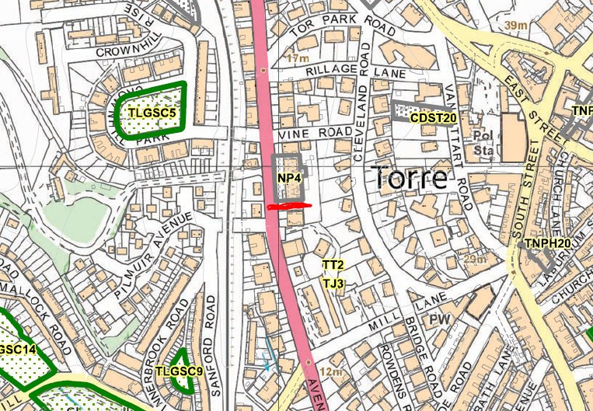
SUITABILITY ASSESSMENT: STAGE A

Strategic potential: No
Housing? | Yes
Employment? | No
Other Use? | Yes – Class E
Biodiversity- Within SAC/SSSI | No
Flood Zone 3b | No – front of site (car park) in SW flooding area
Other NPPF Showstoppers (not policy constraints) | None
Conclusion | Suitable if available

SUITABILITY ASSESSMENT: STAGE B

Access | Avenue Road
Flood risk, water quality and drainage | Part of site falls within surface water flooding area
Heritage and Archaeology (including distance from assets). | Torre Conservation Area
Infrastructure | N/A
Landscape | N/A
Ecology | N/A
Safety related constraints | N/A
Soils (Agricultural Land classification) and contamination | N/A
Local Plan | Surface Water Flooding
Neighbourhood Plan | housing sites NP4
Development progress (where relevant) | No
Other
HELAA Panel Summary
Site potential

AVAILABILITY ASSESSMENT
Reasonable prospect of delivery (timescale):
The next 5 years
A 6-10 year period | 10
An 11-15 year period
Later than 15 years

