SITE OVERVIEW: Yellow – minor constraints
Town | Torquay
Site Name | Land adjacent to Broadley Drive, Livermead
HELAA Reference no. | 21T050
Approx. yield | 50
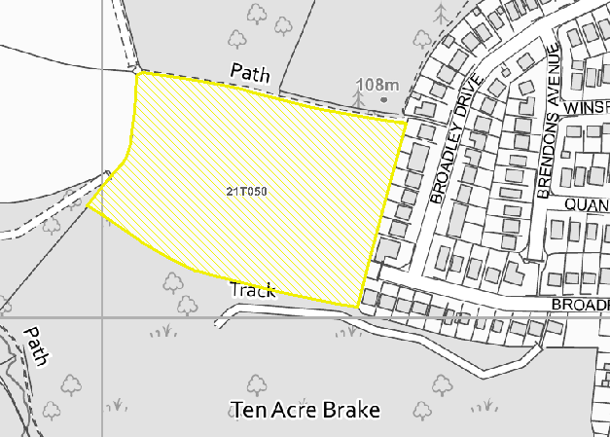
Suitable | While the site is located at the edge of the settlement boundary, it is within 10min walking distance of bus stops, a local shop and a primary school, and within 20min walking distance of the Preston District Centre. Subject to adequate mitigation of any ecological impacts, the site is considered suitable for housing development.
Available | The site was promoted for development to this HELAA.
Achievable | Subject to successful resolution of the possible ransom strip, and subject to any necessary ecological mitigation, development of the site is likely to be achievable. The site received a favourable response from developers at the 2021 HELAA Panel.
Customer Reference no.
Source of Site (call for sites, Local Plan allocation etc.). | Call for Sites
Current use | Agriculture
Site descriptions | Agricultural field at the edge of the settlement to the rear of Nos. 99-113 Broadley at the top of Livermead, with Manscombe Wood to the north, Scadson Woods to the south, and an agricultural field to the west beyond a footpath which runs along the western boundary of the site. The western half of the site slopes fairly gently downhill towards the west, with the gradient becoming steeper towards the southwestern corner of the site.
Total site area (ha) | 3.19
Developable site area (ha)
SUITABILITY ASSESSMENT: STAGE A

Strategic potential | Yes
Housing? | Yes
Employment? | The site may have some limited potential to support employment uses, although the site is at the edge of a residential area and potentially not well located for employment uses.
Other Use? | Agriculture, food production. Older persons housing?
Biodiversity- Within SAC/SSSI | Within South Hams SAC Landscape Connectivity Zone, Cirl Bunting Consultation Zone, and Greater Crested Newt Consultation Zone.  Manscombe Plantation to the north of the site falls within Cockington Country Park and the Cockington Court Local Nature Reserve. The woodland to the south of the site falls within the Scadson/Ten Acre Brake Local Nature Reserve.
Flood Zone 3b | No
Other NPPF Showstoppers (not policy constraints) | No
Conclusion

SUITABILITY ASSESSMENT: STAGE B

Access | Access is possible from Broadpark Road (although this would potentially be subject to a ransom strip).
Flood risk, water quality and drainage | No significant constraints.
Heritage and Archaeology (including distance from assets). | Manscombe Wood to the north of the site falls within the Cockington Conservation Area, although this is unlikely to be a significant constraint to development (as the historic significance of the conservation area primarily derives from the buildings and grounds of Cockington Court).  There is a Grade II Listed barn approximately 250m to the northwest of the site, although visually separated from the site by Manscombe Wood.  The site has some archaeological potential and a programme of archaeological mitigation may be required.
Infrastructure | Access, drainage and sewage connections could be taken from the adjacent residential developed land to the east.
Landscape | Countryside area - LCA - Area of Local Character: Type 1G Rolling Farmland.  Devon Wide Landscape Character Type 3A: Upper Farmed & Wooded Valley Slopes.  Overall rated Moderately Sensitive in LCA. LCA Management Strategy: Conserve.  Landscape impact is lessened by partial screening due to adjacent woodland to the north and south.
Ecology | Located within the South Hams SAC GHB Landscape Connectivity Zone, the Greater Crested Newt Consultation Zone, and the Cirl Bunting Consultation Zone.  Manscombe Plantation to the north of the site falls within Cockington Country Park and the Cockington Court Local Nature Reserve. The woodland to the south of the site falls within the Scadson/Ten Acre Brake Local Nature Reserve.
Safety related constraints | No
Soils (Agricultural Land classification) and contamination | 3B Moderate limitations.
Local Plan | Potential housing site TNPH48 (Site identified in Table 26 of the Local Plan as a possible neighbourhood plan housing site, but not allocated in the Torquay Neighbourhood Plan)  Policy NC1 Biodiversity and geodiversity  Policy C1 Countryside and the rural economy  SS8 Natural environment
Neighbourhood Plan | Policy TS4 Support for brownfield and greenfield development  Policy TH4 Affordable homes from greenfield developments  Policy TH11 Rural village conservation areas (w.r.t. setting of Cockington Conservation Area)
Development progress (where relevant) | No
Other
HELAA Panel Summary | Strong support for this site from developers on the panel, although it was noted that there may be a ransom strip which would be a challenge with respect to deliverability.
Site potential | 50

AVAILABILITY ASSESSMENT
Reasonable prospect of delivery (timescale):

The next 5 years
A 6-10 year period | 50
An 11-15 year period
Later than 15 years

