SITE OVERVIEW: Yellow site – minor constraints
Town | Torquay
Site Name | Fleet Walk Shopping Centre
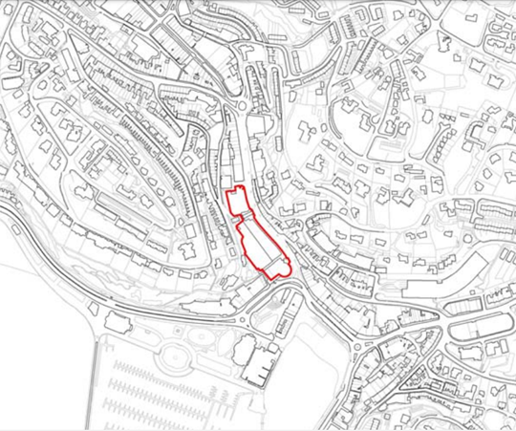
Allocation or HELAA Reference no. | 21T047  Map Site Label: TNPH43  Neighbourhood Plan Reference: TNPH39  SHLAA/Housing Land Monitor Reference: T766
Approx. yield | 25
Suitable: How the principle of development is established | The site is allocated in the Torquay Neighbourhood Plan for 25 units. The site is in a highly sustainable town centre location and is suitable for residential development subject to the retention of a retail frontage (as the front elevation forms part of the Secondary Shopping Frontage) and subject to a design that conserves/enhances the character of the Torquay Harbour Conservation Area. While the residential units would be likely to be on the upper floors, the site is exposed to flood risks which need to be addressed.
Available: Any change in circumstances since principle established | Subject to confirmation from the Torbay Development Agency, this Council-owned site is likely to be available.
Achievable | Yes.
Customer Reference no.
Current use | Retail
Site description | The site comprises a multi-storey shopping centre with car park in a prominent position in Torquay’s Town Centre, located at the corner of Fleet Street and Cary Parade. The site is located within the Primary Shopping Area and the front elevation forms part of the Secondary Shopping Frontage.
Total site area (ha) | Approximately 0.05ha.

AVAILABILITY ASSESSMENT
Reasonable prospect of delivery (timescale):

Confirmation of availability needed from owners. Planning permission would need to be sought given that the previous permission has lapsed.
The next 5 years
A 6-10 year period | 25
An 11-15 year period
Later than 15 years

