SITE OVERVIEW: Yellow site – minor constraints
Town | Torquay
Site Name | Adjacent to Abbey Hall, Rock Road
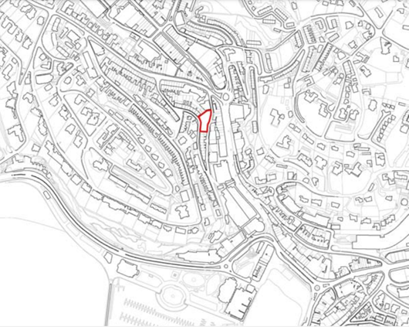
Allocation or HELAA Reference no. | 21T043  Map Site Label: TNPH37  Neighbourhood Plan Reference: TNPH33  SHLAA/Housing Land Monitor Reference: R149  Planning Application Reference: P/1986/2635 (29 flats, approved), P/1998/1891 (29 flats, approved)
Approx. yield | 15
Suitable: How the principle of development is established | The site has had planning permission (P/1986/2635 and P/1998/1891) for 29 flats, however the permissions have since expired. The site is allocated for 30 dwellings in the Torquay Neighbourhood Plan (reference TNPH33).  The site is in a highly sustainable location close to the town centre and is suitable for redevelopment subject to a design that conserves and enhances the character of the Abbey Road Conservation Area.  In the interests of ensuring a good standard of development amenity with a positive contribution to the creation of mixed and balanced communities within the Community Investment Area, the yield has been reduced to reflect an expectation for a smaller number of larger flats compared to the previous permission for the site.
Available: Any change in circumstances since principle established | Given the number of years the previous permissions, it is important to confirm whether or not the site remains available for development. Contact landowner to enquire.
Achievable | Yes if available, although the timescale will depend on viability and market demand.
Customer Reference no.
Current use | Vacant plot.
Site description | The site comprises a vacant plot of previously developed land sited between Melville Street (which forms the western boundary) and Rock Road (which forms the eastern boundary. Melville Street is at a much higher level than Rock Road, and there is a fairly steep vehicular access leading up to the plot from Rock Road supported by a stone retaining wall.
Total site area (ha) | Approximately 0.09ha.

AVAILABILITY ASSESSMENT
Reasonable prospect of delivery (timescale):

Confirmation of availability needed from owners. Planning permission would need to be sought given that the previous permission has lapsed.
The next 5 years
A 6-10 year period
An 11-15 year period | 15
Later than 15 years

