SITE OVERVIEW: Yellow site – minor constraints
Town | Torquay
Site Name | Pimlico
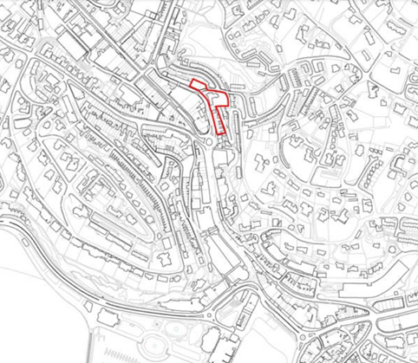
Allocation or HELAA Reference no. | 21T041  Map Site Label: TNPH34  Neighbourhood Plan Reference: TNPH30  SHLAA/Housing Land Monitor Reference: 13229
Approx. yield | 10
Suitable: How the principle of development is established | The site is allocated for 50 dwellings in the Torquay Neighbourhood Plan (reference TNPH30) however the projected yield has been reduced due to the lack of suitability/availability of parts of the site.  The site is in a highly sustainable location but is in an area with identified flood risks.  The row of terraced properties which comprises the southeastern part of the site dates from the 1850s, forms part of the Torquay Harbour Conservation Area, and is therefore unlikely to be suitable for redevelopment due to the impact on the conservation area.
Available: Any change in circumstances since principle established | The terraced row in the southeastern part of the site and the four storey building (‘Madrepore Place’) in the central part of the site are both already in residential use (with parts of the terraced row also having commercial uses at ground floor level), and are therefore not considered available for redevelopment. The landowner of the northwestern part of the site will need to be contacted to confirm availability.
Achievable | The site would appear to have limited viability for redevelopment in the current market but may be achievable in the future subject to an upturn in market demand.
Customer Reference no.
Current use | The building in the northwestern part of the site would appear to comprise of ancillary storage/warehousing serving nearby commercial premises, possibly vacant. The four storey building (‘Madrepore Place’) in the central part of the site is in residential use. The terraced row in the southeastern part of the site is in residential use with some properties also having commercial uses (mainly service uses) at ground floor level.
Site description | A stretch of developed land on the eastern side of Pimlico and Madrepore Road in Torquay’s Town Centre, comprising of a multi-storey, flat-roofed, utilitarian building to the north of the corner of Pimilico and Stentiford Hill Road, a four-storey, pitch-roofed, residential building to the southeast of the corner of Pimilico and Stentiford Hill Road, and an 1850s terraced row which rises up Madrepore Road behind a stone retaining wall.
Total site area (ha) | Approximately 0.35ha.

AVAILABILITY ASSESSMENT
Reasonable prospect of delivery (timescale):

Confirmation of availability needed from owners. Planning permission would need to be sought given that the previous permission has lapsed.
The next 5 years
A 6-10 year period
An 11-15 year period | 10
Later than 15 years

