SITE OVERVIEW: Yellow site – minor constraints
Town | Torquay
Site Name | 3-9 Pimlico, Torquay
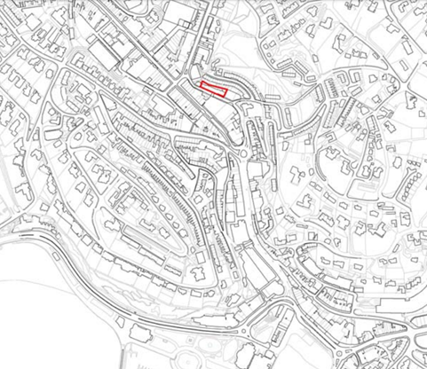
Allocation or HELAA Reference no. | 21T040  Map Site Label: TNPH33  Neighbourhood Plan Reference: TNPH29  SHLAA/Housing Land Monitor Reference: T801  Planning Application References (relating to the building on the western half of the site): P/2005/1423 (refused); P/2005/1841 (refused, appeal dismissed); P/2006/1964 (approved); DE/2012/0049 (negative response).
Approx. yield | 20
Suitable: How the principle of development is established | The western part of the site (comprising approximately one quarter of the site area) has had planning permission (P/2006/1964) for 11 flats, however the permission has since expired, and the units would not meet current dwelling space standards. The site is allocated for 10 dwellings in the Torquay Neighbourhood Plan (reference TNPH29). The site is in a highly sustainable location but is in an area with identified flood risks.
Available: Any change in circumstances since principle established | Given the number of years since the granting of P/2006/1964, it is important to confirm whether or not the site remains available for redevelopment. Ownership appears to have changed since previous consent, and it appears that the site may comprise of land owned by multiple separate landowners. Contact landowner(s) to enquire.
Achievable | The site would appear to have limited viability for redevelopment in the current market but may be achievable in the future subject to an upturn in market demand.
Customer Reference no.
Current use | Predominantly ancillary storage/warehousing serving nearby commercial premises, possibly vacant.
Site description | Two multi-storey, flat-roofed, utilitarian buildings in Torquay Town Centre fronting onto a one way road, with a steep hillside to the rear leading up to the rear elevation of a row of terraced houses. One of the buildings on the site has an elevated link over Pimlico to the commercial building to the south. (It should be noted that the abovementioned planning applications relate solely to the double-storey building comprising the western half of the site.)
Total site area (ha) | Approximately 0.08ha.

AVAILABILITY ASSESSMENT
Reasonable prospect of delivery (timescale):

Confirmation of availability needed from owners. Planning permission would need to be sought given that the previous permission has lapsed.
The next 5 years
A 6-10 year period
An 11-15 year period | 10
Later than 15 years | 10

