SITE OVERVIEW: Yellow site – minor constraints
Town | Torquay
Site Name | TNPH28 Site opposite Market, Market Street (former Blockbuster site)
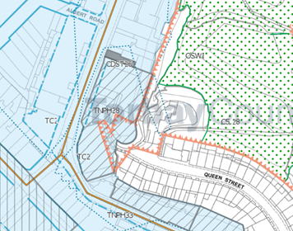
Allocation or HELAA Reference no. | 21T037  Houisng proposal TNPH28  13237
Approx. yield | 30 dwellings
Suitable: How the principle of development is established | Yes - Allocated site  Also within larger allocated area (reference TNPH22)
Available: Any change in circumstances since principle established | Old Morrison’s building appears to still be vacant – some of the retails units are in use including pet store.
Achievable | Achievable subject to availability.
Customer Reference no. | Leave Blank for now
Current use | Site comprises a vacant building previously in use as Morrison’s/blockbuster and a row of A1 units – some in use and some vacant – likely rented so could become vacant with 15yrs
Site description | The site is located at the southern end of Market street and includes a corner plot which adjoins Pimlico.
Total site area (ha) | 0.15

AVAILABILITY ASSESSMENT
Reasonable prospect of delivery (timescale):

Confirmation of availability needed from owners.
The next 5 years
A 6-10 year period
An 11-15 year period | 30
Later than 15 years

