SITE OVERVIEW: Yellow site – minor constraints
Town | Torquay
Site Name | Land Rear Of Market Street
Allocation or HELAA Reference no. | 21T034  Housing proposal TNPH24  NP ref – TNPH22  T887  CDST26
Approx. yield | 30 dwellings
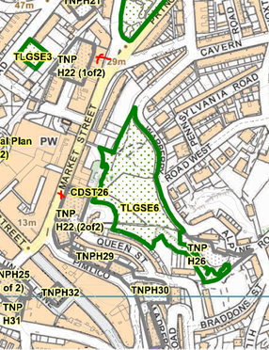
Suitable: How the principle of development is established | Yes - Allocated site
Available: Any change in circumstances since principle established | Old Morrison’s building appears to still be vacant – some of the retails units are in use including pet store.
Achievable | Achievable subject to availability.
Customer Reference no.
Current use | Two sites, one comprises a vacant building previously in use as Morrison’s/blockbuster and a row of A1 units – some in use and some vacant – likely rented so could become vacant with 15yrs  One a warehouse? – vacant shop / warehouse
Site description | Two sites, one is located at the southern end of Market street and includes a corner plot which adjoins Pimlico  The second site is located to the south of the Briary Lane and Ellacombe Rd junction to the rear of a terrace of buildings which front onto Market Street.
Total site area (ha) | 0.15 (blockbuster) and 0.07 (warehouse)

AVAILABILITY ASSESSMENT
Reasonable prospect of delivery (timescale):

Confirmation of availability needed from owners.
The next 5 years
A 6-10 year period
An 11-15 year period | 30– brownfield, no permission
Later than 15 years

