SITE OVERVIEW: Yellow site – minor constraints
Town | Torquay
Site Name | TNPH11 Quintaville, junction Reddenhill Road
Allocation or HELAA Reference no. | 21T023  Housing proposal TNPH11  TNPH10  13020
Approx. yield | 10 dwellings
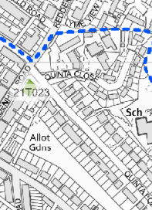
Suitable: How the principle of development is established | Yes - Allocated site
Available: Any change in circumstances since principle established | Building sold in 2020  P/2006/1374 | Demolition Of Residential Care Home And Erection Of 15 Self Contained Flats | Approved
Achievable | Achievable subject to availability.
Customer Reference no. | Leave Blank for now
Current use | A closed residential care home
Site description | The site comprises a three storey mansard roof property that is situated on the junction of Quinta Road and Reddenhill Road.
Total site area (ha) | 0.08

AVAILABILITY ASSESSMENT
Reasonable prospect of delivery (timescale):

Confirmation of availability needed from owners.
The next 5 years | 10
A 6-10 year period
An 11-15 year period
Later than 15 years

