SITE OVERVIEW: Yellow site – minor constraints
Town | Torquay
Site Name | TNPH8Site 1, Higher Cadewell Lane
Allocation or HELAA Reference no. | 21T021  Housing proposal TNPH8
Approx. yield | 18 dwellings
Suitable: How the principle of development is established | Yes - Allocated site
Available: Any change in circumstances since principle established | In use as parking spaces and garages – privately Owned  P/2018/1205 – refused on the grounds: The proposed development would result in a significant loss of parking spaces, which currently serve the existing residential area, where individual properties tend to lack parking spaces and there are extensive parking restrictions along the highway. The proposal is therefore likely to result in an unacceptable level of parking congestion, and have an unacceptable impact on the amenities of existing residents.  - 57 Letters of objection received
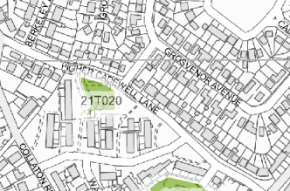
Achievable | Achievable subject to availability.
Customer Reference no.
Current use | Currently in use as parking spaces and garages
Site description | The site slopes gently from the south west to north east, away from the residential properties to the west and south. The majority of the site is hard surfaced, with landscaped boundaries (grass / fir trees). The site is accessed to the west via Larch Walk.
Total site area (ha) | 0.19

AVAILABILITY ASSESSMENT
Reasonable prospect of delivery (timescale):

Confirmation of availability needed from owners.
The next 5 years
A 6-10 year period | 18
An 11-15 year period
Later than 15 years

