SITE OVERVIEW: Yellow site – minor constraints
Town | Torquay
Site Name | TNPH7Site 2, Higher Cadewell Lane
Allocation or HELAA Reference no. | 21T020  Housing proposal TNPH7
Approx. yield | 12 dwellings
Suitable: How the principle of development is established | Yes - Allocated site
Available: Any change in circumstances since principle established | Currently in use as public green space – Council Owned  Unlikely any change in circumstance
Achievable | Achievable subject to availability.
Customer Reference no. | Leave Blank for now
Current use | Currently in use as public green space
Site description | Green space bound by residential properties located north of Wallace Avenue and south west of Higher Cadewell Lane residential area.
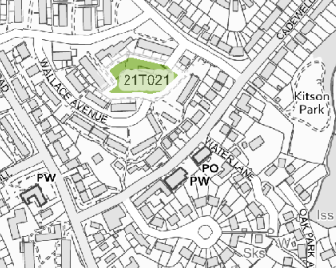
Total site area (ha) | 0.27

AVAILABILITY ASSESSMENT
Reasonable prospect of delivery (timescale):

Confirmation of availability needed from owners.
The next 5 years | 12 (possibly longer)
A 6-10 year period
An 11-15 year period
Later than 15 years

