SITE OVERVIEW: Yellow site – minor constraints
Town | Torquay
Site Name | 50/54 Swan Street
HELAA Reference no. | 21T014, C287 (SHLAA ref)
Approx. yield | 10
Suitable | Yes
Available | Yes – site appears vacant/derelict so assume available
Achievable | Yes
Customer Reference no.
Source of Site (call for sites, Local Plan allocation etc.). | Expired sites
Current use | Part of site in use as restaurant garden, unclear what the use of the remainder is.
Site descriptions | 50-54 Swan Street, Torquay
Total site area (ha) | 0.05
Gross site area (ha) | 0.05
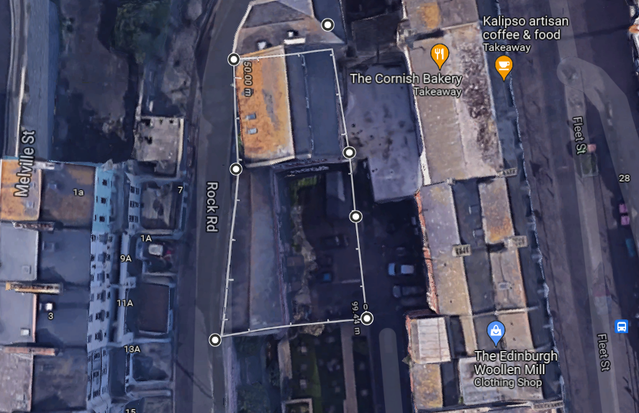

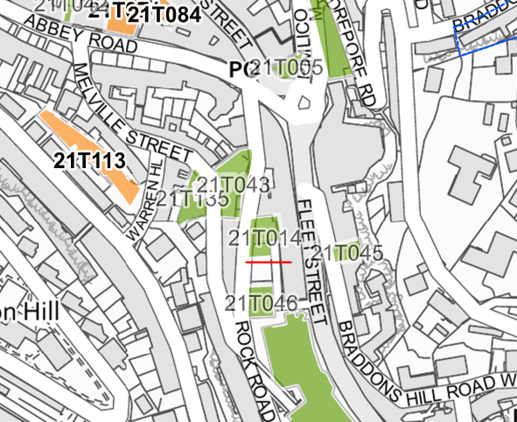

SUITABILITY ASSESSMENT: STAGE A

Strategic potential: | No
Housing? | Yes- redevelopment as town houses and apartments.
Employment? | Within Class E
Other Use? | Yes – Class E
Biodiversity- Within SAC/SSSI | No –town centre site
Flood Zone 3b | Small section of the site within flood zone
Other NPPF Showstoppers (not policy constraints) | None
Conclusion | Suitable if available

SUITABILITY ASSESSMENT: STAGE B

Access | Rock Road or Swan Street
Flood risk, water quality and drainage | Small part of site in flood zone
Heritage and Archaeology (including distance from assets). | COBURG PLACE grade II listed – on rock road adjacent to the site  Within conservation area
Infrastructure | Within built up area.
Landscape | No – built up area.
Ecology | Urban brownfield site.
Safety related constraints | No
Soils (Agricultural Land classification) and contamination | N/A
Local Plan | Torquay Town Centre, Torquay Harbour CA
Neighbourhood Plan | Torquay NP TS4 Support for brownfield sites
Development progress (where relevant) | P/2003/1002 – approved
Other
HELAA Panel Summary | To be completed later
Site potential | Leave blank until after HELAA Panel

AVAILABILITY ASSESSMENT
Reasonable prospect of delivery (timescale):

The next 5 years
A 6-10 year period | 10
An 11-15 year period
Later than 15 years

