SITE OVERVIEW: Review of Car Parks
Town | Torquay
Site Name | Brunswick Square Car Park
Site Description
Total site area (ha) | 0.23ha
Map (if needed)
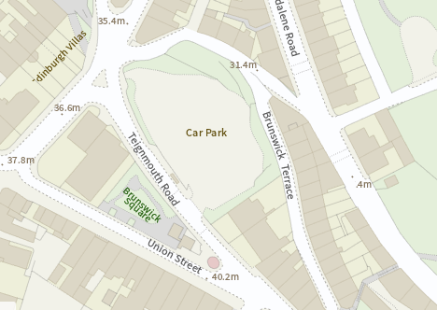

HELAA Reference no. | 21T114  HC105
Approx. yield | Up to 30 assessed in 2013 SHLAA
Suitable: Previous assessment of suitability | Scope to make use of space above existing car park.  Upton (?) Conservation Area
Any Change in circumstances to consider suitable?
Available?
Achievable
Customer Reference no.
Current use
Assess in 2021 HELAA?

AVAILABILITY ASSESSMENT
Reasonable prospect of delivery (timescale):

Confirmation of availability needed from owners.
The next 5 years
A 6-10 year period
An 11-15 year period
Later than 15 years | 30

