SITE OVERVIEW: Review of car parks
Town Torquay
Site Sheddon Hill Car Park
HELAA Reference no. | 21T076  HC076
Customer Reference no.
Source of Site (call for sites, Local Plan allocation etc.). | “Below the line” site considered at Local Plan review.
Current use | Car park
Site descriptions | Car park on north side of Sheddon Hill
Total site area (ha) | 0.2 ha at top of site
Gross site area (ha)
Approx. yield
Map
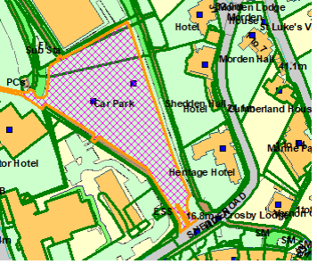

SUITABILITY ASSESSMENT: STAGE A

Strategic potential: 50+ dwellings
Housing?
Employment?
Other Use?
Biodiversity- Within SAC/SSSI
Flood Zone 3b
Other NPPF Showstoppers (not policy constraints)
Conclusion

SUITABILITY ASSESSMENT: STAGE B

Access | Access would need to be across Sheddon Hill Car park. Would be subject to the need for parking.
Flood risk, water quality and drainage | No
Heritage and Archaeology (including distance from assets). | Belgravia CA  Proximity to Torre Abbey Scheduled Monument. May require programme of archaeological mitigation.
Infrastructure | Urban site
Landscape | |No
Ecology | Not likely to be significant
Safety related constraints | Access needs to go across car park
Soils (Agricultural Land classification) and contamination | Not agricultural land
Local Plan
Neighbourhood Plan
Development progress (where relevant)
Other
HELAA Panel Summary
Site potential | 10 town houses or apartments

AVAILABILITY ASSESSMENT

The site promoter(s) has confirmed that the site will be available for development within:
The next 5 years
A 6-10 year period
An 11-15 year period | 10
Later than 15 years

