SITE OVERVIEW: Review of car parks
Town | Paignton
Site Name | Station Lane/Great Western Car Park
Site Description | Car park south of Great Western Road and Paignton Library, in use as a surface level car park.
Total site area (ha)
Map (if needed)
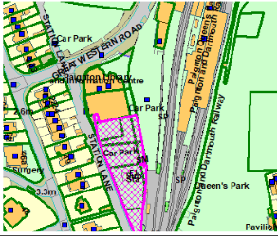

HELAA Reference no. | 21P028 PNPH16 (SHLAA H1.014)
Approx. yield | 30
Suitable: Previous assessment of suitability | Identified as PNPH16. Brownfield Town Centre site.  Flooding issues – partly Flood Risk Zone 3.  Review of parking needed but principle of reuse implied by Town Centre Masterplan.
Any Change in circumstances to consider suitable? | Review of parking needed.
Available? | Site has been allocated for many years.
Achievable | As above – likely to be a longer term site years 11-15
Customer Reference no.
Current use | Car park
Assess in 2021 HELAA? | Review of Parking needed.

AVAILABILITY ASSESSMENT
Reasonable prospect of delivery (timescale):
Unlikely to come forward
The next 5 years
A 6-10 year period
An 11-15 year period | 30
Later than 15 years

