SITE OVERVIEW: Review of car parks
Town | Paignton
Site Name | Churchward Road Car Park
HELAA Reference no. | 21P013
Approx. yield | 15
Suitable | Subject to review of parking needs.
Available | Subject to review of parking needs.
Achievable | Subject to review of parking needs.
Customer Reference no. | Leave Blank for now
Source of Site (call for sites, Local Plan allocation etc.). | Council owned car park/below the line site.
Current use | Car park
Site descriptions | Surface level car park, of Churchward Road, The site is surrounded by development , including the backs of houses on Cecil Road,
Total site area (ha)
Gross site area (ha)
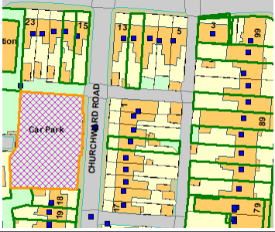
SUITABILITY ASSESSMENT: STAGE A

Strategic potential: | No
Housing? | 15 units
Employment? | Yes
Other Use? | Some Class E uses (although probably little demand in this location).
Biodiversity- Within SAC/SSSI | No
Flood Zone 3b | No – but flooding issues
Other NPPF Showstoppers (not policy constraints) | No
Conclusion | Suitable if available (Review of car parking needs)

SUITABILITY ASSESSMENT: STAGE B

Access | Existing access from Churchward Road.
Flood risk, water quality and drainage | Surface water flooding issues.
Heritage and Archaeology (including distance from assets). | Approx. 75 m from Old Paignton Conservation Area and various historic assets. No direct effect for developing the car park; but parking may be displaced to the CA.  Archaeology: Historic settlement core. Requires programme of archaeological mitigation.
Infrastructure | Within the built up area.
Landscape | No
Ecology | No
Safety related constraints | No
Soils (Agricultural Land classification) and contamination | Not agricultural land
Local Plan | ER1. Food risk  SS11 Sustainable Communities: Community Investment Area.
Neighbourhood Plan | PNP13 Housing opportunities in the town centre
Development progress (where relevant) | No
Other | Parking review needed to determine if the site is required for parking.
HELAA Panel Summary | To be completed later
Site potential | Circa 15 apartments, if not required for parking

AVAILABILITY ASSESSMENT
Development would be dependent on a review of parking need close to Paignton Town Centre

The next 5 years
A 6-10 year period | 15 (subject to parking review)
An 11-15 year period
Later than 15 years

