SITE OVERVIEW: Red rejected site
Town | Torquay - Broad Location
Site Name | Broad Location - Maidencombe Broad Location east of Teignmouth Road (coastal slopes) TQY
HELAA Reference no. | 21T152
Approx. yield | 0
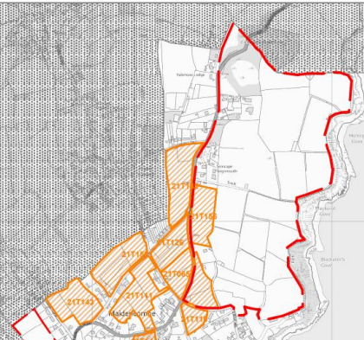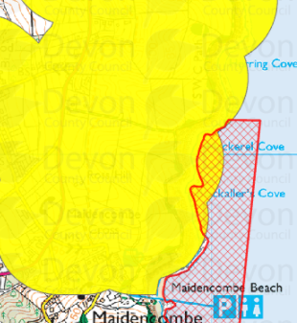
Suitable: How the principle of development is established | Principle of development not established. Sparse established residential units close to Teignmouth Road within bounded curtilages.
Available: Any change in circumstances since principle established | Potential amber sites within broad location. 21T156 & 21T065?
Achievable | Unlikely No
Customer Reference no. | N/A
Current use | Open fields / agriculture/RSPB.
Site description | The site is a greenfield area on the east side of Teignmouth Road A379, within the Torquay Neighbourhood Plan area. The site consists of open, undulating agricultural land to the east of Teignmouth Road and the coast that includes approximately twenty five fields and approx. 20 properties, largely bounded by hedgerows. Maidencombe village envelope and conservation area lies to the south. Open fields surround the site to the east , part of the undeveloped coast and countryside sone. The land is subject to Cirl bunting activity. Torbay Marine SAC and northern most limits of Torbay Boundary. Teignbridge rural area to the north.
Total site area (ha) | Approximately x ha.

AVAILABILITY ASSESSMENT
Reasonable prospect of delivery (timescale):

Confirmation of availability needed from owners. Planning permission would need to be sought given that the previous permission has lapsed.
The next 5 years | 0
A 6-10 year period | See 21T156 & 21T065?
An 11-15 year period | See 21T156 & 21T065?
Later than 15 years | See 21T156 & 21T065?

