SITE OVERVIEW Red rejected/Review of Car Parks
Town | Torquay
Site Name | Torquay Town Hall.
Map (if needed)
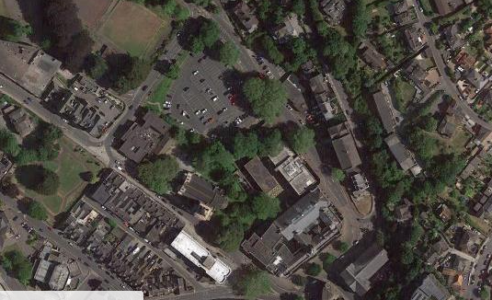

Allocation or HELAA Reference no. | 21T121 13227 in the 2013 SHLAA
Approx. yield
Suitable: How the principle of development is established | Grade 2 Listed Building in a CA. Currently used as council offices, market, library, and surface level car park.  Redevelopment of the car park is proposed in the current Local Plan TNPH21 but would need to be subject to a review of Parking.  The re-use/partial redevelopment of the town hall and associated listed buildings would need to be considered in the context of their heritage value and suitability for residential use. Another commercial use such as an hotel may be more appropriate to the buildings’ historic character. In any event, redevelopment is likely to take many years to achieve and the buildings are not currently available.
Available: Any change in circumstances since principle established | Rejected in 2013 SHLAA because not available.
Achievable | See above – would be a longer term project
Customer Reference no.
Current use | Council offices, library and associated uses.
Site description | Torquay Town Hall, library and car park, Castle Circus, Torquay,
Total site area (ha) | The entire area is about 1.3 ha.

AVAILABILITY ASSESSMENT
Reasonable prospect of delivery (timescale):

Likely to be a longer term project, if considered to be acceptable.
The next 5 years
A 6-10 year period
An 11-15 year period
Later than 15 years

