SITE OVERVIEW
Town | Torquay
Site Name | The Grove, Babbacombe
Map (if needed)
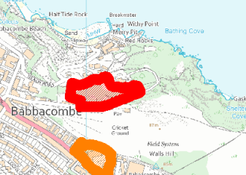

Allocation or HELAA Reference no. | 21T120 T903
Approx. yield
Suitable: How the principle of development is established | Not suitable- rejected in 3013 SHLAA due o high ecological value of the land. Local Green Space TLGSM17 in the Neighbourhood Plan.  Note that LGSs have been scoped out of the HELAA
Available: Any change in circumstances since principle established | N/A
Achievable | N/A
Customer Reference no.
Current use
Site description | The Grove, to the N of Walls Hill Road, Babbacombe.
Total site area (ha)

AVAILABILITY ASSESSMENT
Reasonable prospect of delivery (timescale):

Not suitable. Ecology and LGS

Confirmation of availability needed from owners.
The next 5 years | 0
A 6-10 year period
An 11-15 year period
Later than 15 years

