SITE OVERVIEW: Red rejected site
Town | Torquay
Site Name | Former Gasholder site, Barton Hill Road
Site Description
Total site area (ha) | 0.54
Map (if needed)
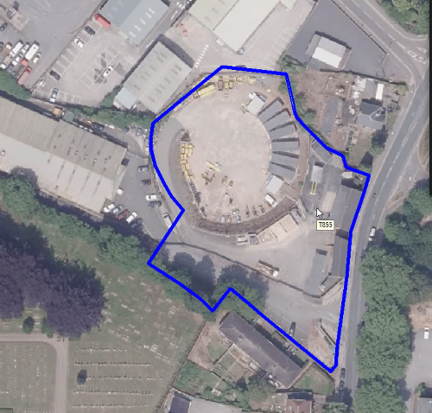

HELAA Reference no. | 21T117  T855
Approx. yield | Circa 200 sq m employment
Suitable: Previous assessment of suitability | More suitable for employment use
Any Change in circumstances to consider suitable? | Torquay Neighbourhood Plan TPE11 Barton Hill/Barton Way commercial and employment area.
Available?
Achievable
Customer Reference no.
Current use
Assess in 2021 HELAA?

AVAILABILITY ASSESSMENT
Reasonable prospect of delivery (timescale):
Check availability
Confirmation of availability needed from owners.
The next 5 years | 5
A 6-10 year period
An 11-15 year period
Later than 15 years

