SITE OVERVIEW: Red rejected site
Town
Site Land Off Seymour Drive, Watcombe Park
HELAA Reference no. | 21T083  13194 (Rejected site)
Customer Reference no.
Source of Site (call for sites, Local Plan allocation etc.). | ULPA/Council owned site
Current use | Open space
Site descriptions | Urban landscape Protection Area south of Seymour drive and east of Padacre Road, Torquay.
Total site area (ha) | 0.58ha
Gross site area (ha)
Approx. yield | 0 (LGS)
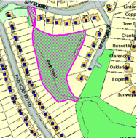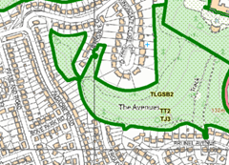
SUITABILITY ASSESSMENT: STAGE A

Strategic potential: 50+ dwellings No
Housing?
Employment?
Other Use?
Biodiversity- Within SAC/SSSI
Flood Zone 3b
Other NPPF Showstoppers (not policy constraints) | LGS in Neighbourhood Plan.
Conclusion | LGS Screened out

SUITABILITY ASSESSMENT: STAGE B

Access | Difficult to gain access
Flood risk, water quality and drainage | No
Heritage and Archaeology (including distance from assets). | Impact on the setting of Watcombe Park.
Infrastructure | Within built up area.
Landscape | ULPA
Ecology | Could be valuable for local wildlife  TPO 2007.014
Safety related constraints | No
Soils (Agricultural Land classification) and contamination | Not agricultural land
Local Plan | ULPA C5.01
Neighbourhood Plan | Part of LGSB2
Development progress (where relevant) | No
Other | Topography
HELAA Panel Summary
Site potential | Zero- screened out as the site is an LGS and also subject to TPOs

AVAILABILITY ASSESSMENT

The site promoter(s) has confirmed that the site will be available for development within:
The next 5 years | 0
A 6-10 year period
An 11-15 year period
Later than 15 years

