SITE OVERVIEW: Red rejected site
Town | Torquay
Site Name | Genting Casino
HELAA Reference no. | 21T078
Approx. yield | DPH / 0 ha employment N.B Starting assumption is for 25% of strategic sites to be employment.
Suitable | Yes
Available | Probably not – purchased by Templestowe
Achievable | Probably not.
Customer Reference no. | Leave Blank for now
Source of Site (call for sites, Local Plan allocation etc.). | Knowledge sites
Current use | Lawful use as casino
Site descriptions | Casino on SW side of Abbey Road, close to junction with Tor Church Road. Adjacent and attached to majestic Templestowe Hotel.
Total site area (ha) | 0.22 ha
Gross site area (ha)
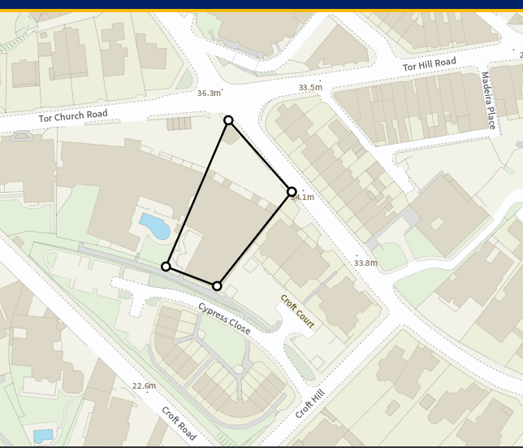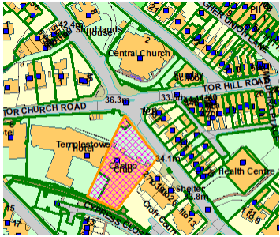
SUITABILITY ASSESSMENT: STAGE A

Strategic potential: | No
Housing? | Yes
Employment? | Leisure/tourism
Other Use? | Leisure/tourism  Or if right on sea front you could put suitable for tourist accommodation
Biodiversity- Within SAC/SSSI | No
Flood Zone 3b | No
Other NPPF Showstoppers (not policy constraints) | None
Conclusion | Suitable , but appears not to be available: purchased by Majestic

SUITABILITY ASSESSMENT: STAGE B

Access | Existing access from Abbey Road and rear lane
Flood risk, water quality and drainage | No
Heritage and Archaeology (including distance from assets). | Abbey Road Conservation Area.  Archaeology: Historic core of Torre. May require programme of archaeological mitigation.
Infrastructure | Within built up area.
Landscape | No
Ecology | No
Safety related constraints | No
Soils (Agricultural Land classification) and contamination | Not agricultural land
Local Plan | Not CTIA
Neighbourhood Plan
Development progress (where relevant) | No relevant history
Other | Existing use as a casino may be higher value than residential value. Alternative tourism/leisure use.
HELAA Panel Summary | To be completed later
Site potential | Leave blank until after HELAA Panel

AVAILABILITY ASSESSMENT
Reasonable prospect of delivery (timescale):

Appears not to be available: site purchased by Majestic. Casino use may be more valuable than residential.
The next 5 years | 0
A 6-10 year period
An 11-15 year period
Later than 15 years

