SITE OVERVIEW: Red rejected site
Town | Torquay
Site Name | Seascape Hotel 8 - 10 Tor Church Road Torquay TQ2 5UT
HELAA Reference no. | 21T077  P/2018/0910
Approx. yield
Suitable | Yes
Available | Not known
Achievable
Customer Reference no. | Leave Blank for now
Source of Site (call for sites, Local Plan allocation etc.). | Withdrawn Application P/2018/0910
Current use | Hotel
Site descriptions | Three storey hotel on south side of Tor Church Road. Adjacent to Majestic Templestowe Hotel.
Total site area (ha) | 0.2ha
Gross site area (ha)
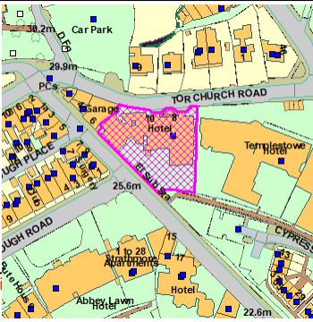
SUITABILITY ASSESSMENT: STAGE A

Strategic potential: | No
Housing? | Yes
Employment? | No (other than Hotel or leisure use)
Other Use? | Hotel, leisure
Biodiversity- Within SAC/SSSI | Not significant
Flood Zone 3b | No
Other NPPF Showstoppers (not policy constraints) | None
Conclusion | Likely to be suitable for conversion into apartments if available; but does not appear to be available (in current hotel use)

SUITABILITY ASSESSMENT: STAGE B

Access | Existing building with access/court yard onto Tor Church Road
Flood risk, water quality and drainage | No
Heritage and Archaeology (including distance from assets). | Abbey Road CA. Historic building of merit within the CA.  Archaeology: Historic core of Torre. May require programme of archaeological mitigation.
Infrastructure | Within built up area
Landscape | No
Ecology | Not significant
Safety related constraints | No
Soils (Agricultural Land classification) and contamination | Not agricultural
Local Plan | Not Core Tourism Investment Area
Neighbourhood Plan | Policy TT1 requires evidence of marketting prior to change of use being allowed.
Development progress (where relevant) | No – application withdrawn, IUn use as a hotel.
Other
HELAA Panel Summary | To be completed later
Site potential | Leave blank until after HELAA Panel

AVAILABILITY ASSESSMENT
Reasonable prospect of delivery (timescale):
Does not appear to be available
The next 5 years
A 6-10 year period
An 11-15 year period | 15
Later than 15 years

