SITE OVERVIEW: Red rejected site
Town | Paignton
Site Name | Land west of Grange Road
Site Description | Open space,/woodland between Lancaster Drive (Roselands) and Grange Road.
Total site area (ha) | 5.1
Map (if needed)
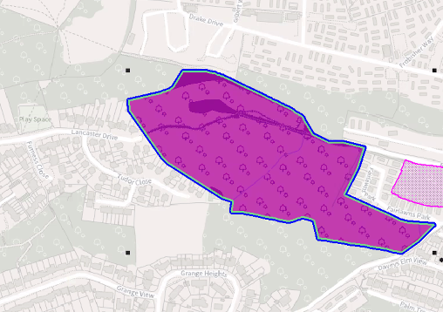

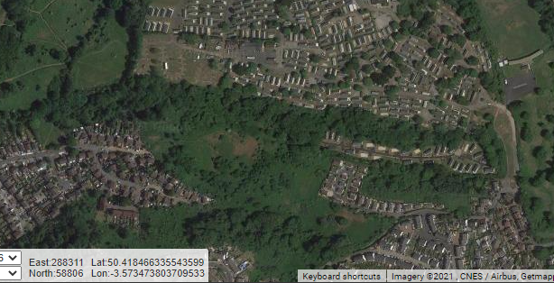

HELAA Reference no. | 21P074 13255
Approx. yield
Suitable: Previous assessment of suitability | No judgement made in 2013. ULPA C5.44, Other site of wildlife interest. Links to Clennon Valley open space. Significant tree cover – but not TPO’d. Two areas of flood risk.  Archaeology: Former marsh. Palaeoenvironmental potential. Requires evaluation.
Any Change in circumstances to consider suitable?
Available? | Not being pursued by landowner in 2013 SHLAA. Land is largely council owned.
Achievable
Customer Reference no.
Current use
Assess in 2021 HELAA?

AVAILABILITY ASSESSMENT
Reasonable prospect of delivery (timescale):

Confirmation of availability needed from owners.
The next 5 years
A 6-10 year period
An 11-15 year period
Later than 15 years

