SITE OVERVIEW: Red rejected site
Town | Paignton
Site Name | Blagdon Road, Collaton St Mary
Site Description | Land north of Blagdon Road, Collaton St Mary, to the NW of primary school
Total site area (ha) | 1.3
Map (if needed)
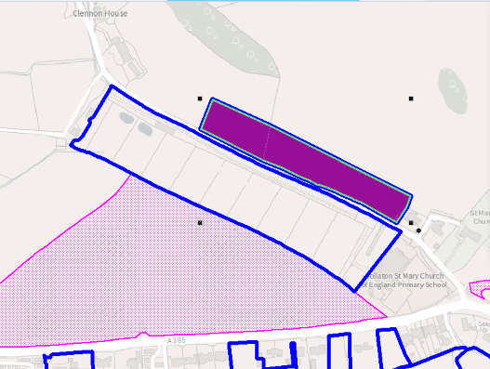

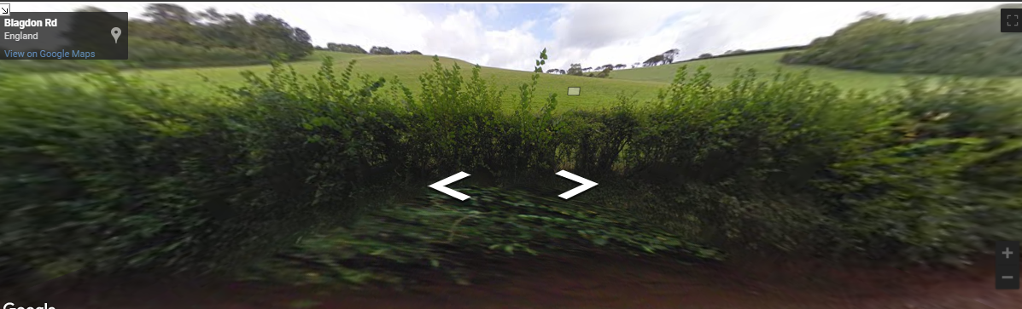

HELAA Reference no. | 21P073  13252
Approx. yield | 70 identified in the 2013 HELAA
Suitable: Previous assessment of suitability | P/2006/0741 static caravan – refused.  N.B land to the south has flooding issues and is in use a poultry breeding farm so not available.
Any Change in circumstances to consider suitable? | Paignton Neighbourhood Plan 1(a) Rural Character Area, PNP19 Safeguarding open countryside.  Adjacent Future Growth Area (and southern part of the site is within the FGA). Next to Bloor Homes site P/2019/0281 (permission for 100 dwellings, 18 June 2021)  Landscape Character assessment 3H: Blagdon Valley, highly sensitive/conserve.  Impact on Grade 2* listed church.
Available? | Has not been promoted, but uplift in value would be significant.
Achievable | Could link to approved adjacent Bloor Homes scheme if the decision was taken to allow additional development to the north (further up the hill) of the Bloor Homes site
Customer Reference no.
Current use | Agriculture
Assess in 2021 HELAA? | Yes- partly FGA

AVAILABILITY ASSESSMENT
Reasonable prospect of delivery (timescale):

Confirmation of availability needed from owners.
The next 5 years
A 6-10 year period | 10
An 11-15 year period
Later than 15 years

