SITE OVERVIEW: Red rejected site
Town | Paignton
Site Name | Land at Occombe Farm
Site Description | Wider area of land at Occombe Farm, beyond existing identified site.
Total site area (ha) | 7.37ha
Map (if needed)
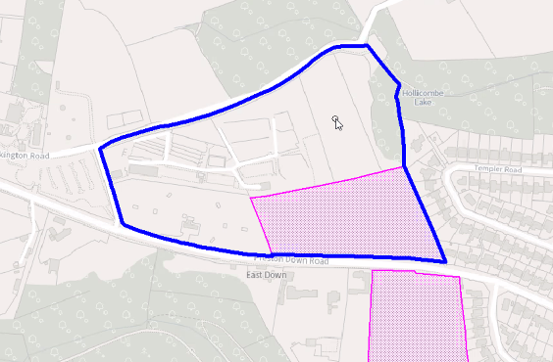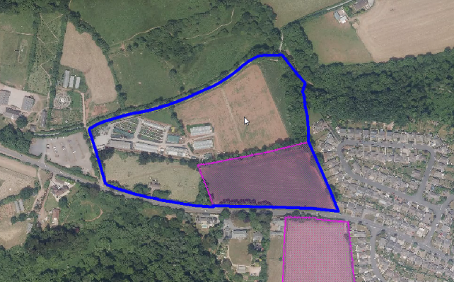

HELAA Reference no. | 21P070  T831
Approx. yield
Suitable: Previous assessment of suitability | Rejected in 2013 SHAA. Grade 1 Agricultural Land. Impact on greater crested newts, and close to SSSI. Would have greater impact than smaller area of land (13195) assessed separately. Landscape Character Area 1H: Occombe Cross, Highly sensitive.  Archaeology: Prehistoric or Roman settlement enclosure to south. Archaeological potential. Requires programme of evaluation and mitigation.
Any Change in circumstances to consider suitable? | PNP - Rural Characer Area PNP1(a) PNP19.  Remains unsuitable: ecology anfd landscape
Available? | N/A
Achievable
Customer Reference no.
Current use
Assess in 2021 HELAA? | 0

AVAILABILITY ASSESSMENT
Not suitable
The next 5 years | 0
A 6-10 year period
An 11-15 year period
Later than 15 years

