SITE OVERVIEW
Town | Paignton
Site Name | Queens Park and Rugby Club
Map (if needed)
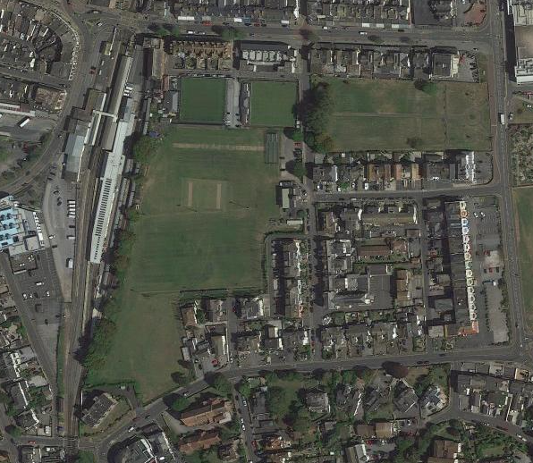

Allocation or HELAA Reference no. | 21P089  PNPH17 houisng location but superseded by LGS designation.
Approx. yield
Suitable: How the principle of development is established | Designated Local Green Space in Paignton Neighbourhood Plan PLGS05 and PNP10. The site is withing Flood Risk Zone 3 and as a greenfield site there are few regeneration benefits gained by its development. ULPA 5.37  Loss of a sustainably located open space and sports club.
Available: Any change in circumstances since principle established | Council owned site but in use as sports club.
Achievable | Sustainable town centre location, but flooding issues and loss of sports facilities.
Customer Reference no.
Current use | Sports facility.
Site description | Queens Park sports ground to the South of Torbay Road, Paignton.
Total site area (ha)

AVAILABILITY ASSESSMENT
Reasonable prospect of delivery (timescale):

The site is not suitable for development and is rightly identified as an LGS.

Confirmation of availability needed from owners.
The next 5 years | 0
A 6-10 year period
An 11-15 year period
Later than 15 years

