SITE OVERVIEW Red Rejected Broad Location
Town | Paignton
Site Name | Broad Location: Langdon/Whitehill Holiday Camp
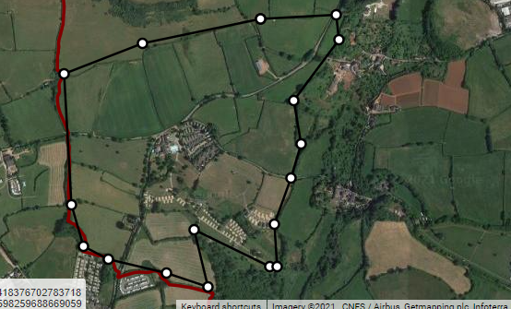

Allocation or HELAA Reference no. | 21P084
Approx. yield | 0
Suitable: How the principle of development is established | Smaller areas 21P065 and 21P066 rejected due to remote location, landscape impact and flooding issues. AOLC 1M Rolling Farmland: highly sensitive in the 2010 Landscape Character Assessment .  Despite not being AONB there would be a significantly harmful landscape impact. The area is not flat which will increase the landscape harm.  The location is remote from facilities and good transport links and is unlikely to be able to accommodate sufficient development to provide sufficient infrastructure.  The land to the sough has flooding issues and the area has ecological issues within the GHB sustenance zone and for cirl buntings.
Available: Any change in circumstances since principle established | Only part of the land was prevously promoted.
Achievable | Unsustainable location remote from facilities . There is unlikely to be sufficient development to fund the required infrastructure to provide adequate infrastructure. The steep terrain is likely to reduce development viability.
Customer Reference no.
Current use | Agriculture (Grade 3)
Site description | Broad Location to the West of Lower Yalberton Road, comprising agricultural and holiday camps, including Whitehill Camping site.  The wider area is considered as a broad location as 21P084.
Total site area (ha) | Broad Location- approx. 55ha

AVAILABILITY ASSESSMENT
Reasonable prospect of delivery (timescale):

Remoteness of site

Confirmation of availability needed from owners.
The next 5 years | 0
A 6-10 year period
An 11-15 year period
Later than 15 years

