SITE OVERVIEW: Red rejected site
Town | Paignton
Site Name | West of Great Parks
Site Description | Valley west of Great Parks
Total site area (ha) | 15.5ha
Map (if needed)
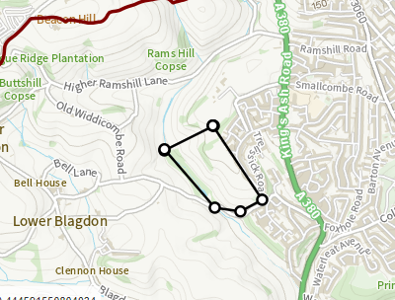

HELAA Reference no. | 21P072  13199
Approx. yield | 450 dwellings
Suitable: Previous assessment of suitability | No – major incursion into valley system.  LCA 1J the Blagdons: highly sensitive.  Rejected by the Planning Inspectorate as too environmentally sensitive for a Ring Road site in the 1990s.  Archaeological potential needs to be assessed and evaluated.
Any Change in circumstances to consider suitable? | Paignton Neighbourhood Plan – Rural Character Area and PNP19Safeguarding Open Countryside, PNP20 Great  Parks
Available? | If allocated
Achievable | If allocated
Customer Reference no.
Current use | Designated for Green infrastructure. Agriculture
Assess in 2021 HELAA? | No – reasons for rejection remain valid

AVAILABILITY ASSESSMENT
Reasonable prospect of delivery (timescale):
Not suitable
The next 5 years | 0
A 6-10 year period
An 11-15 year period
Later than 15 years

