SITE OVERVIEW Red Rejected
Town | Paignton
Site Name | South of Lower Yalberton Holiday Park, Long Road
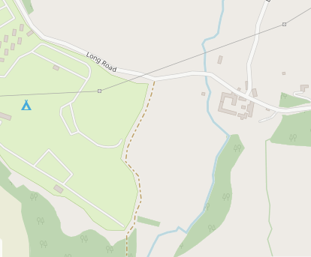

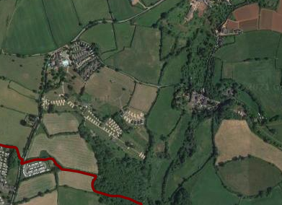
Allocation or HELAA Reference no. | 21P066 (T770 in 2013 HELAA)
Approx. yield | 0
Suitable: How the principle of development is established | Rejected in 2013 HELAA: landscape impact and flooding issues. The land is not particularly flat and is very rural. There would be a significant landscape harm. Within the GHB sustenance zone/ landscape connectivity zone.  AOLC 1M – Rolling farmland overall highly sensitive, conserve.  It is noted that sites in more sensitive locations (i.e. AONB) have been coded “amber” rather than rejected. This site has been rejected despite not being AONB due to its remoteness as well as landscape impact.
Available: Any change in circumstances since principle established | Has not been actively promoted in the 2021 HELAA, but has in the past been promoted.
Achievable | Likely to be viable in principle, but is a long way from the built up area and significant infrastructure would need to be provided. The site would not represent a sustainable location without very significant transport etc. investment.
Customer Reference no.
Current use | Agriculture (Grade 3)
Site description | Land south of Long Road Note that although called Lower Yalberton Holiday Park the main use appears to be agricultural, with Whitehill Hol Park located to the West. Land to the North of Long Road is coded as 21P066  The wider area is considered as a broad location as 21P084.
Total site area (ha) | 9.3ha

AVAILABILITY ASSESSMENT
Reasonable prospect of delivery (timescale):

Confirmation of availability needed from owners.
The next 5 years | 0
A 6-10 year period
An 11-15 year period
Later than 15 years

