SITE OVERVIEW Red rejected
Town | Paignton
Site Name | North of Lower Yalberton Holiday Park, Long Road
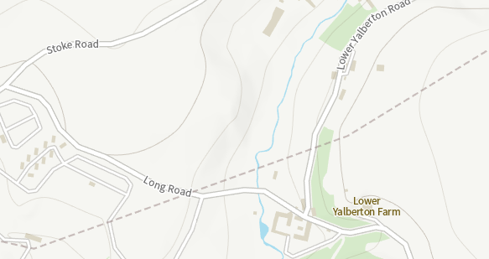

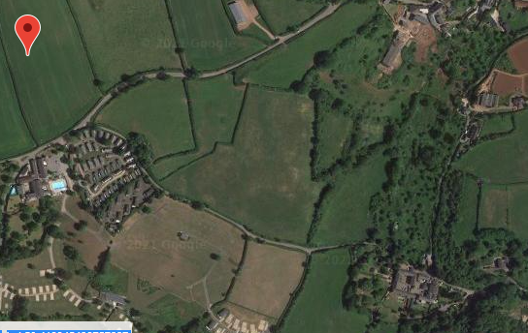

Allocation or HELAA Reference no. | 21P065 (T769 in 2013 HELAA)
Approx. yield | 0
Suitable: How the principle of development is established | Rejected in 2013 HELAA: landscape impact and flooding issues. The land is not particularly flat and is very rural. There would be a significant land scape harm. Within the GHB sustenance zone/ landscape connectivity zone.  AOLC 1M – Rolling farmland overall highly sensitive, conserve.  It is noted that sites in more sensitive locations (i.e. AONB) have been coded “amber” rather than rejected. This site has been rejected despite not being AONB due to its remoteness as well as landscape impact.
Available: Any change in circumstances since principle established | Has not been actively promoted in the 2021 HELAA, but has in the past been promoted.
Achievable | Likely to be viable in principle, but is a long way from the built up area and significant infrastructure would need to be provided. The site would not represent a sustainable location without very sifnificant tansport etc. investment.
Customer Reference no.
Current use | Agriculture (Grade 3)
Site description | Land north of Long Road and the south of Stoke Road. Note that although called Lower Yalberton Holiday Park, the main holiday use appears to relate to the land to the south of Long Road (21P066)
Total site area (ha) | 7.49ha

AVAILABILITY ASSESSMENT
Reasonable prospect of delivery (timescale):

Confirmation of availability needed from owners.
The next 5 years | 0
A 6-10 year period
An 11-15 year period
Later than 15 years

