SITE OVERVIEW Red Rejected
Town | Paignton
Site Name | Land NE of Long Meadow, Collaton St Mary
Map (if needed)

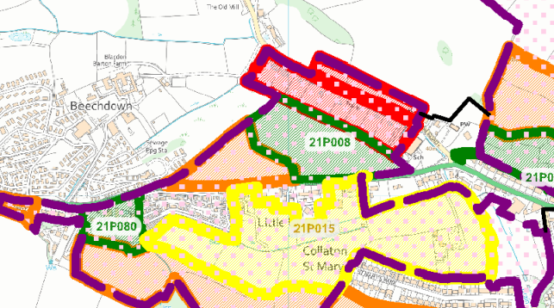

Allocation or HELAA Reference no. | 21P062 formerly SAHLAA site T734
Approx. yield | Shown as 50 in SHLAA
Suitable: How the principle of development is established | Shown as 50 in the SHLAA, but the site appears to have significant flooding issues, so not likely to be suitable for development.
Available: Any change in circumstances since principle established | Does not appear to be available for development- in use as poultry farm
Achievable | Likely to be a viable site, but not suitable or available.
Customer Reference no.
Current use
Site description | Land used as poultry farm, running along the NE of Long meadow, Collaton St Mary.
Total site area (ha) | 3.6

AVAILABILITY ASSESSMENT
Reasonable prospect of delivery (timescale):

Confirmation of availability needed from owners.
The next 5 years
A 6-10 year period
An 11-15 year period
Later than 15 years

